Incorporation of Geospatial Data into Modern Numerical Models: A SMaRK Case Study in Arizona

Ryan J. Erickson

B.A., University of California, Santa Barbara - Geography, 2020

B.A., University of California, Santa Barbara - Physics, 2020

A thesis submitted to the

Faculty of the Graduate School of the

University of Colorado in partial fulfillment

of the requirement for the degree of

Masters.

Department of Geography

2025

Committee Members:

Guofeng Cao

Rachel Isaacs

Stefan Leyk

Erickson, Ryan J. (MA, Geography)

A SMaRK Way to Map: Statistical Model and Residual Krige Case Study of Urban Surface Ozone Mapping in Arizona

Thesis directed by Associate Professor Guofeng Cao

Modeling surface ozone concentrations at high spatial resolutions is essential for informed decision-making regarding air pollution regulation, healthy ecologies, and biological cycles within the world’s unique micro- and macro- biomes. Geospatial datasets that combine complex numerical models by way of statistical machine learning (Deep Learning, Artificial Intelligence, GEOS-Chem, DOAS, etc.) are not as strong as they could be due to a lack of proper geospatial connection to the surface they represent. Inspired by the idea of regression kriging, this thesis proposes a simplified, hybrid, and practical approach to integrate advanced numerical methods with traditional geospatial kriging to explicitly incorporate complex spatial effects to improve surface ozone concentration mapping. With a case study for metropolitan areas in Southern Arizona (Maricopa, Pima and Pinal counties), we showcase the performance and advantage of this hybrid approach with daily high-resolution maps of surface O3 concentrations for this area of interest (AOI). This methodology is readily available and reproducible for the contiguous United States of America.

TABLE OF CONTENTS

I. INTRODUCTION 1

1. Machine Learning/Artificial Intelligence Predictions Require Incorporations of Geospatial Data x

2. Why Surface Ozone? – Relations to Urban Air Quality x

3. A Tale of Two Layers x

3.1. The Atmospheric O3 Cycle x

3.2. Surface O3 Exposure and Transport x

4. Tobler’s Law – A Short History of Modern Geographic Information Science x

5. The Geo-Atom: A Relationship Between Theory and Law x

6. Structure of the Thesis x

II. LITERATURE REVIEW x

1. Machine Learning/Artificial Intelligence Predictions Require Incorporations of Geospatial Data x

2. Why Surface Ozone? – Relations to Urban Air Quality x

3. A Tale of Two Layers x

3.1. The Atmospheric O3 Cycle x

3.2. Surface O3 Exposure and Transport x

4. Tobler’s Law – A Short History of Modern Geographic Information Science x

5. The Geo-Atom: A Relationship Between Theory and Law x

6. Structure of the Thesis x

III. DATA COLLECTION AND PRE-PROCESSING x

1. Machine Learning/Artificial Intelligence Predictions Require Proper Incorporation of Geospatial Data x

2. Why Surface Ozone? – Relations to Urban Air Quality x

3. A Tale of Two Layers x

3.1. The Atmospheric O3 Cycle x

3.2. Surface O3 Exposure and Transport x

4. Tobler’s Law – A Short History of Modern Geographic

Information Science x

5. The Geo-Atom: A Relationship Between Theory and Law x

6. Structure of the Thesis x

IV. METHEDOLOGY x

1. Machine Learning/Artificial Intelligence Predictions Require Proper Incorporation of Geospatial Data x

2. Why Surface Ozone? – Relations to Urban Air Quality x

3. A Tale of Two Layers x

3.1. The Atmospheric O3 Cycle x

3.2. Surface O3 Exposure and Transport x

4. Tobler’s Law – A Short History of Modern Geographic

Information Science x

5. The Geo-Atom: A Relationship Between Theory and Law x

6. Structure of the Thesis x

V. RESULTS x

1. Machine Learning/Artificial Intelligence Predictions Require Incorporations of Geospatial Data x

2. Why Surface Ozone? – Relations to Urban Air Quality x

3. A Tale of Two Layers x

3.1. The Atmospheric O3 Cycle x

3.2. Surface O3 Exposure and Transport x

4. Tobler’s Law – A Short History of Modern Geographic

Information Science x

5. The Geo-Atom: A Relationship Between Theory and Law x

6. Structure of the Thesis x

VI. DISCUSSION x

1. Machine Learning/Artificial Intelligence Predictions Require Proper Incorporation of Geospatial Data x

2. Why Surface Ozone? – Relations to Urban Air Quality x

3. A Tale of Two Layers x

3.1. The Atmospheric O3 Cycle x

3.2. Surface O3 Exposure and Transport x

4. Tobler’s Law – A Short History of Modern Geographic

Information Science x

5. The Geo-Atom: A Relationship Between Theory and Law x

6. Structure of the Thesis x

VII. CONCLUSION AND FUTURE DIRCTIONS x

1. Machine Learning/Artificial Intelligence Predictions Require Proper Incorporation of Geospatial Data x

2. Why Surface Ozone? – Relations to Urban Air Quality x

3. A Tale of Two Layers x

3.1. The Atmospheric O3 Cycle x

3.2. Surface O3 Exposure and Transport x

4. Tobler’s Law – A Short History of Modern Geographic

Information Science x

5. The Geo-Atom: A Relationship Between Theory and Law x

6. Structure of the Thesis x

VIII. BIBLIOGRAPHY x

XI. APPENDIX x

TABLES

Table 1 x

Table 2 x

Table 3 x

Table 4 x

Table 5 x

FIGURES

Figure 1 x

Figure 2 x

Figure 3 x

Figure 4 x

Figure 5 x

Figure 6 x

MAPS

Map 1 x

Map 2 x

Map 3 x

Map 4 x

Map 5 x

Map 6 x

CHAPTER I

INTRODUCTION

Historical analysis of atmospheric chemistry shows global ozone (O₃) concentrations are heavily influenced by multiple catalytic cycles involving halogen, nitrogen, hydrogen, and oxygen species (Caffrey et al. 2001; Dobson 1923; S. He and Carmichael 1999; Lyons, Reinhard, and Planavsky 2014; WMO 2022). The global movement of carbon among the atmosphere, biosphere, oceans, and geosphere, indirectly yet significantly influence O3 concentrations, in the troposphere through greenhouse gas effects and atmospheric chemistry interactions (Danyang Ma et al. 2023; Hata et al. 2023; Q. Liu et al. 2022). Continued regulation, monitoring, and development of air pollution control initiatives are essential for continued maintenance of ozone depleting substances (US EPA 2015a; WMO 2022) which can impact the evolutionary potential of biological mechanisms on Earth (Grenfell et al. 2010; Kasting and Siefert 2002). The source of atmospheric cycles seems to be this highly reactive, unstable, triatomic molecule; providing a canvas for dioxide cycles necessary for organic systems (Caffrey et al. 2001; Lyons, Reinhard, and Planavsky 2014). Varying degrees of O3 allow for redox reactions, forming as both a product and constituent of the natural environment (Chapleski et al. 2016; Xing et al. 2016; Zoran et al. 2014).

Anthropogenic sources have deeply affected these necessary cycles by shifting natural concentrations of O3 in unnatural manners (Chauhan, Gupta, and Liou 2023; Cheadle et al. 2017; Danyang Ma et al. 2023; Flynn et al. 2021). As climate change continues to abet abnormal temperatures and weather cycles, the development of high-resolution predictive models such as those shown by this thesis are even more necessary to combat the exponential rate of urbanization (Balk et al. 2018; EPA 2021; Iglesias et al. 2021). This thesis seeks to provide a novel methodology which better incorporates geospatial relationships into modern statistical methods via residual kriging to three of the most populous counties in Arizona. The Statistical Model and Residual Krige (SMaRK) methodology is overlayed with statistical representations of census data in Maricopa, Pima, and Pinal Counties to show that leveraging the advantages of both techniques can better depict complex systems like O3. Similar methods have already shown great promise in modeling PM2.5, NOx, and similar air pollutants as complex as O3 (Y. Liu et al. 2018).

I.1. Machine Learning/Artificial Intelligence Predictions Require Proper Incorporation of Geospatial Data

Policies set by world governments can help reduce overall surface ozone pollution, but this is only as effective as the models used in gauging vulnerable areas. Current numerical modeling approaches, such as WRF-Chem, GEOS-Chem, and GODfit-Algorithms (Flandorfer 2019; Lerot et al. 2010; C. Lin et al. 2016; Yu et al. 2018b), are computationally expensive, restricting the output of surface O3 maps to coarse spatial resolutions that are not suitable for public health studies. Health experts build their own datasets, resulting in highly accurate, but non-rasterized depictions of surface O3. Most ozone representations of the surface take numerous days to produce their final products (Kwok et al. 2015; C. Lin et al. 2016; Travis and Jacob 2019; L. Wu et al. 2021) and modelling efforts based on remote sensing measurements still have trouble capturing the complexity of surface ozone in urban settings without further improvements made by the researcher (Balamurugan, Balamurugan, and Chen 2022; Yuting Wang et al. 2023a). When predictions from modelled O3 reactions are compared against surface observations from monitors, they tend to have difficulty simulating O3 concentrations at high-temporal resolutions. This suggests that the underlying geospatial patterns used during observation may not fully characterize regions accurately and/or that the resolution of the models is not adequate to simulate the photo-chemical environment of these finer observations. There is a compelling need in recent literature to improve high resolution surface O3 concentrations by incorporating simple spatial patterns into complex models.

Machine learning methods like Random forests can account for complex relationships between ozone and other covariates but tend to ignore spatial correlations of remote sensing (Niu et al. 2022a; Telesca et al., n.d.; Wright and Ziegler 2017b). With large data, linear and weighted regression tends to be exponentially faster, at the cost of egregious error (Feng et al. 2016; M. Huang et al. 2017; Watson et al. 2019). Combining an advanced model with its corresponding geospatial residuals helps account for the spatial correlation between modeled values while simultaneously accounting for complex relationships. Regression kriging is a commonly used kriging method based on multiple linear regressions and variograms (Yakowitz and Szidarovszky 1985; Q. Meng, Liu, and Borders 2013; Kleijnen 2017). In application to surface O3 values, this helps in incorporating co-funding covariates from a non-geospatial perspective. Five ensemble learning models were compared: Adaptive boosting, Stochastic Gradient Boosting, Extreme Gradient Boosting, Random Forest bagging, and a 2D recursive convolutional neural network (RCNN). These were created over a study area containing Arizona’s most populous counties of Maricopa, Pinal, and Pima from 1980-2023. Each model was created using a hyper-parameter tuner available through sci-kit learn in python (Raschka and Mirjalili 2019).

I.2. Why Surface Ozone? – Relations to Urban Air Quality

O3 has been detected in Earth’s stratosphere, troposphere, and more recently, on its surface (Claeyman et al. 2011; Davies and Schuepbach 1994; S. He and Carmichael 1999; M. Lin et al. 2012; Richter 2009; Xing et al. 2016). In 1955, the United States of North America (USNA) issued the Air Quality Control Act which dedicated the nation’s vast resources to additional monitoring, addressing air pollution concerns post-scientific revolution enticed by the Space Race of 1950. The acting President of the United States (POTUS) at the time; Richard Nixon, aided in the establishment of an Environmental Protection Agency (EPA) and National Oceanic and Atmospheric Administration (NOAA) to combat this newfound enemy with extreme prejudice (Nixon 1970). In doing so, new environmental movements emerged due to unprecedented economic growth at the time; regulation policies which initially slowed some sectors, later exhibited long-term beneficial human and economic trends, as was theorized in the early 90s by Dr. Micheal E. Porter (Ambec and Barla 2002). Geographic Informational Science (GIS) has been dedicated to the proper implementation of these goals set forth in the early 1970s. With it came a new way to write Earth’s history via digital transformation of newfound resources; relating to trends near and far to answer difficult questions associated with life. From micro- to macro-scales, a geographer specializes in observations and predictions from planetary to microbial systems, inadvertently weaving complex knowledge of space and time beyond the scope it represents (Goodchild 1992).

Many communities at risk of high surface ozone concentrations are further threatened by urban heat island effects, vehicle emissions and industrial processes attributing to a variety of pollutants due to the mechanism which drives O3. It’s a precursor to many things due to its highly degenerative state (Afonso and Pires 2017; Bojkov and Fioletov 1995; Harithasree et al. 2024; J. Li et al. 2014). After zooming-in, ground-level O3 has been found to have a lasting impact on human health via reductions in life expectancy, abrupt changes to normalized Earthly air chemistries, and related oxo-based cycles for its development (Barzeghar et al. 2020; Ding, He, and Liu 2021; C. Lin et al. 2016; Manisalidis et al. 2020; Schlink et al. 2006; WHO 2013; J. Zhang, Wei, and Fang 2019). Surface O3 exposure has been found to contribute to several adverse respiratory symptoms, childhood cancers, adverse birth outcomes, overall mortality, and neurological disorders (Ni et al. 2024; Ghozikali et al. 2015; Tang et al. 2024; Turner et al. 2016). In addition, atmospheric studies have found the most significant constituents of ground-level O3 reactions to be nitrogen-oxides (NOx) and volatile organic compounds (VoCs) (Brown-Steiner and Hess 2011; Cheng et al. 2018; Girach et al. 2012). When these are combined with large amounts of UV radiation, O3 begins to form and can have numerous effects on organic and in-organic material. Surface ozone has been found to be one of the leading pollutants on the Global Burden of Disease (GBD) (Anenberg et al. 2018; Brauer et al. 2024; H. Z. Sun et al. 2024), harboring stealthy consequences that can only be seen with appropriate consideration of both formation and exposure to fully understand its impacts. Varying concentrations of O3 have been found to have numerous beneficial and adverse effects on various systems in a myriad of ways due to interactions with surrounding ecosystems (US EPA 2015). This thesis applies the three laws of Geography to create a high-resolution representation of surface O3 at tiled resolutions ranging from 300m down to 25m. While the starting area is a small section of three counties within the United States, the framework applied here can be utilized for representations of O3 across the world as the incorporation of GIS and improvement of computational systems continue to progress in this era of Big Data (Cao 2022; Tamiminia et al. 2020; Bughin 2016; Curry 2016; Xu et al. 2023).

I.3. A Tale of Two Layers

Two layers in Earth’s atmosphere are known to house this reaction. It is generally beneficial to the environment and can act as a catalyst for certain biological and chemical systems whose main constituent is oxygen. Therefore, the patterns observed by researchers of specifically surface O3 (i.e 2m above the ground), have been difficult to follow. Generally, O3 is highly reactive and decomposes quickly, therefore increasing the probability for a reactive oxygen species (ROS) to “unnaturally” exist in any environment/system which it’s found to be a part of. Highly concentrated O3 areas near Earth’s surface typically affect populations outside highly industrialized zones with high vegetation, as the byproduct of plants is mainly CO2. Studies interested in surface ozone exposure within one’s activity space have noted severe differences in health outcomes among varying populations. To better understand the harmful cycles of surface O3, the beneficial aspects of O3 are worth mentioning in detail.

In the Stratosphere, O3 protects the surface of Earth by absorbing UV rays. Due to the chemical composition of this layer, stratospheric O3 naturally follows seasonal cycles, as these correlate to the distance from the sun and positioning of Earth’s tilt in its rotational pattern. However, due to rising temperatures, this beneficial, and natural cycle is threatened, potentially mixing with surface air quality and chemistries. As the Ozone Layer doesn’t absorb all UV radiation, what’s left over reflects off the surface of the Earth. Remote sensing is a field dedicated to measuring these reflections, correcting for the numerous atmospheric and geographic distortions provided by optical, electrical, and human error.

Ground-level ozone combined with other reactive gases will tend to correlate to the quality of air encompassing human communities (Bojkov and Fioletov 1995; Díaz et al. 2018; Gaudel et al. 2018a; Schultz, Schröder, Lyapina, Cooper, Galbally, Zhiqiang, et al. 2017b). As this dual formation involves titrations with varying chemicals, complex, non-linear associations begin closer to the source of common pollutants; later being reincorporated into the environment at some distance away. This makes it difficult for these O3 reactions to be identifiable and effectively modelled for decision making and regulatory entities. (S. Abdullah et al. 2019a; Balamurugan, Balamurugan, and Chen 2022; Gaudel et al. 2018a; M. Huang et al. 2017; Yamashita et al. 2010). In addition, concentrations of stratospheric ozone in the future will depend on the decrease of O3-depleting substances (ODS)s found near the surface due to reducing the frequency and hence; likelihood of these interactions (M. Huang et al. 2017; Manisalidis et al. 2020; Na Zhao et al. 2021).

I.4 Surface O3 Exposure and Transport

While most hazardous pollutants are emitted directly, complex pollutants such as surface O3 form as byproduct, later becoming a constituent for other chemicals. O3 is known as a secondary pollutant (J.-T. Lin et al. 2012a; Watson et al. 2019; Venkanna et al. 2015) wherein it can act as an ingredient and result of chemical processes. The slightest change in wind speeds, environmental conditions (coastal to arid), and ecological elements (available greenspace vs. concrete) can influence O3 formation and degradation (Badia et al. 2023; K. Meng et al. 2022; Xing et al. 2016). The data provided by these, and numerous other works gives insights into historical transport of O3 due to urban, suburban, and rural development which were incorporated during development. Studies which gathered similar data products have found a link between urbanization and the populations which are exposed to unhealthy levels of air pollution; typically well above those of current standards set by the Environmental Protection Agency and World Health Organization (EPA 2021; Kumar et al. 2015; X. Liu et al. 2022; WHO 2013) set at 70 ppb (U. EPA 2013).

The trajectory of these emissions has a direct impact on policy decisions affecting numerous socio-economic statuses (SES) due to inherent constituents. Sand, smoke, volcanic plumes, dust, other gaseous components like clouds can affect the overarching operations of O3 cycles and complexity as seen in many studies (Harithasree et al. 2024; Venkanna et al. 2015; Tong et al. 2017). The precursors for its existence are risks to human health, as indicated by informed policies limiting exposures to other pollutants (e.g. Particulate matter (PM), Carbon monoxide (CO), Nitrogen dioxide (NO2), and more) per the CDC, EPA, and WHO (CDC 2024; US EPA 2015a; WHO 2013). Policies which limit the general reduction of emissions; like carbon dioxide (CO2), formaldehyde (HCHO or CH2O), methane (CH4) and nitrous oxides (NOx), tend to reduce surface O3 reactions as well, decreasing the probability for a reaction to occur in populated areas. Current representations and remote sensing methods used for surface ozone can be too coarse for urban analysis, and might not highlight key details known to interact with urbanization and natural disasters in communities at finer spatial scales (Nawaz 2023; J. Zhang, Wei, and Fang 2019; S. Abdullah et al. 2019a). These instruments often rely on novel approaches to aerosol forecasting and implement a slew of corrective algorithms for proper representation of meteorological variables. A Statistical Model and Residual Kriging methodology is proposed to refine S5P’s tropospheric O3 representation into a surface O3 estimates with a spatial resolution of 250m, a resolution suited for urban analysis (Yuting Wang et al. 2023b)

I.5. Structure of Thesis

This thesis seeks to compare the performance of common machine learning (ML) and artificial intelligence (AI) methods with the enhancements made by the Residual Kriging method on forecasted O3 values for further development into a python-based air pollution modelling library. Beginning with a substantial literature review on the formation of O3, it’s found that almost every aspect of it can impact local ecologies, health, and people. These are heavily discussed to provide a high-quality basis for feature creation and model tuning based on scientific evidence. Some drivers included in the initial dataset were not utilized in the final model, albeit all data initially gathered was due to the synthesis of literature. A section dedicated to data sources and materials delves into further reasoning for the features best suited for ML/AI ensembles and integration with the RK method. After understanding the fundamental drivers, constituents, and numerical model tuning methods, a geospatial regression krige is applied to the resulting uncertainty left by the estimated trend. The full combination of these techniques creates daily high spatial resolution rasters for the urban cities of Phoenix and Tucson in Arizona. These cities are encompassed in two counties, with a third sitting in between them. An extremely brief demographic analysis depicting income, total population, and occupied households is conducted via census data provided by the U.S. Census Bureau followed by an assessment of possible health outcomes due to excessive exposure to surface O3 above concentrations of 70 ppb. The main portion of the thesis is concluded with a detailed description of future directions, model improvements, and further reasonings for why high-spatial resolution surface O3 models are needed, especially within the contiguous United States. A small portion on the use of Geographical laws and theory in historical scientific literature is presented as the final notes to this thesis to depict a proposed economic solution garnered from the betterment of air pollution modelling. Methodology used in this thesis can be best described as a common case-study using the Scientific Method, Geo-spatial statistical analysis, and application of the three main laws of geography to modern ML/AI modelling methodologies.

CHAPTER II

LITERATURE REVIEW

As noted in Chapter I.3, complex interactions of O3 formation have been an interest in academics for over a century. Discovery and detection of O3 can be dated back to an isolated study conducted by Dr. Gordon Dobson in the early 1920s. This resulted in the first in-situ measurement of total column ozone (TCO) by comparing UV absorption at specific wavelengths (Dobson 1923). The establishment of the Dobson Unit (DU), the development of the Dobson Spectrophotometer, and discovery of the stratospheric O3 layer later enabled researchers to detect substantial depletions of Arctic stratospheric ozone, most notably the 1985 finding by (Farman, Gardiner, and Shanklin 1985). Later, was found that the Arctic contained higher levels of inorganic chlorine (Clₙ, such as HCl and ClONO₃), which, under temperatures below ~196 ± 4 K, undergo heterogeneous activation on polar stratospheric cloud (PSC) particles, converting them into reactive radicals (Cl, ClO) that catalyze ozone destruction (Webster et al. 1993). This activated chlorine enters catalytic ozone-destroying cycles that continue until chlorine reservoirs are depleted. While ozone depletion itself does not directly drive sea-level rise, Arctic ozone loss indicates polar stratospheric cooling, which can be linked to broader climate feedback such as ice-albedo and greenhouse warming, contributing indirectly to ice melt and sea-level rise (Girach et al. 2023; Minghu Ding et al. 2020; Nadzir et al. 2018). Ozone (O₃) primarily absorbs UV radiation but also plays a complex role in atmospheric chemistry by modulating the concentrations of other trace gases, such as reactive chlorine and nitrogen species, thereby acting as a catalytic agent within stratospheric cycles (Farman, Gardiner, and Shanklin 1985; Hansen 2007; S. He and Carmichael 1999; Webster et al. 1993; Zvyagintsev, Tarasova, and Kuznetsov 2008).

This literature review seeks to utilize as many resources as possible through professional CUB guidance, free Big Data sources, and course work to better understand overall surface O3. Due to its simplicity, it has many complexities with both short- and long-term trends occurring at coarse- and fine-resolutions. Due to the grandiose potential of computer science, this project follows two informal laws from computer science and military backgrounds: Keep It Stupid Simple and Proper Planning and Preparation Prevents Piss Poor Performance, or K.I.S.S and the 7P’s respectively. Providing streamlined access to data allows for numerous resources used for project implementation in a variety of fields. This thesis seeks to create a simple solution to high resolution surface mapping via thoughtful, out-of-the-box methods because of literature found regarding O3 models.

II.1. Search Methods

The literature synthesized utilized the University of Colorado, Boulder’s (CUB) vast academic resources to conduct a thorough investigation into O3 mechanisms and related processes to air pollutants. With access to prominent sources of academic literature via CUB’s library, EBSCOhost and Web of Science, numerous documents were selected from keywords found throughout literature consumed during course work. A python script accessed the API of each database with the following categorization of key-terms:

|  |  |
| --- | --- |
| **TOPIC** | **Name** |
| **1** | Ozone |
| **2** | Models |
| **3** | Ecology |
| **4** | Human |
| **5** | Risk |
| **6** | Prediction |
| **7** | Transport |

TABLE II.1

Used in conjunction with Table II.2, the main categories which this thesis covers can be used as key terms summarizing this thesis as well.

Combinations of the terms following Topic 1 (T1) in Table II.1 were utilized to construct patterns within the abstracts and titles of the literature to sort them into respective categories, in which many were reviewed by accessing the associated DOI with CUB credentials. For this thesis, 246 sources of unique documents pertaining to O3 were found among both databases:

|  |  |  |  |  |
| --- | --- | --- | --- | --- |
| **Chapter** | **Set Combination** | | **EBSCO** | **WoS** |
| I | All sets | | 29 | 196 |
| II | T1, T2, T6, T7 | | 436 | 964 |
| III | T1, T2, T6 | | 2,365 | 4,750 |
| VI | T1, T3, T4, T5, T7 | | 350 | 1,238 |
|  | | **Thesis Count** | | **246** |

Table 2

Total Count of literature sources selected and then utilized for this thesis. The full results of the coded literature can be found in Chapter VIII under Figures VIII.1-3.

This was captured by combining the topics O3 and Prediction with Ecology terms in the abstract to capture numerous disciplines like Environmental Sciences, Ecology, Meteorology, Atmospheric Sciences, Public Health, etc., which all have interest in surface O3 accumulation and have utilized relevant techniques helpful to this thesis (S. Abdullah et al. 2019a; Bashter et al. 2020; Bauer et al. 2004; De Marco et al. 2022; Ghozikali et al. 2015; Glaze 1986; Hakim et al. 2019; L. He et al. 2024; Heal et al. 2013; Jerrett et al. 2009; NIOSH 1994; Niu et al. 2022b; Nuvolone, Petri, and Voller 2018; Serra et al. 2022; Turner et al. 2016a).

Citations gathered from these searches were imported into python and Zotero for proper formatting and de-duplication. Many works utilized throughout this thesis, inclusive of the introduction, were from this process, though some works were also gathered during informational meetings and coursework. Certain works mentioned earlier e.g. (Dobson 1923; Farman, Gardiner, and Shanklin 1985; Tobler 1970; Webster et al. 1993; S. He and Carmichael 1999) and others published before 2000 e.g (Bojkov and Fioletov 1995; Davies and Schuepbach 1994; Goodchild 1992) were not excluded from the time frame for a few reasons: continued relevancy to further denote how long O3 chemistry and transport mechanisms have been grinding within the metaphorical academic cog (W. Chu et al. 2024; Cocchi, Fabrizi, and Trivisano 2005; De Marco et al. 2022; Glaze 1986; Honrath et al. 2017; Loughner et al. 2020; Mulholland et al. 1998), and they highlight methodologies applied in numerous works in the past decade, as further analyzed in this chapter. Literature was sorted into three main categories: Modelling, Transport, and Health.

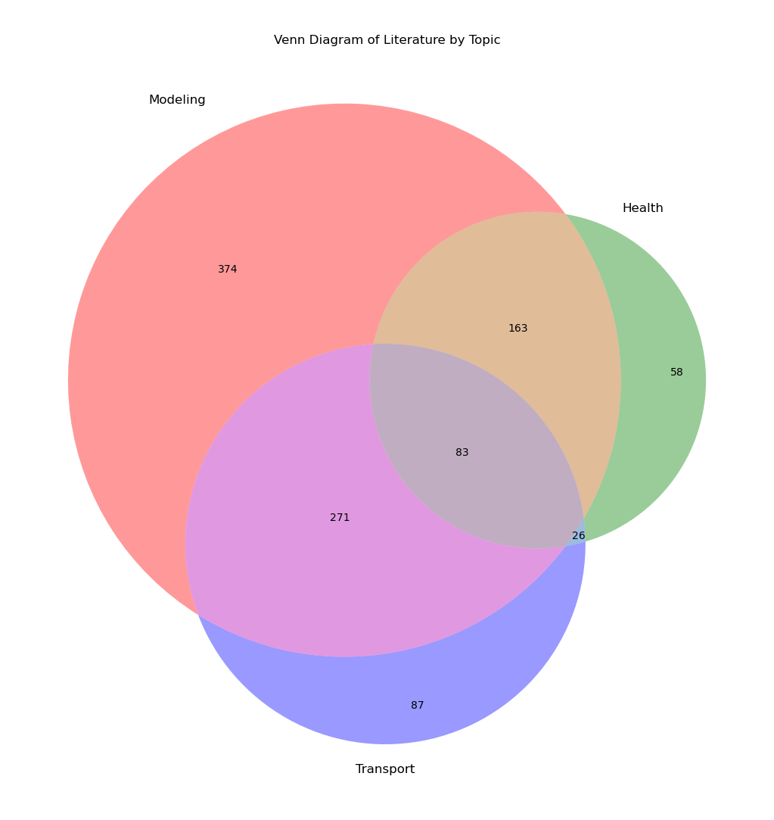FIGURE II.1

Result of separating literature into three main categories which best describe reasoning and content of this thesis. Estimating the correlation between literature gathered by the sets mentioned in Table II.1. This was done to gain a general understanding of what types of O3 literature exist can correlate to this thesis. Note, only 26 documents had keywords with a similar amount of all three topics. Some of these include researchers like Wang, Yiu, and Kim which model O3 for the public health related reasons.

Each category was based on a certain combination of keywords noted in Table 1. Modelling consisted of papers which mainly mentioned keywords from topics 1 and 2. Trasport represents topics 1 and 7. Health used the rest, with overlapping words and topics falling into remaining categories based on frequency of used words. A word cloud and plot of publications overtime shows the expected jump of literature pertaining to ozone modelling. This commenced a dictionary of similar key words in the gathered literature to look out for during the review. Out of the total documents filtered, around 900 documents were initially reviewed and separated into categories for which they may pertain in this thesis (Figure II.1). Topics covered in this section include the general formation of O3, utilization and/or development of surface O3 models in a modern technological world, and overall effects surface O3 can have on inorganic and organic processes. Literature was also gathered from colleagues and course work accomplished during the writing of this thesis.

This chapter seeks to conduct a full, yet brief analysis of O3 models today throughout numerous disciplines to develop in-depth knowledge of surface O3 reactions wherever they may occur. It was expected that appropriate models to use would be the same for most cases of complex adaptive system(s) (CAS). These systems generally contain numerous, similar predictive features with an undetermined unifying principle. As such, significant multi-collinearity within prominent features for CAS predictions is expected. Given numerous physical, chemical, and biological trends, this section seeks to provide a better understanding of where surface ozone reactions mainly occur and how they’ve been incorporated into models today.

II.2. Surface O3 Formation and Transport

The rate of O3 reactions overtime exhibit patterns at extremely close distances. Unlike most pollutants, surface O3 reactions tend to cyclically increase at distal locations from non-maintained and overly-maintained spaces (Y. Choi et al. 2012; D’Amico et al. 2024; Guan et al. 2023; Kim et al. 2016; Oltmans and Levy 1992; Zvyagintsev, Tarasova, and Kuznetsov 2008). Surface O3 formation tends to follow seasonal high and low concentrations, while steadily increasing in urban areas overtime due to interactions with solar radiation (UV) and VoCs (Alves et al. 2024; P. Chen et al. 2022; Guan et al. 2023; Perera et al. 2019; You et al. 2017). O3 trends cannot be modelled with something unable to consider complex systems, so this thesis seeks to utilize models beyond linear scopes. While linear regression is often used in combination with Principle Component Analysis (PCP) and Artificial Neural Networks (ANN) (Arsić et al. 2020; Moustris et al. 2012; Sousa et al. 2007; W. Sun et al. 2015), it was found to yield less accurate results than non-linear methods (Alessandro Fassò and Ilia Negri 2002; R. Wang et al. 2023; Z. Yang et al. 2021; N Zhao, Zhang, and Wang 2025). Model strengths, weaknesses, and potential contributions to the success of the end prediction established here are used for the final models in Chapter III.4.

The constituents and drivers of O3 might have a heavy effect on urban layouts where geophysical systems force higher temperatures to heavily populated areas. If the separation in urban density versus available green space is too great, surface ozone reactions trend towards areas of either well-kept high biological activity or areas at risk to natural hazards relating to heat and aerosol movement like storms, heat waves, and volcanic eruptions (Brown-Steiner and Hess 2011; Badia et al. 2023; Han et al. 2018; Kumari, Lakhani, and Kumari 2020; Platikanov et al. 2022). While the latter may not be found in most areas in the USNA, golf courses, urban parks, and similar anthropogenic constructions may experience the brunt of ozone concentrations due to these transport mechanisms (Al-Qassimi and Al-Salem 2020; Kong et al. 2023; F. Liu, Zhu, and Zhao 2008; Monks et al. 2015; You et al. 2017).

II.2.1. Complexities of Urban Surface O3

The rate of O3 reactions overtime should exhibit patterns at close distances, but the ideal distance for the proper representation of patterns regarding surface O3 have yet to be formally established (S. Abdullah et al. 2019b; Tong et al. 2017; Yuting Wang et al. 2023b) due to the interaction of O3 molecules. Unlike most pollutants, surface O3 concentrations tend to cyclically increase with interactions within anthropogenic spaces (Y. Choi et al. 2012; D’Amico et al. 2024; Guan et al. 2023; Kim et al. 2016; Oltmans and Levy 1992; Zvyagintsev, Tarasova, and Kuznetsov 2008). Similarities across studies areas have revealed that surface O3 does follow seasonal high and low concentrations during Summer and Winter respectively; steadily increasing overtime in urban areas due to interactions with solar radiation and VoCs where Winter may not be as cold due to the overall geography of the AOI (Alves et al. 2024; P. Chen et al. 2022; Guan et al. 2023; Perera et al. 2019; You et al. 2017). In Chapter I, surface O3 formation was mentioned to be induced from stable tropospheric ozone cycles if the area is met with consistent high temperatures and presence of constituents, such as within PHOTUC.

Large populations can effectively contribute to O3 formations and are especially at risk to complex variations due to the large differentials in access to green space and industrialized zones (J. Pan et al. 2024; Cai, Zhuang, and Ren 2022; Meo et al. 2021). In addition, at low temperatures and combined with severely polluted, low photolysis days will typically denote lower ozone concentrations (CH Chen et al. 2021; S. He and Carmichael 1999; Jenkin and Clemitshaw 2000; Jiménez and Baldasano 2004; Kalabokas et al. 2008; E. Lee et al. 2009; M. Li et al. 2021; Manzini et al. 2024; Wie and Moon 2016; Zvyagintsev, Tarasova, and Kuznetsov 2008). The locations of these spaces don’t follow general, non-spatially related patterns, and pollutants which follow spatial non-heterogeneity at small distances must be properly related to the source. While linear regression is often used in combination with Principle Component Analysis (PCP) and Artificial Neural Networks (ANN) (Arsić et al. 2020; Moustris et al. 2012; Sousa et al. 2007; W. Sun et al. 2015), it was found to yield less accurate results than non-linear methods (Alessandro Fassò and Ilia Negri 2002; R. Wang et al. 2023; Z. Yang et al. 2021; N Zhao, Zhang, and Wang 2025).

II.2.2. Modern Numerical Models and Overcoming Adversity

By nature, applying a model for individual participants over some designated space and time is arduous work. Public health based O3 models are extremely effective at incorporating proper fields and values for persons of interest due to the amount of in-situ knowledge about the population and AOI. This thesis completes a high spatial resolution model of surface ozone values utilizing similar high-resolution techniques for three counties in Arizona using monitor locations instead of participants due to each other’s similarities as geo-atoms based on a location in time (Goodchild, Yuan, and Cova 2007). While Pina, Pimal, and Maricopa counties were chosen due to their population densities; this project results in reproducible functions for all areas with the appropriate materials due to innovations mentioned in Chapter I and III. Atmospheric conditions, constituents, model types, and depictions of surface O3 here build an expectation of the final predictive outputs to note both the accuracy and applicability of the SMaRK method in reference to the study area.

Trends and transportation mechanisms should appear in the final display over PHOTUC and be representative of the information seen in this section. The new revolution in Big Data and complex modeling schemes have allowed for methods outside typical linear scopes to introduce transport, anthropogenic, and thermodynamical mechanisms into their feature bases for urban locations (Chiacchiaretta et al. 2024; Gagliardi and Andenna 2020; Yu et al. 2018a). Modeling techniques for training, validation, prediction and implementation with the residual kriging method are noted and discussed further in the methods section. Studies such as (Congdon and Martin 2007; Demyanov et al. 2001; Mousavi et al. 2019; Seo, Kim, and Singh 2015) utilize CTM based methods to combine atmospheric dynamics and satellite imagery (Lin et. al., 2024). Some researchers like (De Marco et al. 2022; D. Gao et al. 2019; Javanmardi et al. 2017; Jerrett, Gale, and Kontgis 2010; Reid et al. 2012a; Schlink et al. 2006; Zhou et al. 2018) utilized statistical methods for public health to assign ozone exposures to individuals within a distance to nearest monitor methodology.

These must be done per study/cohort, and subsequent participants/locations within them. A study spanning numerous states, spans exponentially more counties and subsequent data points necessary for conclusive analysis.

II.3. CHEMICAL TRANSPORT MODELS

CTMs and ML ensembles represent distinct modeling paradigms; CTMs are process-based and mechanistic, while ML ensembles are data-driven. Recent studies demonstrate they can be effectively combined to improve surface ozone forecasting accuracy at coarse resolutions (HC Sun et al. 2021; Yu et al. 2018a; HC Sun et al. 2021; P. Cheng et al. 2022; Mo et al. 2021; X. Zhao et al. 2024) which can later be aggregated to a finer resolution. Typically, CTMs and ML ensembles sit at opposite ends of the modeling spectrum, but they can complement one another when studying pollutants such as surface ozone. ML ensembles don’t deal with spatial data; they’re combined with CTMs which are a mechanistic, 3D Eulerian framework accounting for some spatial variation through linear associations over a large trend predicted by the ensemble (Travis and Jacob 2019; Balamurugan, Balamurugan, and Chen 2022; Y. Cheng, He, and Huang 2021; Kang et al. 2021; Nelson et al. 2023; Smith et al. 2018; Tondini, Scilla, and Casari 2024; T. Wu, Tseng, and Huang 2024). Most CTMs around have 8-13 ppb +- 5ppb RMSE associated with them (Long et al. 2014; Travis and Jacob 2019; Q. Wang et al. 2022; Yu et al. 2018a; Zhou et al. 2018) stemming from the modifiable unit area problem (MAUP) when resampling outputs to the desired higher resolution.

CTMs separate emissions and transport mechanisms to later model the relations between surface measurements and satellite detections, typically incorporating valuable spatial information into the associated model’s overall error rather than accounting for this geospatial uncertainty (Konovalov et al. 2006; J.-T. Lin et al. 2012b; Miñarro et al. 2011; Rojas, Venegas, and Mazzeo 2016). What’s more, CTMs are computationally and temporally costly, with most models requiring extensive access to Big Data systems and expensive technology for proper depictions of surface trends (Brown, Waśniewski, and Zlatev 1995; Keller et al. 2017). CTMs using ML and AI methods for transport can be further improved by properly incorporating geospatial uncertainty from monitored data into them by way of residual kriging, making these costly systems more reliable and worthwhile given their typical inaccessibility. Their representations of transport rely on continuity equations like advection, convection, emissions, detailed gas‐ and/or aqueous‐phase, and more atmospheric equations and chemistry (Petetin et al. 2021); proper incorporation of numerical models are essential as uncertainties in general aerosol models are known to be exponentially greater (J.-T. Lin et al. 2012b; Miñarro et al. 2011; Rojas, Venegas, and Mazzeo 2016). CTMs typically use meteorology from remotely sensed data assimilations and chemical mechanisms of choice which simulate global to rural-scale concentrations at higher than average spatial-temporal resolutions. These are physically coherent fields suited to investigate long chemical lifetimes, transport, and stratosphere–troposphere cycles of certain chemicals, but extremely complex molecules like O3 usually yield the highest error. The general laws of physics applied within CTM are extracted and utilized in feature creation, discussed later in Chapter VI.

II.4. Statistical Regression

CTMs used to rely mainly on linear regression; a widely used statistical method used in regression and prediction (W. Sun et al. 2015; Ghazali et al. 2010; M. Wang et al. 2016; Starbuck 2023). Its simplicity, interpretability, and efficiency make it a valuable tool in geographic predictions involving binary classification problems such as land cover changes, habitat presence, or the classification of environmental hazards (Tucker 1979; Sousa et al. 2007; Dalezios 2017). Linear Regression is incredibly straightforward, typically going by the notation:

$$f\left(x\right)=m\left(x\right)+b+ε$$

where m(x) is an indirect rise over run correlation between the independent variable and some feature, b is the y-intercept, and ε denotes the residual error that each point x deviates from the mean trend. Extending this same equation to multiple covariates initializes multi-linear regression:

$$y(x)=β_{0}+β_{1}x_{1}+β_{2}x_{2}+…+β_{i}x_{i}+ε$$

wherein each $β_{i}$ represents a weighted value on which $x_{i}$ attributes to y(x) (Starbuck 2023). There are minimal interpretations to deviate from, and linear methods require next to no tuning unless additional weighing methods are used, but surface O3 requires more complexity.

Linear regression is a great starting point used for exploratory analysis and pre-determination of applicable features, but adaptive algorithms such as least absolute shrinking (LASSO) and similar weighted regularization methods (RIDGE) have become necessary to improve accuracy in numerous case studies using linear regression. RIDGE and LASSO methods represent weighted combinations of multi-linear or multiple-logistic regression to show a trend for a given variable. While working well for semi-complex systems, they can be too heavily constrained to begin with due to their basis in linear regression. Machine Learning and Artificial Intelligence methods work slightly more complexly, by learning weights during a bagging of samples into statistically related bins (often referred to as boosting).

II.5. MACHINE LEARNING

CTM models today use the combination of statistical trends and weighted boosting methods to learn from the metrological tendencies into the dataset via Machine Learning (ML). These garner accurate depictions of atmospheric physics and may utilize ML methods, but CTMs mechanically don’t learn from data. Rather, they are features for use in an ML model, and carry their own spatial uncertainties requiring corrections from the researcher (Yu et al. 2018a; Travis and Jacob 2019; Xiong et al. 2024). CTMs come at a high computational cost, often resulting in hundreds to thousands of CPU-hours for resolutions of 500m-1km. They are also dependent on emission inventories and parameterizations that carry additional uncertainties (K. Chen et al. 2021; Gilliland et al. 2008; Han et al. 2018; Jena et al. 2015; Konovalov et al. 2006; Kuo and Fu 2023). Utilizing these to represent 100m-300m of space is unsuitable due to the uncertainty in model error at these resolutions. CTMs are based on the standard representations of tropospheric–stratospheric chemistry with models like the MOZART-TS1 (Emmons et al. 2010), the Modal Aerosol Model with four modes (MAM4; Liu et al., 2016), and the multi-model reanalysis of Surface Ozone (MUSICA, Lin et al., 2021).

Most CTMs are tree-based algorithms, as they’ve more recently been found to better model chemical transport for O3 further discussed in Chapter V. O3 related literature using regression vs tree based correction ensembles mention the power of these learners, effects on error with unproper tuning and necessity for proper database management (Long et al. 2014; Q. Wang et al. 2022; Wen et al. 2021; Xiong et al. 2024). In their infancy, these models had trouble establishing proper trends for urban areas until further corrections were made within the CTMs themselves (Staehle, Rieder, and Fiore 2023; Saeipourdizaj et al. 2022; Monteiro et al. 2013; Djalalova et al. 2010). All statistical concepts within boosting ensembles are similar; sorting binned data via pre-determined constraints into trees for use in an overall ensemble to make a predictive algorithm and select an outcome given a set of features.

While complex in nature, these are extremely power representations of systems outside of linear scopes (R. Cao et al. 2024; Rafael et al. 2019; Q. Wang et al. 2022). The number of branches and decisions differ within each ensemble and can be tuned to represent different spreads of data (Keller et al. 2017; Gagliardi and Andenna 2020; Ko, Cho, and Rao 2022). The order in which trees are separated allows for a myriad of potential complex algorithms known as machine learning, where in each tree is based on trends established during the binning process. While normality and non-stochastic are preferred, these ensembles have parameters which account for this, further bolstering the need to learn these methods and incorporate them into this thesis. Boosting algorithms can be separated into two main categories: Sequential and Parrel. Both techniques work like series and parallel circuits in electrodynamics, with the former learning from an iterative binning of data and the latter learning by sorting all data at once and finding trends within subsets of created statistics.

II.5.1. SEQUENTIAL BOOSTING

Sequential bagging involves training base learners one after another, where each subsequent model tries to correct the errors made by its predecessor. Rather than drawing bootstrap samples independently, the model assigns higher weights to data points that were previously misclassified, ensuring that future learners focus on harder cases. This dependency creates a feedback loop, which allows the ensemble to iteratively improve its performance. While sequential bagging generally achieves higher accuracy, it can be more sensitive to noise and overfitting due to its focus on hard-to-classify examples.

Three main types of sequential boosting are used in this thesis. Adaptive boosting sequentially fits trees that focus on residual error by reweighing the data Gradient Boosting fits trees to linear residuals of prior trees via gradient descent of a chosen loss function. Extreme gradient boost (XGB) is the engineering goal to push the limit of computational resources for gradient boosted ensembles. XGB is one of the best performing algorithms utilized for machine learning, due to the many trees and tuning parameters it can yield; seeing positive results e.g. (XM Hu et al. 2022). The series nature of these processing steps limits the overall reproducibility of them on conventional machines. Computation times for sequential and parallel boosting strategies are compared in Chapter V.

II.5.2. PARALLEL BOOSTING

Parallel bagging is the classical approach to ensemble learning. Multiple base learners typically known as decision trees are simultaneously trained on independent samples of the overall dataset. Each model learns without being influenced by other models; regression is estimated through a majority averaging of predictions. Because the models are trained in parallel, this method benefits from faster training when computational resources support parallel processing. Naturally independent features help reduce overall variance, making parallel bagging especially effective in mitigating overfitting with large co-variance. This thesis uses the most common of parallel boosting techniques, Random Forest.

Random Forest (RF) ensemble learning methods are primarily used for classification and regression tasks. Their applications in geographic data sets have been extensively studied and validated due to their robustness, accuracy, and ability to handle complex datasets. Improvements in computer science alongside similar improvements in geographic practices have given rationale for using RF models in modern day geographic models and prediction systems. By nature, they exceed at handling high dimensionality datasets and complex trends (J. Wang et al. 2024; Runmei Ma et al. 2021; Wright and Ziegler 2017a). RF models offer substantial advantages for complex geographic trends including high accuracy, robustness to noise, the ability to handle diverse data types, and account for non-linear relationships. However, they have limitations, like computational complexity, lack of spatial explicitness, and potential challenges in interpretability with many trees of large datasets. While there are other parallel boosting strategies, basic RF strategies were more than enough for this thesis. Other parallel boosting strategies are essentially minuet variations of the base RF ensemble.

II.6. ARTIFICIAL INTELLIGENCE

Before the development of GPU integration, all processing was done on the main computer processing unit (CPU), which is responsible for simultaneously running the rest of the computer and its systems. By incorporating a GPU into the training portion of the model, the CPU doesn’t have to work as hard and can focus on giving commands to the GPU, which does the rest to process the data. Recently, these implementations have seen high success when used to model complex trends such as PM2.5 emissions, disease transmission/hospitalizations, metrological processes, and land use classification (Adel El-Shahat 2018; Arsić et al. 2020; Braik et al. 2024; Binjie Chen et al. 2024; Faris, Alkasassbeh, and Rodan 2014; Seo, Kim, and Singh 2015). The full power of GPU integrated methods has allowed learning methods such as Neural Networks (NN)s to become the pinnacle of today’s modelling systems. NN is a layered, learning-driven architecture that excels at capturing high-dimensional, nonlinear relationships in data. It underpins many breakthroughs in modern AI by enabling scalable, end-to-end learning across diverse fields—from computer vision to healthcare.

II.6.2. Defining Complexity: Convolution and Recurrence

This project utilized a Multi-Layered Perceptron (MLPR), the most basic implementation of an NN in the sci-kit learn library. When trained utilizing the proper series of activation functions, layers, and ensemble learning methods, MLPR can make predictions not unlike the human brain (BJ Chen et al. 2024; S. Gao et al. 2021; T. Li et al. 2022). While there is a significant amount of math involved for determining activation functions and step sizes, the complexity of creating, tuning, and therefore utilizing neural networks in Geography is becoming more accessible. For instance, MLPRs are easy to implement, but lack specialized structure making them ideal for tabular or flattened data. While more complex models like Convolutional Neural Networks (CNN)s and Recursive Neural Networks (RNN) were experimented with, the lack of proper GPU access required this to be completed in future work. These models use the fully connected layers of MLPR with pooling and memory retention methods to either define convolutions across preset areas in the image or recurrence within indexed images to model complex spatial patterns via remote sensing.

CNNs are powerful for spatial patterns, especially in images. While they don’t model spatial patterns, they do incorporate corrected imagery as learners and make deductions based on the learned trend of related pixels, mimicking spatial thought by way of inheriting associated satellite corrections. Imagery is loaded into convolutional layers that scan inputs with weights commonly called kernels. These weights move across the image to detect local patterns given exact positioning of the kernal. RNNs are designed for temporal or sequential data, handling time dependencies. These maintain hidden states which enable the use of past information across an ordered sequence as opposed to a moving window. Combining CNN and RNN architectures form Hierarchical Convolutional Recurrent Neural Networks (HCRNN)s, combining kernel feature extraction with temporal sequencing to improve classification accuracy in multi-spectral, time-varying geospatial datasets. These offer power future directions for this thesis and the means to address numerous gaps in surface O3 literature; an MLPR combined with a spatial temporal regression of uncertainty can be though of a basic implementation of a HCRNN with geospatial kernals. These have seen high promise in surface O3 datasets and trend modelling, but still yield high geospatial error in dense urban locations (Arsić et al. 2020; Mandal et al. 2024; Felix Kleinert, Leufen, and Schultz 2020; S. Gao et al. 2021; HT Sun et al. 2022).

II.7. Gaps in Surface ozone Literature

One of the most obvious gaps in literature is the full coverage of rasterized data depicting surface ozone values for the United States. As is with most cases regarding high resolution data, many specialized forms of surface ozone exist, but have yet to be incorporated into high-resolution raster models depicting universal surface trends, save a few case studies such as this thesis (Y. Choi et al. 2012; X. Lu et al. 2016; Mousavinezhad et al. 2023; Peng Liu et al. 2018; Pozzer, Schultz, and Helmig 2020; Reddy and Pfister 2016; Rui Zhu et al. 2023; Schnell and Prather 2017). Many high resolution models have been created for the EU, China, India, Iran, and other urbanized nations similarly concerned with the growing rate of surface ozone reactions (Dong et al. 2021; Z. Li et al. 2023; Tian et al. 2024; J. Wang et al. 2024; Y Wang et al. 2021). Urban based public health case studies tend to focus on personal exposures from environmental aspects related to O3. These typically assign O3 concentrations to wiling participants via advanced statistical modellings, with geo-located addresses to predict the expected exposure of the individual to surface O3 (Ghozikali et al. 2015, 2015; Jerrett et al. 2009; Malley et al. 2017a; Niu et al. 2022b; Tang et al. 2024; Tian et al. 2024; Turner et al. 2016a).

The information provided by exposure studies such as these tend to be extremely informative for modeling due to their nature as a high-resolution dataset. These are usually built from estimated measurements like distance to the nearest monitor or road and aren’t used to make a full depiction of the area due to their basis in individual activity spaces. Most are difficult to create, as the movement of a human can drastically change their exposure to surface ozone in addition to other harmful pollutants, potentially co-funding with NOx and PM2.5 constituents (Balmes 2019; Jerrett et al. 2009; Malley et al. 2017a; Niu et al. 2022b; Turner et al. 2016a). Due to the interactions with naturally occurring chemicals in Earth’s atmosphere explained in Chapter I, it is well known that anthropogenic sources and isoprene related VoC’s tend to yield the larges correlations with surface ozone reactions (You et al. 2017; R. Wang et al. 2023; Nelson et al. 2023; K. Ma et al. 2023; Q. Liu et al. 2022).

When exposed over long-terms, O3 has potential associations with hospitalization rates of upper and lower respiratory diseases, varies with age, gender, initial health of the individual, and promotes unnecessary/unregulated oxidative stress causing irreversible cognitive/immune system damage (Barzeghar et al. 2020; J. Choi et al. 2024; Crouse et al. 2015; Ghozikali et al. 2015; Heal et al. 2013; Im et al. 2023; Javanmardi et al. 2017; Nuvolone, Petri, and Voller 2018; Turner et al. 2016a). Many other studies across the world have found minor to major associations between short-term exposure at the surface during seasonal cycles, having potential direct and indirect consequences which are still being discussed (S. Chen et al. 2023; L. Chu et al. 2023; Karimi et al. 2019; H. Ma et al. 2023; Orellano et al. 2020; Reid et al. 2012b; Tang et al. 2024; Tian et al. 2024; Shin et al. 2018). The trend makes sense due to the chemical volatility of O3, as oxidative stress becomes easier to achieve with O- as a product of unstable O3 in lieu of solely O2. The implications and harm surface O3 can have on both human health and the environment are further discussed in Chapter VI. Within ozone models for health-related risk, policy making, or similar cohort-based studies; air pollution along with growing worries of climate change, and associated health risks, have spurred the need for high resolution imagery at around 300m, which SMaRK can easily achieve.

The most notable gap in O3 literature is the same found with all ML/AI representations of geospatial data. Due to the revolution in Big Data and scientific technology, in-situ surface measurements are readily available across the globe (Emetere 2020; Gaudel et al. 2018b). Researchers specializing in hybrid ML/AI methods for geospatial data don’t typically incorporate these in-situ measurements in the final prediction. Simply using them during the training process can establish an accurate trend based on corrections made by remote sensing satellites; however, these satellites don’t rely on ground-based observations. Chapter III later mentions that all remote sensing images are stemmed in corrected measurements of reflected light. When applied to coarse resolutions, these errors can be negligible due to the large area they’re meant to describe (about 1km and above). Remote Sensing data utilized for these also only represent total column estimates, not complex surface interactions. Chapter I revealed that chemical transport models (CTM)s, while accurate, at a high resolution ~500m-1km, and cover national boundaries, still depict some error regarding tropospheric chemicals in the upper and lower hemispheres of Earth when using remotely sensed imagery.

CONCLUSION

Models covered in this chapter helped better understand complex processes governing Ozone formation and transport. These are ultimately used by decision-makers of all scales and influence decisions surrounding efforts to mitigate the impacts of constituents attributing to surface O3 prominence (Balamurugan, Balamurugan, and Chen 2022; Watson et al. 2019; You et al. 2017). Given this information, it was expected that the dataset would need to be as complex as the reaction itself, requiring many features to accurately represent known interactions ozone has with natural and built environments (Jenkin and Clemitshaw 2000; Ziemke et al. 2011; M. Huang et al. 2017). Studies with a brief depiction, section, or which focus on surface O3 entirely suggest the best models suited for this project are tree-based and neural network models.

Many tropospheric ozone transport models assume constant distribution of the gas over the system in question and only result in predictions at a resolution of around 4km. CTM models are used in a wide variety of studies due to the robustness of the methodology; calculation expenses stem from the vast effort required to optimize the model pending on the complexity of the gas in question (Emetere 2020). For Ozone, these models are often complex but imperative to ensure a safe future for current and future generations. The health impacts and concerns associated with surface ozone exposure can’t rely CTM based models due to coarse results, which tend to under- or over- estimate ozone concentrations in the upper and lower and upper latitudes respectively (Long et al. 2014; Yu et al. 2018b).

Researchers have developed interpolated exposure rates via temporal analysis of extrapolated statistical learning models to create unique activity space exposures (De Marco et al. 2022; J. Lu and Yao 2023; Malley et al. 2017a; Turner et al. 2016a). Utilizing the geo-located point of a willing respondent or location of interest with metrological data of nearby environmental and urban aspects to capture the high variations of ozone concentrations. These are extremely fine resolution, depicting exposures in-terms of the populations exposed space (Jerrett et al. 2009; Balmes 2019; Niu et al. 2022b). As the models in this thesis are to be trained on data gathered from similar satellite observations, the development of a large dataset which combines these techniques may improve exposure assignment times by reducing the amount of coding work necessary to add ozone as a variable of interest. This work could benefit numerous case studies in areas pertaining but not limited to; public health, surface chemistry/air quality, environmental health, atmospheric health, chemical transport trends, and others of similar methodologies.

CHAPTER III

METHODS

The recent scientific revolution in data science, acquisition and pre-processing for those outside the field of strict computer science doctrine has become readily available through unique online learning programs, literature, and university classrooms. Institutions, groups, and labs such as the EPA monitoring service, Tropospheric Ozone Assessment Report (TOAR), and Global Monitoring Laboratory at the National Oceanic and Atmospheric Administration (GML-NOAA) have all provided easy access to surface level data and monitoring networks (U. EPA 2013; Schultz, Schröder, Lyapina, Cooper, Galbally, Ma, et al. 2017). Many researchers have used these vast stores of data and ML/AI ensembles to assign exposures and deduce health trends (S. Abdullah et al. 2019b; Bin Chen et al. 2023; De Marco et al. 2022; Turner et al. 2016b). Large databases generously produced by the wealth of disciplines using established GDAL libraries and ESRI suite programs for analysis of air pollutants, land use classification, and economic strategies offered unlimited development options for this project (Rouault et al. 2025; Dangermond and Goodchild 2020).

As technologies improve, advanced analytical methods become easier to understand, continually emerging into current and future disciplines (Miller and Goodchild 2015). ML and AI models are known to work better if pre-existing conditions and assumptions about the dataset are met, such as non-stochasticity and normalized distribution of training features, as stated in (Raschka and Mirjalili 2019). Ample preprocessing and separation of training features e.g. (Ilić, Popović, and Markić 2020; Napi et al. 2021; Staehle, Rieder, and Fiore 2023) was conducted due to the co-variance between metrological features and constituents driving surface O3 mentioned in Chapter II.. Each geo-atom was constructed of a property defined by a complex ensemble and assigned a value with its corresponding uncertainty predicted from an RK trend estimation of the same features, hence forth known as $β$. Values for $β$ and additional data sources across available time periods can be viewed in Chapter IV. Table V.2 in Chapter V depicts the final selection of variables for each model and timeframe used in this project.

Depictions of this surface O3 are exhibited in PHOTUC by predicting the residual geospatial error at each location given values of $β$, then applied to each geo-atom within a raster brick created in python. The number of variations in surface O3 predictive features from their true values are minimized via $β$’s like CTMs, emissions-based features, and geospatial uncertainty of $β$ at monitor locations. This thesis combines similarities in spatial-temporal cycles, like-minded sciences, and the three laws of geography to propose a novel geospatial method for incorporating geospatial uncertainty into ML/AI ensembles (G. Cao 2022; Goodchild 2004; Y. Liu et al. 2018). Each of the proposed models in this thesis have been seen in a myriad of geographical studies utilizing similar methods with high success.

III.1. PRE-PROCESSING METHODS

Linear regression, Ridge and LASSO optimization methods were omitted due to early results yielding significant errors greater than 15% due to their inability to capture cyclic trends over long periods of time. Features overtime can be seen in Figure VIII.2.4 having more seasonal tendencies and variation by county in the AOI. While regression methods with the incorporation of spatial uncertainties can appear more cyclic, their overall results were never better than today’s models e.g. (C. Hsu et al. 2024; S. Pan et al. 2017; Y Wang et al. 2021) Temporal ranges of satellite technologies were utilized to create different datasets for testing. GRIDMet data is available from January 1st, 1979 and is continuously updated until a couple days before today by the ECMWF (European Centre For Medium-Range Weather Forecasts 2019), allowing for historical insights with the aforementioned feature transformations. This thesis covers the differences in data available from 2019-2024 and displays daily predictions for 5 randomly chosen months across the time frame, resulting in about 150 images. Full applications of the code will have more than ten thousand images depicting different AOIs across a 20-to-40-year timespan.

A Python script performed the pulling requests, JSON processing, and conversions to a common tabular format for further cleaning (Raschka and Mirjalili 2019). Monitoring data was narrowed down to the counties of Maricopa, Pinal, and Pima, used as a point feature in raster statistics, and saved as a CSV file providing the foundation for the datasets found at the end of section III.5. Variables used in this project can be found in Figure VIII.4.2. Further analyses and applications of these methods are expanded upon in Chapter VI with urban data. Future directions and the impacts of feature transformations proposed in this section are commented on in Chapter VII.

III.2. VECTOR LOCATIONS AND SPATIAL CORRECTIONS

The AZ State shapefile from the ((United States Census Bureau 2022)) was downloaded at a census tract resolution for the corresponding years within the timeframe. Unique Identifiers (UID) were comprised of state, county, and census tract codes and spatially extracted in ArcPRO/Python. ArcPRO was utilized due to its extreme presence in geographic academia and technical settings. Python allowed for rapid cleaning, duplication, and distribution of project material with ease. Both programs aided in the spatial joining of the TIGER-Line shapefile and raster representations of PHOTUC. The shapefile was also used for the creation of a mask for use in raster extraction, display, and overall uniformity of features during training. This mask was created at an initial resolution of 30m from a DEM provided by the U.S.G.S (U.S. Geological Survey 2024). The final mask for the AOI was 250m.

In addition, the US Census Bureau contains vast statistical collections of housing and income data that were joined to the study area to incorporate a visually appealing bivariate map of the AOI seen in Maps VIII.3.1 and VIII.3.2. 30 monitors were used within the boundary, with another 35 monitors available for AZ, for a total of approximately 65 monitors to be used in future work. Maricopa, Pima, and Pinal correspond to county codes 013, 019, 021 respectively (United States Census Bureau 2025). Chapter II revealed that O3 mechanisms are heavily based on energy components, urban presence, and meteorological drivers (A. M. Abdullah et al. 2017; Ye, Wang, and Zhang 2022) which are common in these three counties. Some features were used to create unique predictor variables for use in the ML/AI ensembles based on CTM and Physics concepts learned in the researcher’s early academic career.

III.3. DEPENTANT AND INDEPENDENT VARIABLE EXTRACTION

Necessary corrections, transformations, and resampling methods were made to reduce the complexity of error and implement estimated trends into the final models. The assumed independent variable, daily maximum 8-Hour surface O3 detections, was selected based on extensive scientific evidence regarding the effects of surface ozone concentrations on public health and transport trends on the surface (Travis and Jacob 2019; M. Wang et al. 2016; W. Zhang et al. 2022); assumed potential dependent variables such and surface temperatures and precipitation were similarly gathered from known physical and chemical factors. Due to collaboration efforts among geospatial engineers, filtering is based on values commonly found in conventional GIS databases. The EPA (E. P. A. EPA 2025) Air Quality Systems (AQS) data for O3 were retrieved via Application Programming Interface (API) using the "dailyData”, “byState" endpoint via in Python. Monitor locations whose center spatially intersected with the PHOTUC region were gathered, filtered by site ID, and corrected based on their provided coordinate reference systems (CRS). Some monitors before 2010 were reported with the North American Datum 1983 (NAD83; EPSG:4269) and were transformed to the World Geodesic System 1984 (WGS84), then finally reprojected to a meter (m) based projection based on the European Petroleum Spatial Grid (EPSG) 32612 using data provided by epsg.io (Pridal et al. 2014). Filtering methods were done with spatial intersections between the latitudes and longitudes of monitor locations, satellite imagery, and shapefile of PHOTUC in EPSG 4326 and displayed in EPSG 32612.

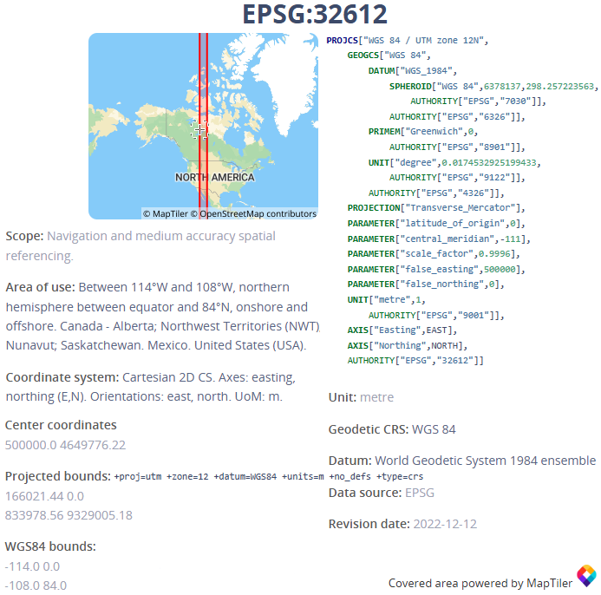

Figure 1

Denotes the full description of the projection system used for AZ. This was done to minimize geospatial error and is a common tactic in many GIS based programs.

III.4. FROM GOOGLE EARTH ENGINE TO A MACHINE NEAR YOU

GEE is designed for planetary-scale environmental data analysis (Gorelick et al. 2017) and provides access to a vast repository of satellite imagery and geospatial datasets, along with tools based in java for analysis and visualization (Figure VIII.2.4.). As a Big Data source, this overwhelming repository of satellite imagery and geospatial datasets includes Landsat, Sentinel, MODIS, and more prominent satellite technologies. It’s being utilized more frequently in recent environmental monitoring, research, and management due to its accessibility. The cloud-based infrastructure of GEE allows for large-scale data processing without the need for local high-performance computing resources. This capability was particularly useful for SMaRK by processing and analyzing large datasets with precision and efficiency.

While the interactive code editor and Graphical User Interface (GUI), make it accessible to users well versed in JavaScript, it may be a difficult grasp for less code-savvy personnel. However, GEE enables collaborative work by allowing users to share scripts, data, and results easily for those willing to learn. The platform now has a strong Python integration provided by Dr. Wu at the University of Tennessee (Q. Wu 2020). This package facilitated the automation of image gathering and is crucial to the reproducibility of this project. Feature integration into SMaRK was quintessential to this project and the many potential future uses among scientists, cooperate managers, and policymakers. GEE supports near-real-time data analysis, which is crucial for monitoring and responding to real-time environmental events. If translated from python to java correctly, SMaRK can work directly with GEE’s code editor, providing an essential air pollution model for the platform.

III.4.1. RASTER CONFIGURATIONS AND EXPORTATION

Missing daily rasters were reconstructed using temporal differencing, interpolating between raster pairs with pixel-wise daily deltas across relative missing intervals. If there was at least N=1 missing days in between the first and last known detection at some time, t; then each subsequent missing raster ${R(t)}_{N}$ was created to depict a mean scaling time-series of the missing data: $${R(t)}_{N}={R(t)}_{1}+\int_{1}^{N}{\frac{R\left(t_{N}\right)-{R(t)}_{1}}{N}}$$

They can be done better with proper incorporation of missing images from other remotely sensed data sources into the model and is discussed in Chapter VI. Raster datasets were reprojected, resampled, and harmonized into a multi-band structure using rasterio and GDAL, then stacked into prediction grids for later use in the final model. Imagery in GEE has a maximum exportation limitation, resulting in 500m resolution files which were later resampled to 50m and finally 300m after noting the lack of proper imagery for 50m resolution predictions. A drawback of this project is the use of MODIS NDVI as opposed to Landsat imagery and hand calculating NDVI at the offered 30m resolution. Resampling methods with bilinear, cubic, and cubic spline interpolation strategies aggregated coarse resolutions from GEE to 300m. Geographic variables provided by sources mentioned later were extracted. PHOTUC polygons were adjusted and used as a mask to clip rasters to 100m using similar polygon rasterization techniques provided by GDAL. Monitors in this location are overlayed and noted on Map M in the Appendix.

III.5. TRANSFORMATIONS AND THEORY BASED FEATURES

Domain-inspired features were calculated to test if depictions based on physics and chemistry could improve the model without the full use of a CTM or GEOS-Chem model. Column ozone values in Dobson Units (DU) were converted from total column measurements to surface concentration estimates of mol/unit2 using area, volume, and unit normalization principles (e.g. 1 DU = 2.69x10¹⁶ mol/cm²). An estimation of the kinetic energy of O3 was derived from the ideal gas law (PV=nRT) using downward solar radiation, total ozone column values, surface temperature, and O3 column temperature to potentially estimate thermodynamic energy states for use in later works. Cloud base and top height differentials were combined with pressure gradients and overall cloud fraction to represent potential cloud energy radiating within the atmosphere. Weekly moving averages were applied to multiple variables to capture temporal smoothing and remove high-frequency noise. Each of feature implemented into the final model reduced spurious correlation between co-variates by combining their covariance into a representation of O3 based on transport and chemical mechanisms. The second law of classical mechanics by Issac Newton (F=mass*acceleration; (Taylor 2005a) can be applied to bonds between molecules; it is equal to the amount of heat an object generates over some distance, known as work (W=Fdx) (Borgnakke and Sonntag 2014). This section details the overall extraction process, feature transformations, and thermodynamics of chemical states used in the final algorithm.

III.5.1. TOMS/OMI DOBSON UNIT (DU) CONVERSION TO SURFACE REPRESENTATION

One Dobson Unit is the number of molecules of ozone that would be required to create a layer of pure ozone 0.01 millimeters thick at a temperature of 0 degrees Celsius and a pressure of 1 atmosphere. Ground-based O3 measurements taken from the EPA monitors are represented in parts-per-million (ppm). As stated in the Data Sources section, the TOMS/OMI satellite total column estimates are in Dobson Units (DU). 1 Dobson Unit would contain about 2.69x1016 ozone molecules for every square centimeter of area at the base of the column. For an array O3 values in DU where 1 mole of Ozone is 47.9982 grams:

$$1 DU\left(O_{3}\right)=2.69×{10}^{16}\frac{O_{3}\left(mol\right)}{{cm}^{2}}*\frac{47.9982 O_{3}(g)}{6.0221×{10}^{23} O_{3}(mol)}*\frac{1^{ }mg}{{10}^{6}g}*{\left(\frac{100cm}{1m}\right)}^{2}$$

$$=\frac{1.2912×{10}^{18} mg\left(O_{3}\right)}{{6.0221×{10}^{29} cm}^{2}}*\frac{1×{10}^{4}cm^{2}}{1m^{2}}$$

$$=\frac{1.2912×{10}^{22} mg\left(O_{3}\right)}{6.0221×{10}^{29}m^{2}}$$

$$1 DU\left(O_{3}\right)=2.1441×{10}^{-7}\frac{mg\left(O_{3}\right)}{m^{2}}$$

As parts-per-million (ppm) is a dimensionless quantity used to relate weight to volume, this rendition of DU requires some form of divisible meter metric to be an accurate representation of surface ozone at some location. It’s quite convenient as a geographer to have access to a representative surface that can be stated in terms of x, y, and z. If one liter (L) can be represented as 0.0001m3, the ppm representation of the Dobson Unit per m2 can be stated as:

$$ppm\left(O_{3}, x,y\right)=\frac{mg(O_{3})}{L}=\frac{mg(O_{3})}{{0.001m}^{3}}=\frac{2.1441×{10}^{-7} mg\left(O_{3}\right)}{{0.1m*m}^{2}}$$

$$ppm\left(O_{3}, x,y\right)= 2.1441×{10}^{-4} \hat{X}(DU)$$

Where the vector $\hat{X}$ is the monitor value of TCO in Dobson Units. Using this transformation, the TCO measurement from TOMS/OMI was converted to a surface representation of ozone in $\frac{mg\left(O_{3}\right)}{m^{2}}$. This was used to scale the DU down to a comparable measurement with Sentel 5-p Imagery.

III.5.2. KINETIC ENERGY REPRESENTATIONS

Briefly switching into the realm of chemists and their amazing ability to provide concrete evidence of physical processes without the mathematical relationship via a tool called observation, chemical reactions always happen at a given rate. Calculated temperatures, concentrations, and unique combinations of constituents can be observed to do many different things, such as ice melting to water, then evaporating to vapor. Chemically, this is all H2O, simply in different thermodynamical states of a solid, liquid, and gas. As simplistically as possible (assuming no container (volume (V(L)(fluid + gas)) = 0), this can be mathematically represented as:

$$Q(E)= {mc_{s}​ΔT}_{ice}​+{mc_{s}​ΔT}_{liquid}​+{mc_{s}​ΔT}_{gas}$$

As mentioned in Chapter II.2, surface ozone reacts with certain VOC’s and emissions, oxidizing organic and inorganic material and causing what we know as surface O3. Chapter II.3.1 showed that the remaining parts of this pseudo-catalyst are typically preserved and reintegrated into the atmosphere if given enough energy overtime. This has many different chemical representations; however, this thesis mainly focuses on nitrous oxides and carbonous aerosols as these are two of the most chemically influential chemicals of surface O3 production (Y. Cheng et al. 2018; Y. Li et al. 2024; Richter 2009). Chapter II.3.3 revealed that carbon and nitrous based VoC emissions impact surface-level air quality, tropospheric photochemistry, and climate feedback mechanisms in addition to sustaining surface ozone concentrations

CO + OH = O2 + Q(E) > CO2 + HO

NO2 + O2 + Q(E) = NO + O3 + Q(E) = NO2 + O2+ Q(E)

Chapter 2 revealed that carbon and nitrous based VoC emissions impact surface-level air quality, tropospheric photochemistry, and climate feedback mechanisms in addition to sustaining surface O3 reactions. These chemical relations are depictions of the sub-photosynthesis process, photolysis which has been found to drive O3 (CH Chen et al. 2021; S. He and Carmichael 1999; V. Shah et al. 2024). In more thermodynamical terms, it is an energy-based oxidation event. If a constituent is required to produce O3 and UV rays are necessary for ozone production, then it must exist in a constant reactionary state. The first law of thermodynamics states that matter can neither be created nor destroyed. This can be seen with the remaining O- that tend to titrate with VoCs. Atmospheric cycles attempt to rebalance the amount of newly seen negative oxygen molecules, in which energy is lost. This energy is measured by way of remote sensing and can theoretically be represented through a series of proper transformations.

III.5.3. A BASIC IMPLEMENTATION OF THERMODYNAMICS

O3 is comprised of three oxygen (O-) molecules. Known as a triatomic molecule, if one mol of oxygen is roughly 15.999 grams, then 1 mole of Ozone is about 47.9982 grams. Chemicals can only be comprised of a certain number of elements; there is a limitation to its state before it’s something else entirely (i.e, H2O vs. H2O2 or water versus hydrogen peroxide). As air pollution exhibits a system of finite degrees of freedom, estimated kinetic energy must be representative of the chemical and physical properties of constituents. The basic take away from this is that theoretical kinetic energies of any reaction at a given state, in some space, at some time, can be represented as a combination of chemical-thermodynamics and derivations of the Ideal Gas Law. For later use with a scaled field correlating to the predictor variable, the kinetic energy for a potential geo-atom could be represented as a combination of spatial pressure, temperature, and volume dynamics of a system.

The proposed average translational kinetic energy for a geo-atom z(x,y) is started as:

$${KE(x,y)}_{t}=\frac{1}{2}mv^{2}=\frac{3}{2}k_{b}T(x,y)$$

Where at some time t, the estimated KE of a geo-atom can be represented as the and temperature ($T(x,y)$) of the constituent and kb, Boltzmann’s Constant. The short of this theory is that on average, atoms exist with a thermal energy of $\frac{3}{2}k_{b}T$, allowing the ideal gas law to be re-written as:

$$KE{\left(p,v,t\right)}_{O_{3}}=\frac{3}{2}k_{b}T=DS\left(x,y\right)N\left(x,y\right)T(x,y)R$$

Where ${P(x,y)}_{t}$ is pressure, ${DS(x,y)}_{t}$ is replace in lieu of the constant $\frac{3}{2}k_{b}$ as a measurement of energy, R is the gas constant estimation used in the Boltzmann’s constant, and N(x,y) is number of O3 molecules estimated by remotely sensed imagery.

III.6. INTERPOLATION AND IMPUTATION STRATEGIES

Linear, modified 2-Dimensional Akima, 1-Dimensional Akima, and polynomials with degrees 0,1,2 and 3 were evaluated using the same RMSE, MAE, and MSE strategies as model evaluation methods:

* + Selecting all available monitor values
  + Randomly changing 10% of these values to Nan in python
  + Establishing trend with missing monitors
  + Calculating error statistics, results seen in Table 2
  + Placing known values back into the dataset
  + Predicting with the established trend for unknown values

The R2 correlation coefficient was added to interpolation-based methods, but not to regression-based imputation methods due it not being as valuable for low error in small predictions. A time-series based KNN imputation strategy was also developed for complex features missing in HD for further work on this project. Using the mean value between the best correlation methods, missing values were estimated with high precision and accuracy. Modified 2D Akima represents a moving piece-wise polynomial approximation over the given periods (Akima 1970). The trend estimated from training on replaced missing values was then used on the full data set, inclusive of the missing values taken out for KNN training. Resulting errors during training holds true for all tested values (Beretta and Santaniello 2016; Liao et al. 2014) when applied to the final dataset.

III.6.1. MISSING DAILY RASTER DATA

Some of the datasets only had either yearly averages/estimations before 2000 or required a set amount of time to pass before estimation of the variable became possible. For example, nighttime light imagery is only available with daily resolution from 2013 on, though it is available yearly via another source. NDVI imagery is subject to 16-day intervals to effectively “see” the change in wavelengths each source of vegetation is producing. To better account for daily changes, a function was created to calculate the difference between available temporal averages and daily differences to produce estimated daily changes. The function is simply a linear representation between the available data and number of days missing:

$$dR{\left(v,x,y\right)}_{μ}=\frac{\left({R(v,x,y)}_{2}- {R(v,x,y)}_{1}\right)}{N_{days}}$$

Where $R\left(v,x,y\right)$ is a feature raster with a value, longitude, and latitude. $N_{days}$ is the difference in days from t1 to tmax:

Once the average daily change was calculated, a new, estimated disaster comprised of the summation of the first date and the average daily change can be:

$$\sum_{n=0}^{Total Days}{{R\left(v,x,y\right)}_{pred}={R\left(v,x,y\right)}_{1+n}+dR{\left(v,x,y\right)}_{μ}}$$

While this dataset is bound to incur slightly repetitive values across monitor locations, this method allowed for the incorporation of a date-like index into the missing values.

For missing raster data, the time of each available raster was extracted. The difference between available raster data was divided by the number of missing days in between the extracted times. The resulting mean was added to the first raster, producing a new raster for each day missing in between the intervals. This had interesting effects on the outcome, working for features used in this these, but not so much for Nighttime light imagery. While the imputation of new rasters from a pre-existing set of models would have been ideal, this level of work would best be suited for a dissertation. This was only meant to introduce daily estimates into the algorithm to incorporate feature trends into each model.

III.7. STATISTICAL MODEL AND RESIDUAL KRIGING METHODOLOGY

The Statistical Modeling and Residual Kriging (SMaRK) method is proposed as a methodology to exploit the flexibility of kriging with complex solutions from modern day ensembles to establish a geo-field via satellite and monitoring systems for use in geo-atoms comprised of satellite data. Chapter II found that nonparametric, decision tree-based, predictive models have been increasingly adopted in spatial statistical analysis due to their flexibility in handling heterogeneous covariates (Y. Liu et al. 2018; Mu et al. 2023; Q. Pan, Harrou, and Sun 2023a). Many of the selected features during each training process showed covariance (i.e. specific humidity, temperature created features among others), ML/AI methods to minimize the influence of similar trends were required to define the overall property for each pixel. SMaRK modelling is comprised of five main steps:

1. Statistically model a trend at known points given n,
2. Measure error at known locations given **f**($\hat{β}$): $ε\left(s_{0}\right)$
3. Apply RK to estimate an error trend at given $x\left(s\right)$: $f\left(x\left(s\right)\right)$- $x\left(s;\hat{β}\right)$
4. Reincorporate estimated error into the established trend.
5. Calculate the result as stationary pixels: $〈x,Z_{sm}\left(fx\left(s\right);\hat{β}\right),z\left(ε(s);\hat{β}\right)〉$

The resulting surface depicting O3 properties was produced at a resolution of 250m for each day within the selected time range. The underlying spatial concepts in SMaRK follow the establishment of initial geo-atoms at monitoring locations based on predicted trends from a chosen ensemble. The full definition of the geo-atom from (Goodchild, Yuan, and Cova 2007) in terms of statistical models and residually kriged uncertainty to represent a value for surface O3 geo-atoms in PHOTUC on a given day can be depicted as:

${〈x,Z,z(x)〉}_{t}$ = $〈s_{0}\left(long,lat,t\right),Z\left(f_{sm}(\hat{z}\left(s_{0}\right);β\right)),\hat{z}{(s_{0})}_{RK}〉$

Where the definition of the property Z at some latitude and longitude and time is $f_{sm}({\hat{z}}_{RK};β)$, established from the estimated complex trend and associated error relative to each monitor location. An overarching theory from some complex trend is corrected by the laws associated with in-situ measurements, making $\hat{z}{(s)}_{RK}$ the value of the system estimated from some **f**($\hat{β}$).

III.7.1. Model Parameters and Tuning

This thesis mainly overviews the sklearn package in Python; offering the most simplistic forms of modern complex analysis (Buitinck et al. 2013) at a CPU processing level. Implementations of PyTorch, Keras, and Tenserflow utilizing GPU components are saved for future work. The novelties within sklearn’s development schemes have allowed for basic integration of the latter packages as a rough start to advanced ML/AI modelling enhancements. XGBOOST is developed as a separate entity and was able to be utilized with a GPU in the middle stages of this project. While computations times are exponentially increased for this thesis, further incorporation of these methods would yield drastically reduced computation times.

In this study, models were trained using RandomSearchCV (RSCV) in Python. The search algorithm employed a parameter list derived from prior known distributions of the data. The initial dataset was reduced from approximately 2,760,000 to 656,000 rows in the 2018–2024 timeframe. This reduction in training points will not be seen in larger, statewide models in future use cases. Keeping reproducibility in mind, each model was trained with a unique parameter combination, ensuring comparability to the data size and preventing overfitting or underfitting. After training, residual values were kriged using geospatial monitor positions and associated residual values, following methodologies from Chapter II. This process produced predictive grids, where testing monitors were placed, and residual values were extracted. A summary of the five models and their potential parameters randomly selected in RSCV is as follows:

1. Adaptive Boosted Sampling: The learning rate was fine-tuned between 0.00001 to 1, with step values reflecting half the number of features. The number of estimators ranged from 50 to 500, with similar step adjustments. Loss calculations considered linear, square, or exponential trends. This model was chosen for its capacity to reduce variance and enhance accuracy beyond Gradient Boosting alone.
2. Gradient Boosting: Parameters such as loss functions (squared error, huber), learning rate, maximum depth, and the number of estimators were adjusted. This model was included due to its effectiveness in minimizing loss and handling complex datasets.
3. Extreme Gradient Boosting (XGBoost): XGBoost was optimized using grow policies (depthwise, lossguide), learning rate adjustments, and regularization parameters. It was selected for its speed and high performance, especially with large datasets.
4. Random Forest: This model utilized different criteria (squared error, absolute error, friedman_mse) and was tuned for maximum depth and the number of estimators. Random Forest was included for its robustness and effectiveness in handling high-dimensional data.
5. Multi-Layered Perceptron (MLP): The MLP model's hidden layer sizes, learning rate, and other parameters were adjusted for optimal tuning. It was chosen for its flexibility in capturing non-linear relationships within the data.

After tuning, the in-situ value from the monitoring locations was used to calculate a residual which was predicted with a geospatial krige of the same parameters.

III.7.1. RESIDUAL KRIGE TUNING

In geo-statistics (Chiles and Delfiner, 2009), regression kriging (RK) (Hengl et al., 2007; Hengl, 2007) represents a hybrid approach for spatial prediction combining a statistical regression of some independent variable based on dependent variables for trend estimation, and a kriging term of the regression residuals representing spatial dependence. As a representation of geo-atoms, this can be amended to the overall geo-field associated with its property. For any location **s** with a vector of observations **x**(**s**), the RK estimator $\hat{z}{(s)}_{RK}$ is written as:

$$\hat{z}{(s)}_{RK}=f\left(x\left(s\right);\hat{β}\right)+ε(s)$$

Where $f\left(x\left(s\right);\hat{β}\right)$ is the regression term for the complex trend defined by the estimated parameters $\hat{β}$. The residual $ε\left(s\right)$ is spatially auto correlated and follows a selected variogram model. The RK method allows for various regression methods for use as the base trend estimation, making it suitable for leveraging complex trends estimated by ML/AI methods. The parameters for potential variograms are as follows:

* Variogram model: linear, spherical, gaussian
* Pseudo-inverse: False, True
* Pseudo-inverse type: None, pinvh
* Drift terms: function, specified, point
* Number of lags: 2, 4, 6
* Functional drift: Fourier Series, Elevation, Sinusoidal

Each statistical model $f_{sm}(\hat{z}\left(s\right);β)$ was fit using the ground O3 concentration **z** as the dependent variable. The previously mentioned geographic datasets and feature transformations were used as predictors at each point. Given V1 as the first feature used in training, and **x** as the remaining features used in training:

$$\hat{z}{{(s}_{0})}_{RK}=f_{sm}\left(({z{(s}_{0})}_{v_{1}},{z{(s}_{0})}_{v_{2}}…,{z{(s}_{0})}_{v_{x}};\hat{β}\right)+ε(s_{0})$$

For every O3 measurement at each monitoring station **z**($s_{0}$), there exists a corresponding residual $ε(s_{0})$ which is compared to the associated estimation of the fitted ensemble. This can be used for interpolation due to inherit relationships between the points, properties, and values in each geo-atom. The residual term, $ε\left(s_{0}\right),$ can be obtained by kriging with residuals at N monitoring stations:

$$ε\left(s_{0}\right)={\left[ε\left(s_{1}\right),…,ε\left(s_{N}\right)\right]}^{T}=λ_{0}^{T}ε$$

where the kriging weights $λ_{0}$ can be represented as a matrix comprised of:

$$λ_{0}={C(β)}^{-1}c_{0}$$

Where **C** is the covariance specified by $β$ among O3 monitor stations to account for the spatial dependence. The covariance vector, $c_{0}$ is the spatial dependence between some geo-atom in the geo-field, $s_{0}$, and its associated complex trend with accounted drift. Tested drift functions included a sinusoidal estimation between latitude and the dependent variable, point specified drift between elevation and a Fourier series representation of the latitude, longitude, and maximum value to represent spatial drift at some point in time. This process allows for the incorporation of many trends into RK analysis estimations for a better representation of surface O3 based on spatially dependent in-situ values.

III.8. MODEL EVALUATION TECHNIQUES

Models were selected based on numerous factors. The mean absolute percent error (MAPE) and root mean standard error (RMSE) were mainly utilized for comparison as studies prefer their use of units relative to the dataset (J. Hu et al. 2023; Mu et al. 2023; Q. Pan, Harrou, and Sun 2023a; A. Zhang et al. 2023). Mean squared error (MSE), mean absolute error (MAE) and overall percent error were also calculated. Though not all metrics were required (e.g. RMSE is simply the square root of MSE so utilizing MSE seems redundant), utilizing all error metrics revealed stronger insights into the improvements made by including geospatial uncertainty. The best model operating with or without RK improvements was applied to the full dataset for prediction of the final rasters. RMSE and Mean Absolute Percent Error (MAPE) calculations are used for the main determinants in model selection. Finally, the R2 correlation coefficient is used to represent the amount of variance in dependent variables that can be explained by the independent variable in a regression model. These error metrics were also used for interpolation and imputation of monitor values.

III.9. CONCLUSION

Models were tested with differing features to determine if data found starting in 1980 can be utilized to make historical models as effective as those with modern data. Features were selected based on the correlation with respect to daily surface ozone values at monitoring locations, associated literature and learned knowledge through coursework. Cutoffs for the number of features included in each model were determined by the ranking of variables across each of the three correlation equations, Pearson, Spearman, and Kendall. The first set of features contained the best correlating variables associated with imagery from GridMET and weekly moving averages. The second set of features depicts variables found in modern imagery and anthropogenic sources. The third set consists of energy, CTM and meteorological representations most seen in literature from Chapter II. The final set contains the top 24 correlating features out of all the datasets combined, essentially combining all variables in the first three sets with a few lower correlated variables which were also key representations of surface O3 mentioned in Chapter II. Table V.2 in Chapter V depicts the final selection of variables for each model and timeframe. Each set of variables contained the top three correlating seasons, omitting the fourth season for use as a baseline category.

A raster dataset was created at a 500m spatial resolution from the imagery in GEE of the following geographic variables provided by the sources mentioned in Chapter IV. The stacked result was resampled to 250m, used as a surface for prediction given the best model, and added to a 250m resolution RK grid created by modeled uncertainty around the monitoring stations for display of the final daily images. Five ML/AI ensembles in total were used to find a trend yielding the least complex error for RK trend establishment. Overall predictive error was further reduced by adding the geospatial uncertainty of the selected features into the chosen ensemble. Even if the model yielded no error, the RK method incorporated this and only enhanced areas which are further from the truth value. A case study of these methods is conducted over PHOTUC further separating the average results into county-based results.

CHAPTER IV

Thesis Materials and Sources

Many surface O3 estimations have been created with similar air pollution measurements, meteorological imagery, and high-resolution estimations via combinations between them (Alvarez-Mendoza, Teodoro, and Ramirez-Cando 2019; Schultz, Schröder, Lyapina, Cooper, Galbally, Zhiqiang, et al. 2017a; W. Wang et al. 2022). Similar methods of kriging and complex trend estimation at high temporal resolutions (i.e. hourly, daily and weekly) are limited by the availability of imagery due to orbital patterns and geographic aspects of Earth. The National Oceanic and Atmospheric Administration/National Centers for Environmental Prediction (NOAA/NCEP), European Centre for Medium-Range Weather Forecasts (ECMWF), National Aeronautics and Space Administration/Global Modeling and Assimilation Office (NASA/GMAO), Japan Meteorological Agency (JMA), etc.; provide rich ensembles of climate data products which can be further combined in overlapping areas as a result of unified interests across nations e.g. (Carrillo-Torres, Hernández-Paniagua, and Mendoza 2017; XM Hu et al. 2022; Schultz, Schröder, Lyapina, Cooper, Galbally, Zhiqiang, et al. 2017a). This section details on datasets both used after filtering through the myriads of features depicted in Table VIII.1.3. and other materials available for future work and similar predictions. These sources all have individual data bases, many of which have been conveniently wrapped into a cloud based Big Data source hosted by Google called Earth Engine (GEE).

IV.1 Satellite Data

Most of this project ustilized raster data. As a representation of signals, raster data is the primary output for remote sensing and satellite technology. Remote sensing is a field dedicated to Earth-bound sun-sourced light while satellites While this type of data is frequently referred to as a “raster” in geography, it’s more simply a lattice of values; depicting whatever we want them to. If, these values come from a signal, then the proper transformations can be applied to properly represent its metaphorical value. For instance, temperature values can be estimated with extreme precision given the difference in Near Infrared (NIR) and incoming UV radiation. Much of this data can be seen on Google Earth Engine’s (GEE) vast cloud database. GEE was accessed to set the framework for the images used in the final predictive model. GEE is designed for planetary-scale environmental data analysis (Cardille et al. 2024) and provides access to a vast repository of satellite imagery and geospatial datasets, along with tools based in java for analysis and visualization [Site studies that used GEE].

GOOGLE EARTH ENGINE

GEE provides free access to a vast archive of satellite imagery and geospatial datasets, including Landsat, Sentinel, MODIS, and more. This accessibility enables users to conduct historical analyses and display modern cycles with ease. Figure GEE depicts the code editor along with a quick representation of NDVI using Landsat 9. GEE has been utilized more frequently in recent environmental monitoring, research, and management due to its accessibility. The cloud-based infrastructure of GEE allows for large-scale data processing without the need for local high-performance computing resources. This capability is particularly useful for processing and analyzing large datasets quickly and efficiently.

While the interactive code editor and Graphical User Interface (GUI), make it accessible to users well versed in computer science, this data source may be a difficult grasp for less tech-savvy personnel. The platform has Python integration provided by Dr. Wu at the University of Tennessee. This package facilitated the automation of image gathering and is crucial to the reproducibility of this project. GEE enables collaborative work by allowing users to share scripts, data, and results easily. This feature integrated into SMaRK is quintessential to this project and potential future uses among scientists, cooperate managers, and policymakers. The platform supports near-real-time data analysis, which is crucial for monitoring and responding to real-time environmental events. When applied correctly, this project can work directly with GEE in JavaScript, providing an essential air pollution model for the platform.

SENTINEL-5P/TROPOMI

To address the necessity of improved data for analyzing environmental concerns, the Copernicus Atmosphere Monitoring Service (CAMS) has become one of the leading institutions in monitoring greenhouse gases, aiming at supporting policymakers, business and citizens with enhanced atmospheric environmental information (Guevara et al., 2021). The European Centre for Medium-Range Weather Forecasts (ECMWF), an independent intergovernmental organization supported by 35 states, implements CAMS behalf of the European Union for such purposes. CAMS launched the Sentinel-5 Precursor (S5P) in 2017, and it boasts the first Copernicus based mission dedicated to monitoring the planet’s atmosphere (Veefkind et al. 2012). The onboard sensor is frequently referred to as TROPOMI (TROPOspheric Monitoring Instrument). All of the S5P datasets, except CH4, have two versions: Near Real-Time (NRTI) and Offline (OFFL) except for CH4 (Methane) is available as OFFL only. The NRTI assets cover a smaller area than the OFFL assets but appear more quickly after acquisition. The OFFL assets contain data from a single orbit.

TROPOMI products are the main source of tropospheric ozone monitoring today, have been validated numerous times, and applied widely in prominent studies at global and national levels thanks to the relatively high accuracy, large geographic coverage, and long timespan (Zheng et al., 2019). This instrument offers a multitude of atmospheric variables including aerosol, NOx, and O­3 measurements which are used in this project. Only VOCs/pollutants which are known drivers of ozone and spatially significant were selected from the S5P satellite. Precursor aerosols such as SO2 concentrations tend to be localized and not representative of broad geographical areas such as in this study.

AEROSOL INDEX

This dataset from the TROPOMI instrument provides high-resolution imagery of the UV Aerosol Index (UVAI) or the Absorbing Aerosol Index (AAI). Commonly referred to AAI, this index is based on wavelength-dependent changes in Rayleigh scattering seen in the UV spectrum for a specific pair of wavelengths, where AAI is the difference between observed and modelled reflectance [Zweers, 2024]. When an AAI value is positive, it indicates the presence of UV-absorbing aerosols like dust and smoke [De Graaf et al. 2005]. It is useful for tracking the evolution of episodic aerosol plumes from dust outbreaks, volcanic ash, and biomass burning which all have known correlations with ozone formation [Honrath et al., 2024]. The 354 nm and 388 nm wavelengths used have very low ozone absorption, so unlike aerosol optical thickness measurements, AAI can be calculated in the presence of clouds, allowing for daily global coverage. These rasters are available with daily averages from GEE and the CAMS home website at a resolution of 1113.2 meters. The collected AAI for the model represents a measure of the prevalence of aerosols in the atmosphere.

NOX RETRIEVALS

Nitrogen oxides (NO2 and NO) are important trace gases in the Earth's atmosphere, present in both the troposphere and the stratosphere. They enter the atmosphere due to anthropogenic activities, such as fossil fuel combustion and biomass burning, and natural processes; such as wildfires, lightning, and microbiological processes in soils [Zheng et al., 2024]. The NO2 values represent concentrations of collective nitrogen oxides. This is to accurately portray the daytime photochemical cycle involving ozone (O3). This cycle converts NO into NO2 and vice versa on a timescale of minutes. The stratospheric vertical column of NO2 and NO2 slant column density bands were used as an estimation of the Ozone reaction happening in the atmosphere. This dataset is available at the same daily and 1113.2-meter resolution as the AAI.

CARBON MONOXIDE RETRIEVALS

Carbon monoxide (CO) is an important atmospheric trace gas for understanding tropospheric chemistry. In certain urban areas, it is a major atmospheric pollutant. Main sources of CO are combustion of fossil fuels, biomass burning, and atmospheric oxidation of methane and other hydrocarbons. Whereas fossil fuel combustion is the main source of CO at northern mid-latitudes, the oxidation of isoprene and biomass burning play an important role in the tropics. TROPOMI on the Sentinel 5 Precursor (S5P) satellite observes the CO global abundance exploiting clear-sky and cloudy-sky Earth radiance measurements in the 2.3 μm spectral range of the shortwave infrared (SWIR) part of the solar spectrum. TROPOMI clear sky observations provide CO total columns with sensitivity to the tropospheric boundary layer. For cloudy atmospheres, the column sensitivity changes according to the light path.

FORMALDEHYDE

Formaldehyde is an intermediate gas in almost all oxidation chains of non-methane volatile organic compounds (NMVOC), leading eventually to CO2. Non-Methane Volatile Organic Compounds (NMVOCs) are, together with NOx, CO and CH4, among the most important precursors of tropospheric O3. The major HCHO source in the remote atmosphere is CH4 oxidation. Over the continents, the oxidation of higher NMVOCs emitted from vegetation, fires, traffic and industrial sources results in important and localized enhancements of the HCHO levels. The seasonal and inter-annual variations of the formaldehyde distribution are principally related to temperature changes and fire events, but also to changes in anthropogenic activities. HCHO concentrations in the boundary layer can be directly related to the release of short-lived hydrocarbons, which mostly cannot be observed directly from space

CLOUD MEASUREMENTS

Cloud properties are based on the OCRA and ROCINN algorithms currently being used on the GOME and GOME-2 products. OCRA retrieves cloud fraction measurements using UV and visible light spectral ranges while ROCINN retrieves the cloud height, pressure, and optical thickness (also called albedo). This is done by using measurements near the oxygen A-band at 760 nm. Version 3.0 of the algorithms are used, which are based on a more realistic treatment of clouds as optically uniform layers of light-scattering particles. Additionally, the cloud parameters are also provided for a cloud model which assumes the cloud to be a Lambertian reflecting boundary.

NEAR-REAL TIME OZONE

For this TROPOMI product, there are two algorithms used to deliver total column ozone values: GDP for the near real-time and GODFIT for the offline products. This thesis focuses on the use of the GDP algorithm, as it is currently being used for generating the operational total ozone products from GOME, SCIAMACHY and GOME-2. These products have been used as the penultimate data in most atmospheric chemistry-based machine learning models as well as policies making for the EPA and EMWCF since 2017 [EPA, Cop, EMWCF, IPCC, 2017]. This product was used as a base line for ozone values and is available at the same resolution as the and NOx datasets.

ERA5 COLLECTION

ERA5 refers to the fifth generation of European Re-Analysis (ERA), which is a climate reanalysis dataset produced by the European Centre for Medium-Range Weather Forecasts (ECMWF) as part of the Copernicus Climate Change Service (C3S) [Dee et al. 2011; C3S, 2017]. ERA5 is the one of the latest climate reanalysis’ produced by ECMWF, providing hourly data on many atmospheric, land-surface and sea-state parameters together with estimates of uncertainty. The data is readily available in the Climate Data Store with grids at a 1km resolution, with atmospheric parameters on 37 pressure levels [Hersbach et al., 2020]. The dataset temporal estimates are from 1940 to the current day, with daily updates being made available 5 days behind real time. ERA5 has provided a consistent view of the evolution of land variables over several decades at an enhanced resolution to other land variable datasets such as the LMCS and GRID-Met dataset for meteorological data [Hersbach et al., 2020; Tarek et al., 2020; Muñoz-Sabater et al., 2021]. This reanalysis combines model data with observations from across the world into a globally complete and consistent dataset using the laws of physics. As this data goes several decades back in time, it has been shown to provide accurate descriptions of climate change through many decades [Dee et al. 2011; Muñoz-Sabater et al., 2021]. This dataset includes 50 meteorological variables, of which, temperature, surface pressure, sum of total precipitation, short-wave radiation metrics, surface albedo, and northern/eastern wind velocities.

The asset used in this project is a daily aggregate of the ECMWF ERA5 Land hourly dataset on GEE, where daily aggregates have been pre-calculated to facilitate many applications requiring easy and fast access to the data. In GEE, the data is available from 1950 to three-months from real time [Muñoz-Sabater, 2019]. As meteorological variables are easier to model and monitor, this data is available at a coarse 11km. The resulting rasters were aggregated to a 500m resolution before being exported from GEE. This project utilized the 2m surface temperature, reflectivity of the Earth's surface, shortwave radiation at Earth’s surface, net change in solar radiation, Norther/Eastern components of wind up to a height of 10m, surface pressure, and total summation of precipitation as these were all suitable precursors for the ozone reaction [Gouw et al., 2024; Honrath et al., 2024; Telesca et al., 2024].

VIIRS DAY/NIGHTTIME LIGHTS

The SNPP Visible Infrared Imaging Radiometer Suite (VIIRS) supports a Day-Night Band (DNB) sensor that provides global daily measurements of nocturnal visible and near-infrared (NIR) light that are suitable for Earth system science and applications. The VIIRS DNB's ultra-sensitivity in lowlight conditions enable us to generate a new set of science-quality nighttime products that manifest substantial improvements in sensor resolution and calibration when compared to the previous era of Defense Meteorological Satellite Program/Operational Linescan System's (DMSP/OLS) nighttime lights image products. Such improvements allow the VIIRS DNB products to better monitor both the magnitude and signature of nighttime phenomena, and anthropogenic sources of light emissions.

VNP46A2 is the short-name for the daily moonlight- and atmosphere-corrected Nighttime Lights (NTL) product called VIIRS/NPP Gap-Filled Lunar BRDF-Adjusted Nighttime Lights Daily L3 Global 500m Linear Lat Lon Grid.

The Suomi National Polar Orbiting Partnership (NPP), a near-polar geosynchronous orbit satellite with an orbital altitude of 824 km, carries a total of five sensors, and the Visible Infrared Imaging Radiometer Suite (VIIRS) is the most important of these. VIIRS has 22 spectral bands with a spectral range of “0.3∼14 μm”. Among them, the Day/Night Band (DNB) operates in the visible and near-infrared spectrum, between 500 and 900 nm, to collect low-light imaging data. This paper uses the NPP/VIIRS DNB dataset to characterize surface dynamics in the analysis of the impact factor of NO2 columns in China. Specifically, we used the DNB images from February 2018 to January 2019 and eliminated the image background noise.

MODIS NDVI

MODIS vegetation indices, produced on 16-day intervals and at multiple spatial resolutions, provide consistent spatial and temporal comparisons of vegetation canopy greenness, a composite property of leaf area, chlorophyll and canopy structure. The main vegetation index is derived from atmospherically corrected reflectance in the red, near-infrared, and blue wavebands. These were used to produce a normalized difference vegetation index (NDVI). This provided continuity with NOAA's AVHRR NDVI time series record for historical and climate applications. Due to its ease of access and corrective model which minimizes canopy-soil variations and improves sensitivity over dense vegetation conditions, the resulting NDVI provided a highly accurate model of vegetation indices for use in the statistical models.

These vegetation indices are retrieved from daily, atmospherically corrected, bidirectional surface reflectance. The VI's use a MODIS-specific compositing method based on product quality assurance metrics to remove low quality pixels. From the remaining good quality VI values, a constrained view angle approach then selects a pixel to represent the compositing period (from the two highest NDVI values it selects the pixel that is closest-to-nadir). Because the MODIS sensors aboard Terra and Aqua satellites are identical, the VI algorithm generates each 16-day composite eight days apart (phased products) to permit a higher temporal resolution product by combining both data records. The MODIS VI product suite is now used successfully in all ecosystems, climate, and natural resources management studies and operational research as demonstrated by the ever-increasing body of peer publications. that each have commonalities with respect to spatial and spectral resolutions. The standard production run will process the NDVI/EVI at 250 m,500m,1km, and 0.05 Deg. resolution for 16-day and Monthly intervals. The output products will have data fields for the NDVI and EVI with corresponding QA, reflectance data, angular information and spatial statistics and std-dev of each VI and for the CMG scales. The 250m, 500m and 1km products are generated for each spatial tile (10 deg. x 10 deg. ~1200km x 1200km) in the sinusoidal projection. CMG products are generated globally in geographic projection.

TOMS/OMI MERGED 10KM SURFACE OZONE PRODUCT

The Total Ozone Mapping Spectrometer (TOMS) data is produced and maintained by the Laboratory for Atmospheres at NASA's Goddard Space Flight Center. It yields a long-term, continuous record of the United States’ role in monitoring global and regional trends of surface ozone values over the past twenty-five years. The Ozone Monitoring Instrument (OMI) is an instrument aboard the Aura satellite and was launched more recently (July 2004 - current). OMI has a higher resolution (1.0 x 1.0 deg) and was used to scale the data observed from the TOMS instrument. Together, they represent a merged ozone product using observations from TOMS/EarthProbe, TOMS/Nimbus-7, TOMS/Meteor-3, OMI/Aura as well USGS based interpolations for dates with no data.

EPA OZONE MONITOR DATA

This API offers access to a wide range of air quality data, including daily and hourly measurements of various pollutants other than ozone layers as well. Of the 65 available monitors in Arizona from 1980-2024, 50 monitors were found within Maricopa, Pinal, and Pima counties.

The importance of dependent variables is evaluated in Chapter for the final model. This was conducted mainly using shap plots, freely available in python (Lundberg et al., 2018, 2020). These features had multiple assignment variables associated with them to ensure each prediction had relevant satellite data per date it was available. For example, the Suomi National Polar-orbiting Partnership (SNPP) was launched Oct. 28, 2011, and is well established to offer statistical insights to the magnitude, signature, and anthropogenic sources of light emissions within the United States (Román et al., 2018). The Harmonized Global Nighttime Lights (HGNTL) dataset is available from 1992-2021 and conveniently implements calibrated DMSP-OLS NTL time series data for historical analysis of nighttime light imagery (Li et al., 2021).

The EPA offers data on numerous ground level pollutants and related metrological drivers (E. P. A. EPA 2025), providing exciting opportunities discussed later. Daily monitor data was collected starting from January 1st, 2018, to January 31st, 2025. The final date is noted for future work, making the potential stopping date the present day. The first max hour was utilized as exposure studies investigating ozone concentrations have found it to reflect the health impacts of long-term exposure better than short-term. (Hoek et al. 1997; Knowlton et al. 2004; Javanmardi et al. 2017; Anenberg et al. 2018; Anbari et al. 2022). The study area boundary was used to filter all monitor locations available in the state of Arizona for this time. This amounted to about 65 available monitors. Each monitor’s location and average maximum eight-hour surface ozone mixing ratio was extracted and averaged over the course of each available day within the yearly timeframe; a total of 5 years with 12 months for a total of 2,215 potential daily averages per monitoring site.

The date associated with each monitor was used in raster extraction as well, with Google Earth Engine (GEE) providing the rapid ability to assign date variable constraints (Hird et al. 2017; Cardille et al. 2024). There was a total of 50 monitors in the sample region, and a total of 30 complete monitors over the 5-year period. The distribution of training data can be seen in Figure X. This data was further processed to only include complete months (i.e all 30 or 31 days, leap years included) after feature creation. This was due to some of the features utilizing a smoothed weekly series described later in this thesis (Chapter 4; section IV). This led to some incomplete weeks near the tails of the dataset which were removed. 36 of the qualifying 50 monitoring locations were available in the PHOTUC region, with N = 61,344 samples avaliable in each model.

In python, monitor data was processed into maximum 8hr surface ozone values, location, and date. Geographic and temporal information were used to extract data from gathered imagery. Dummy temporal variables were implemented via OneHot encoding to give each model a temporal restriction. Month and seasonal values were implemented due to the known temporal patterns in existing literature (Shan et al. 2009; Honrath et al. 2017; S. Abdullah et al. 2019a; Balamurugan, Balamurugan, and Chen 2022). This same date was used as a filtering feature for the Residual Kriging method; however, it wasn’t used during the overall training and testing of statistical models. Implementing the date as a feature would add nearly 365 dummy features, increasing computation time and bias towards time in the models.

ARIZONA BOUNDARIES

The Arizona state boundary was downloaded from TIGER line Census (United States Census Bureau 2022). The shapefiles and related files are an extract of select geographic information from the U.S. Census Bureau's Master Address File. A section within this vase database contains the Topologically Integrated Geographic Encoding and Referencing (TIGER) Database (MTDB). The MTDB represents a seamless national file with no overlaps or gaps between parts. They are an extremely convenient option for projects, as each data product can be further combined to cover the entire nation for later analysis.

The boundaries of incorporated places in the Arizona shapefile have been current since January 1, 2021, as reported through the US Census Bureau's Boundary and Annexation Survey (BAS) (US Census Bureau 2025). State-wide, county level data was downloaded, filtered and displayed [Figure X] to obtain the overall boundary of monitors to use. Each state- and county-level boundary file was run through a unifying process to remove inner state boundaries, leaving one singular shape of the study region containing Pheonix and Tuson, PHOTUC. The boundaries used as a reference to incorporate these two cities are Pinal, Pina, and Maricopa Counties.

FINAL SURFACE OZONE DATASET

Each training feature was checked for correlation and normality prior to model training. Missing data in-between dates due to errors in satellite imagery (Cite Sat Error comments) was interpolated. Some values were extracted at 0 due to pre-processing malfunctions. These were imputed utilizing the KNN imputation with 6 nearest neighbors. The results of data interpolation and imputation can be seen in Table X. In addition, the effectiveness of the residual kriging method approach is tested on the Total Ozone Mapping Spectrometer (TOMS) dataset which has been combined with data from the Ozone Monitoring Instrument (OMI).

CHAPTER V

Figure 1: Distributions of the best features which were part of the TD set mentioned in Chapter IV. This dataset included physics based feature transformations not unlike common CTMs. These proposed features, however, are much simpler to encode and include in ML/AI ensembles. Each of the variables used are representative of chemical reactions and O3 trends mentioned in Chapters II and III.

RESULTS

Variable codes for this chapter are given at VIII.1.3 in the appendix. While there were 44 features extracted from the sources in Chapter IV, only the top 24 best correlative features were used at once for each ensemble. Seasonal dummy variables were included with Fall having the least correlative power among them. This was consistent with trends mentioned in Chapter II e.g. (M. Li et al. 2021; Seroji 2016; H. Zhao, Zheng, and Li 2018). As such, Fall was omitted from the models, establishing a baseline for the overall trend. As each geo-atom is a representation in time, it was important to include temporal trends within the model. Monthly trends offered too recursive of a feature and were not as well correlated as seasons. Many of the best ensemble and RK tuning parameters are found to be representative of the diligent preprocessing work and pseudo-CTM based feature transformation as indicated through common statistical displays and a brief SHAP analysis of features.

The SMaRK method yielded the least error across each of the datasets mentioned in Chapter VI.4.3. The full results can be seen in Figure 10, with SMaRK based gradient boosting yielding the best results for this project. Each ensemble, when tuned properly, better modeled the known trend with the incorporation of spatial uncertainty as opposed to reporting it in the error calculations. In addition, the distribution of resulting errors is the same, but overall accuracy is significantly reduced, indicating strong positive reinforcement from the spatial krige across all models. Ensembles like gradient boost and random forest yielded similar RMSE to studies utilizing sole ML ensembles such as (K. Anand et al. 2025; C T et al. 2020; B Chen et al. 2023; H. Huang et al. 2025; F Kleinert, Leufen, and Schultz 2021; Ko, Cho, and Rao 2022; Q. Li et al. 2024; Mu et al. 2023; Nelson et al. 2023). RK enhancements to these already low predictions further reduced error by adjusting for the probability of error given the trends of selected features over the AOI. Each of the four datasets representing historical, modern, and the best available features reported similar errors with literature associated with surface O3 concentrations. Physics and CTM based features were among the highest predictive variables.

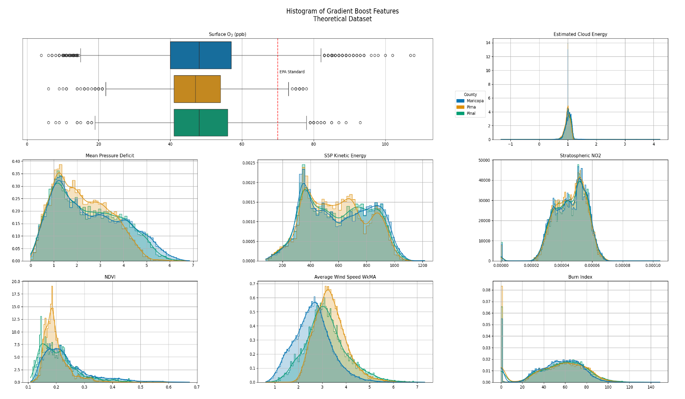

Figure V.1

Final Gradient Boost features which yielded the least error are depicted across each county in PHOTUC. On average, Maricopa sees more values higher than the EPA standard set at 70 ppb. In addition, to having lower wind speeds Maricopa has slightly higher NDVI values while Pima tends to have significantly lower values around 0.2. Maricopa and Pinal which house Phoenix and Tucson respectively might have healthier vegetation on average due to a larger number of resources spent towards maintaining urban greenspace.

These are further compared in Chapter 6, examining the impact of modern efforts to model surface O3 concentrations and overall air pollution monitoring. Figure 9 depicts the Pearson Correlation Matrix which represents the correlation of every feature gathered to the surface O3 before the training process was conducted. All calculations were done in ppm then later converted to ppb for a better representation of differences when writing. The full set of training features can be seen in the appendix; a sample of them with features in the final prediction and the distribution of the average surface O3 in PHOTUC are noted in Figure V.1. They were used mainly due to this excerpt from Figure VIII.2.10.; depicting datasets and their best output from SMaRK predictions:

|  |  |  |  |  |  |  |
| --- | --- | --- | --- | --- | --- | --- |
| **Category** | **Feature Count** | **Variable Code** | **MAPE** | **MAE (ppb)** | **RMSE**  **(ppb)** | **SMaRK Base** |
| Historical  (H.D.) | 13 | V1, V2, V3, V5, V6, V10, V11, V13, V16, V24, V25, V26 | 2.67% | 1.19 | 0.026 | Random Forest |
| Modern  (M.D.) | 13 | V1, V2, V3, V4, V5, V6, V7, V8, V9, V24, V25, V26 | 5.91% | 2.62 | 0.12 | Extreme Gradient Boost |
| Theory  (T.D.) | 12 | V4, V5, V6, V9, V13, V18, V22, V23, V24, V25, V26 | 1.39% | 0.59 | 0.013 | Gradient Boost |
| G.O.A.T.24 | 24 | All features except V22 and V23 | 5.71% | 2.55 | 0.12 | Extreme Gradient Boost |

Table V.1

Variable codes are found under VIII.3. GOAT24 variables did not include NVDI and estimated LN cloud energy due to their low correlations under 0.2. The absolute correlation of all features was taken and used to create each dataset representative of available features in a certain timeframe.

TD had the best model outputs and lowest effective error across all metrics. SMaRK enhanced gradient boost was utilized for PHOTUC due to its consistency across model outputs, yielding errors form around 0.59 ppb ± 0.013 ppb to 2.78 ppb ± 0.14 ppb. All statistical models yielded around 10% error overall, ranging from 1.47% to 14.18% error with variations of proper and improper tuning of the RandomSearchCV. These ML/AI ensembles alone predicted surface O3 concentrations in PHOTUC with an MAE of around 0.61 ppb to 6.02 ppb, like studies using them with CTM based features (B Chen et al. 2023; XM Hu et al. 2022; Ko, Cho, and Rao 2022).

RK enhancements incorporating geospatial uncertainty into the ML/AI models yielded between 1.39%-6.36% error, with MAE values of 0.59 ppb to 2.82 ppb. SMaRK-modeled surface O3 benefited all model ensembles over the course of study. Each ensemble: including early linear regression and weighting methods; ran hundreds of times over varying types of datasets to test reproducibility of the script and computational efficiency. Machines of varying computational processing power evaluated practicality and usability of SMaRK. Three main setups were tested: an Apple A1 MacBook Air 2020, a Windows Desktop with a Ryzen 5700XT Processor, and a Citrix based Cloud Computing Desktop provided by the Institute of Behavioral Sciences (IBS) at CU, Boulder. Many external functions in a library developed with python 3.12.x (Rossum and Drake 2010) upload to GitHub can be easily imported on user machines and implemented for various AOIs.

V.1 PROJECT FEATURES, ML/AI ENSEMBLES, AND RK

The unique functions allowed for rapid creation of several predictive rasters from January 1st, 2019, to December 16th, 2024, over the AOI. The 16th represents the stopping point of the raster interpolation strategy mentioned in Chapter III.2.2. Pre-processing methods for this thesis are reproducible for data from 1980-present day. Some of the raster pre-processing steps, integration, and display functions are currently in development as Python continues development, shifting into well upgraded functions with more, if not better, user accessibility, e.g. Rasterio (Gillies and others 2013) based in GDAL (Rouault et al. 2025) for raster sampling and extraction. The distributions of training features, interpolation strategies, model parameters, kriging enhancements, and case-study statistics are expanded upon in detail. Further review of the final predictive raster displays, model outputs, and relations to Chapter II are in Chapter VI. Despite the These overall errors in predictions, with lack-luster incorporation of training values in each geo-field were lower than that of similar CTM and emission transport representations of surface O3 concentrations e.g.(Chattopadhyay, Midya, and Chattopadhyay 2019; Q. Pan, Harrou, and Sun 2023a; W. Zhang et al. 2022). where the R2, RMSE, and MAE of proposed complex ensembles were around 0.9, 15ppb, and 9 ppb respectively.

Data sets like G.O.A.T 25, which included more features to increase the amount of varying dependent variables, still produced usable models with less error than the statistical model alone, albeit exponentially increasing computation times. The minimal change in error regarding HD and ND models shows the creation of a large, historical database which covers the USNA is possible utilizing SMaRK methods and feature transformations. The selected time frame contained 30 out of 38 unique monitors distributed across the PHOTUC region depicted in Figure X. Monitors with about 80% of missing data, namely due to age or monitor malfunctions, were incapable of interpolation and imputation. After interpolating available monitors in the PHOTUC region, 5,225 dates per 30 monitors for a total of 65,250 data-points were utilized on model training. The two monitor locations omitted did have more data available before 2018 and could be used in the historical model making process.

Most of the features utilized had a normal distribution. Figure VIII.4 and Figure VIII.5 in the Appendix depict the histograms of features and linear correlation between the daily maximum value and proposed measurements respectively. Most training features exhibited normal distributions and either positive or negative linearity, the representations of features noted are the strongest predictors for each model given by the Pearson Correlation Matrix in Figure VIII.9. The full training dataset on GitHub offers training data for the 36 monitors in the study region. Code is reproduceable for other study areas given proper API access to GEE and the EPA Air Quality Now website.

V.2.1. KNN INTERPOLATION VS REGRESSION BASED IMPUTATION

Monitors which had less than 5% missing days over the initial timeframe were estimated. These missing values likely stem from either monitor malfunction or movement, many historical monitors were found to still be in use today (US EPA 2015a). Interpolation and imputation strategies consisted of relating ground truth values from monitor measurements to their predicted value after replacement within the data set:

|  |  |  |  |  |
| --- | --- | --- | --- | --- |
| **Interpolation Strategy** | **MSE** | **MAE** | **R2** | **RMSE** |
| Linear | 0.029 | 4.1 | 0.77 | 5.4 |
| ModAkima | 0.031 | 4.2 | 0.76 | 5.5 |
| Akima 1D | 0.031 | 4.3 | 0.75 | 5.5 |
| P(0) | 0.039 | 4.7 | 0.69 | 6.3 |
| P(2) | 2.4 | 48 | -18.46 | 49.4 |
| P(1) | 2.5 | 48 | -18.54 | 49.6 |
| P(2) | 2.6 | 48 | -19.93 | 51.3 |

Table V.2

Output of resulting estimations via KNN interpolation of the nearest 3 monitors. These errors could be drastically reduced via better spatial-temporal imputation methods as opposed to interpolation strategies. This is further discussed in Chapter VI. P(x) denotes polynomial interpolation of the x degree, strategies which were effective for variables like NDVI and Stratospheric NO2

The average deviation from each estimated value in the final dataset was around 4.1ppb ±5.4 ppb. The final distribution of all max values can be seen in the appendix under Figure VIII.TR.7, which splits the monitors into those which typically see lower than, at, and above average concentrations of max ozone concentrations detected with the AOI. Histograms for each of the training features can be in Figure VIII.TR.4 with the reduced version depicting theoretical training features in Figure 1. These were used in the final raster calculations due to their seasonal consistency and variance in sample ranges.

V.2. INDIVIDUAL MODEL ACCURACY

Due to the stochasticity of surface ozone concentrations overtime (Figure 10), some seasons with low concentrations had minimal corrections made with residual kriging due to a near perfect prediction from the statistical ensemble. This is mainly due to the reaction’s reliance on incoming solar radiation and known seasonality of features as mentioned in Chapter 2. The error at surrounding points was better adjusted due to correlation with a simple, non-stochastic trend of geospatial uncertainty. The effects of residual kriging in this relatively small AOI still offered similar, albeit better representations of surface O3 reactions for dense urban areas such as those in (Al-Qassimi and Al-Salem 2020; Kong et al. 2023; Lo et al. 2024; Sadighi et al. 2018; HT Sun et al. 2022; Tong et al. 2017; Yin et al. 2019; Zou et al. 2019) and many more. Gradient boost yielded the best predictions suited for this project and depictions made in Chapter VI. Maps X and on represent the gradient boosted predictions and their RK enhanced versions to produce the represented surface. An excerpt from 2023 to 2024 is depicted to show a zoomed in variation of predicted values as compared to ground truths overtime:

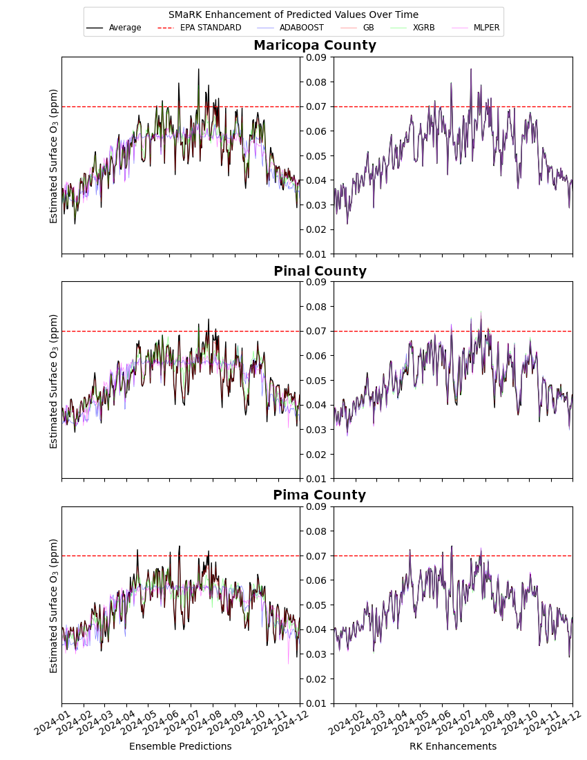

FIGURE V.2

Surface O3 approximations are overlaid with in-situ measurements overtime to depict differences in model error and improvements via RK. For each county, the left graph denotes statistical ensembles with no spatial interpolation of error covariates. The right plot denotes SMaRK methodology estimating these co-variates and incorporating them back into the overall approximation, better accounting for the lack of elevation changes in the AOI.

The full results over time are difficult to depict due to the resolution of the dataset as seen in Chapter VIII.2.9 and Chapter VIII.2.10. Overall, ensemble predictions alone required perfect parameters for effectiveness, else the learned trend was too general for accurate representations of fluctuations during seasons. Chapter VIII.2.10 depicts the variance among purely statistical methods for each county. Correlations for each feature set can be viewed Figure VIII.2.11-VIII.2.14 at better resolutions. When properly corrected for geospatial uncertainty with regression kriging, all methods were able to properly account for complex O3 trends. Ensemble methods alone seemed to fail during known low seasons of O3, where it shows high fluctuations with smaller correlations to lower variations with dependent variables. Model tuning parameters, errors, and the final features selected for prediction are quickly mentioned, then further elaborated on in Chapter VI. ML/AI methods which performed the best were able to establish cyclic trends among the features across datasets; while some models themselves outperformed RK methods (e.g. random forest with the HD), the RK version of those methods performed the best out of the dataset.

V.2.1. ADABOOST

Features tested with Adaptive boosting (ADA) offered the least predictive power with SMaRK error resulting in about 6.5% error and a mean average error of 6.0 ppb and MSE of 0.057 ppb. This was still better than negating spatial uncertainty completely, with 6.26% overall error as opposed to 12.48% overall error. The best dataset for ADA was the GOAT 25 features, likely due to the number of estimators set to 50. Unable to detect cyclic trends, this was best tuned to minimize linear loss with the associations found across surface O3 values in each sample and a constant learning rate of 1.0. Adaboost was the least frequently used method across literature in Chapter II, and this project showed as such. It’s likely that the simplistic linear associations could not be determined with many samples due to variations with surface O3 opposed to linearly co-funding features in G.O.A.T.25. This dataset likely performed the best due to the high usage of features for determining an overall linear loss trend estimation.

V.2.2. GRADIENT BOOST

The best application of Gradient Boosting (GB) yielded a tolerance of 0.0001, maximum number of 366 estimators with no limitation to sampling size. It was trained to minimize absolute error with a learning rate of 0.01 and no additional regularization weights. GB performed the best when trained to sample across yearly bins. This likely worked well due to proper incorporation of linear temporal aspects. Despite minimally increased overall percent accuracy by incorporating RK modelled uncertainty, the upper and lower estimates of the overall tendencies during high and low O3 seasons were estimated closer to the know trend at each monitor. In addition, the low usage of features from TD and trends across the AOI likely had greater trends across yearly samples. Increasing the parameters of the geo-field to include as many possible monitors would likely benefit the overall model, as consistent with (Goodchild 2011) and numerous other sources using point-sourced corrections for imagery e.g. (Adeeb and Shooter 2004; Cavaliere et al. 2023; Ionascu et al. 2021; Pires et al. 2008) to name a few.

V.2.3. EXTREME GRADIENT BOOST

Extreme Gradient Boosting (XGB) emerged as one of the most consistent and high-performing models across nearly all datasets. Its configuration favored the same high number of estimators as GB with 450, but a more moderate learning rate (~0.09). XGB effectively learned complex non-linear relationships in O₃ data and excelled particularly under TD and GOAT 25 features, achieving low overall error across each metric. Total errors ranging from 7.64% to 8.45% were reduced to 5.62% to 5.95% respectively. In addition, its adaptability to both theoretical simulations and high-feature datasets were better by itself, further corrected by RK error additions. The use of the ‘lossguide' grow policy allowed it to build deeper trees selectively, optimizing splits where the data was most informative. Overall, XGBoost proved especially valuable for applications where both feature richness and spatial-temporal variance were prominent like MD and TD. The best RMSE, MAE, MSE, MAPE, and R2 correlation coefficient for XBG compared to XGBRK using MD was 4.80 ppb, 3.63 ppb, 0.0231 ppb, 8.07%, and 0.79 versus 3.38 ppb, 2.53 ppb, 0.012 ppb, 5.61%, and 0.898364. The overall maximum and minimum for XGB was 87.41 ppb ± 4.80 ppb and 10.37 ppb ± 4.80 ppb, with a mean of 48.26 ppb. XGBRK was closer to actual representations with a maximum of 89.58 ppb ± 3.38 ppb, minimum of 5.73 ppb ± 3.38 ppb, and mean value of 48.23 ppb ± 3.38 ppb. MD was the best predictive dataset for XGBRK.

V.2.4. RANDOM FOREST

Random Forest consistently produced some of the lowest error rates, especially under the Historical and Theory datasets, where it achieved an MAE as low as 1.19 ppb and a minimal RMSE of 1.56 under the SMaRK methodology. Its effectiveness with relatively simple tuning — 70 trees and unrestricted depth — shows its innate strength as a bagging ensemble method that averages over diverse trees to reduce variance. The model excelled in datasets with more regular patterns and low noise, suggesting that it captures core linear and mildly non-linear patterns well. Importantly, Random Forest showed exceptional robustness under the SMaRK framework, maintaining stable performance even with spatial uncertainty and reduced training bias. Its ability to adapt without overfitting, even when regularization was absent, highlights its strength as a general-purpose model for environmental monitoring and point-source estimation tasks. This balance of accuracy and stability makes it a practical choice for operational forecasting systems.

V.2.5. MULTI-LAYERED PERCEPTRON

The Multi-Layered Perceptron (MLP) demonstrated moderate but inconsistent performance across datasets, showing potential in theoretical scenarios but struggling with real-world data, particularly in modern conditions. The deep architecture with four hidden layers (11–22–11–2) and adaptive learning via inverse scaling helped it learn non-linear trends effectively, but this came at the cost of generalizability. While the MLP achieved reasonably low errors in the Theory dataset (MAE ~2.5, RMSE ~3.34), it suffered from higher variability and larger total errors in modern datasets, likely due to sensitivity to noise, overfitting, or poor initialization. Its overall reduced error rate under the SMaRK method remained close to that of AdaBoost, indicating only marginal benefit from its complexity. The MLP could potentially be enhanced with more rigorous tuning, dropout, or batch normalization, but in this context, it lagged behind tree-based models in both accuracy and consistency. Thus, while theoretically powerful, MLP was less suitable for practical spatial-temporal O₃ estimation without further optimization.

V.3 RESIDUAL KRIGING ENHANCEMENTS

The residual kriging parameters utilized a Fourier series transformation to model potential data drift. Given the area has extremely low elevation change, drift was likely introduced due to the lack of latitudinal and longitudinal gradients. Since residual kriging accounts for spatial dependence of predicted errors, the relation of prediction, residual and location may depict variation over flat spaces given known trends like the location of monitors or it’s change in elevation (slope), causing spatial drift (Oliver and Webster 2014). Drift occurring from known spatial trends over the AOI can be utilized given the treatment of locations as auxiliary variables. such as in a GIS-based analysis of soil samples (A. Anand et al. 2021). One of the mathematical variations of kriging allowed to incorporate drift to better explain potential spatial dependance is known as Universal Kriging which has been long established (Chilès and Desassis 2018; Oliver and Webster 2014) and implemented in common geospatial libraries in R and Python (Michael Pyrcz 2024; Moraga 2024).

V.3.1. DRIFT SPECIFICATIONS

Initially, some machine learning models were able to adequately predict some seasons, with a very basic implementation of residual kriging. Upon further investigation and understanding of the model, all statistical models were vastly improved by RK of estimated error at each monitoring location. Gradient Boost and related models tend to underpredict values at monitoring locations. Utilizing the power of computer science, Extreme Gradient boost showed a tendency to predict repetitive value. The Top 35 feature training set was able to distinguish enough variation to apply residual kriging, but it seems that pushing the machine to the limit did not incur better predictions. Figure Y shows MAE is greatest for this model, meaning it had the least variation in predictive values. The Random Forest and Multi-Layered Perceptron would tend to both over and under predict, adding more spatial correlation to the errors and hence improving accuracy when implemented back into the model.

The Fourier series implemented into the SMaRK method resulted in a more accurate depiction of latitudinal and longitudinal drift when compared to point drift and specified drift in the kriging function. While elevation specified point drift and sinusoidal longitude and latitude drift still allowed for the model to account for large changes in surface ozone over small areas. A Fourier series can translate any wave equations into an infinite sum of sine and cosines; it estimated the exact difference in surface O3 uncertainty at a geo-atom given the changes in latitude and longitude from the overall area. Functional drift with a Fourier series relationship of was ultimately the best at accounting for areas with either no monitors or large changes in detected surface O3 concentrations.

V.4. COMPUTATION TIMES

Overall, training the models on various datasets didn’t always improve model outcomes or computation times. Historical features were able to predict just as well as modern features when the RK drift function was properly tuned with a complex base. Table VIII.1.3 shows the full results of model training separated into each of the four datasets. Figure VIII.2 shows the results of RK enhanced predictions which better correlated with the overall trend. Gradient boost yielded the least error and ran second fastest next to extreme gradient boost (XRGB). XRGB consistently ran in a matter of seconds, insinuating that further tuning and testing is needed for GPU implementation into RF and MLPR methods. Large tree boosting methods and NNs Which took nearly 8 hours to 1 hour respectively. However, each of the other four models were able to be trained and validated with minimal effort and noting that patience is indeed a virtue.

The total computation time of data processing on the Mac was 24:15.47. Much of the script can be reduced to improve computations times on laptops and lower-power machines. This project was established with Python 3.9; keeping up with the numerous python versions was a lesson to the researcher in of itself. While keeping python up-to-date improving computation times from over 30 hours to a little over a day, the numerous other libraries which also required updating are likely suitable for python 3.14 and upcoming release of 3.15. The desktop in use did not implement the use of a GPU. While this would have dramatically reduced computation times, implementation of AMD’s ROCm software is currently in development, and implementation of this software is relatively new.

The total computation time of data processing with the Ryzen based processor was 14:15.47. Downloading, filtering, and processing of both vector and raster data took 00:46.11. Total computation time for model training, tuning, and prediction output was 01:37.32. Rk was completed with a computation time of 00:16.42. Image processing and final outputs took 01:57.52. The cloud-based desktop provided an NVIDIA based GPU, which allowed for Cuda implementation. Cuda is currently more effective in GPU AI/ML implementation than AMD’s ROCm software and utilizes more stable methods when computing with spatial data. The total computation time of data processing on the Intel x NVIDIA GPU combination was 14:15.47. Downloading, filtering, and processing of both vector and raster data took 00:46.11. Total computation time for model training, tuning, and prediction output was 01:37.32. RK was completed with a computation time of 00:16.42. Image processing and final outputs took 01:57.52.

V.5. FINAL IMAGES AND OUTPUTS

The high-resolution surface O3 imagery captured urban spatial patterns as well as if not better than models of surface O3 using ML/AI techniques with CTM based features. Given the methodology is near the same, improvement can be associated with the incorporation of RK estimated values into the overall depiction of PHOTUC. While some models alone were able to predict with lower errors than with residual kriging implementations, the same statistical model with residual kriging improvements would have the lowest error overall. Random months to depict the full display of surface ozone maps for January 2019, March 2020, May 2021, July 2022, September 2023, and November 2024 can be viewed in Maps XI.3.7 and on from pages X to Y in the Appendix. All prior described trends, statistics, and overall results can be viewed prior to the maps in section XI.2. TD was the final dataset for use in PHOTUC, multivariate depictions of surface O3 and the first of each month with the associated financial year can be seen in Maps XI.3.4-XI.3.9; creating 5 unique maps with the best overall outcome from the SMaRK process.

V.5.1. GBRK Applications to PHOTUC

The best model as mentioned in V.2 was gradient boosting with residual kriging enhancements using TD features. Across all models, trends depicted across each county as in Chapter VI were better associated with the known value and overall distributions of Surface O3 in PHOTUC. The TD results with GBRK predictions are depicted below as an excerpt from Figure VIII.2.XX. These features offered both positive and negative trends for the estimation of the field and allowed for the clearest separation of values in each sampling technique. In addition, model distributions per county were closer to the in-situ trend in both stand-alone and RK versions. Where the model was slightly overfitted, RK estimations of residuals were able to account for the variations in urban locations and high elevations spikes in the AOI.

Further work and incorporation of this method into spatial programs is necessary to unleash the full capacity of GIS into the modern world, as these errors were lower than that of similar CTM and Emissions based representations of surface O3 concentrations e.g.(Chattopadhyay, Midya, and Chattopadhyay 2019; Q. Pan, Harrou, and Sun 2023a; W. Zhang et al. 2022). This project yielded low-errors even with lack-luster incorporation of training values in each geo-field representing surface O3. In addition, this thesis has undergone 3 iterations of python updates, with its final release on GitHub having stability in python 3.12.10. Python 3.13 was released during this work on Oct. 7, 2024, and was not properly implemented due to this string of upgrades to the language that were not yet implemented into libraries like pykrige. Other languages such as R and JavaScript also offer similar utility, perhaps offering much more suitable processing times on laptops and rapid processing times on high-end desktop computers. The resulting script in python produced TIF files where were imported into ArcGIS Pro to demonstrate proficiency with the program and establish the precursors to full implementation of the script for public and private entities using ESRI’s mapping suite.

V.5.2. County Demographics of PHOTUC

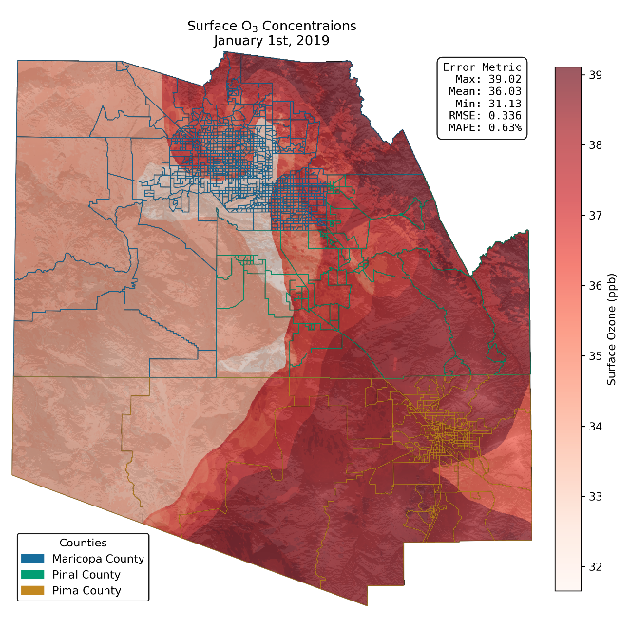Further breaking the results down by county statistics allows for insights into who is affected and by how much surface O3 as estimated by SMaRK. In addition, combining the AOI with its distributions of household and income portrays numerous trends mentioned in Chapter II. Figure V.1 displays the first day of the

predicted dataset from GBRK methods. The rest of the daily images can be seen in the Appendix. Individual maps of population distributions, income, and surface O3 in the AOI can further viewed in Map XI.3.1, Map XI.3.2, and Maps XI.3.7 on. Population data for the year 2020 was used and not updated for this project, as yearly population updates are held for future work. Yearly income data from 2019 to 2023 depict estimated financial changes over the time frame. All daily surface O3 rasters for each month can be seen starting on Map XI.3.13 and on.

The next chapter covers a detailed description of surface O3 trends within the urban centers of Phoenix and Tucson in Arizona to show the effectiveness of these results. Maps of population and income are depicted with bivariate color schemes in which the combination of two colors represents the values of two different fields. For income representations, the deviation between the median and mean income by census tract is represented as yellow. The total percentage of occupied households is depicted as the estimated total amount of occupied households divided by the total number of available homes in each tract and colored blue. Population density and distributions were colored in a similar manner, replacing income deviations with population per 100k; blue will represent the same household percentage used in the population distribution maps. When combined, these two colors merge into a green hue wherein the county depicts high deviations of mean income to median income and a high population per capita.

The textures are left in greyscale for the initial portrayal of these maps; they are later overlaid with a continuous red color scheme of surface O3 values, shifting yellow, green, and blue to shades of orange, yellow, and purple respectively. While the core statistics behind the coloring scheme may seem a little complex, they are not without benefits, depicting interesting spatial trends within PHOTUC. In essence, three main colors are noted as key points within each map. Blue shaded census tracts and census tract groups are representations of communities which have a high percentage of occupied homes. Overall, 16 maps were created with fine detail to show the potential of this work. When the bivariate color schemes denoting census data are properly overlaid with

V.5.3. OMISSION OF CERTAIN METHODS

Given the scale of the final predictive value, Box-Cox or Yeo-Johnson values were not utilized. Upon the initial drafting of this thesis, normalized values yielded minimal improvements in the overall accuracy of each model and confused each model by keeping each value within relatively the same range. Scaling the dataset offered the same deviations as non-scaled data without having to implement another step in an otherwise overall arduous scheme. In addition, the utility offered in the python functions allow for daily predictions at larger AOIs. Development of larger tiles, inclusion of more monitoring systems, and historical trend depictions are saved for future work by the researcher.

CHAPTER VI

A BREIF CASE STUDY USING SMARK PREDICTED SURFACE O3 CONCENTRATIONS IN ARIZONA

This section is dedicated to expanding upon the who, when, and where of surface O3 into what potential outcomes can occur in areas exposed to high concentrations. As mentioned in Chapter II.3.4, O3 is an oxidizing agent, participating in redox reactions while simultaneously reducing itself (Marmett et al. 2023; Qiu et al. 2025; Y. Yang et al. 2024). Many of the transformations applied to the models of O3 in the AOI stem from this idea, incorporating air pollutants and high temperatures into thermodynamical equations. Also noted in Chapter II, air pollution and high temperature can be dangerous in their own rights. Features used with TD are included to show that they do not vary with demographic data as much as the estimated surface O3 concentrations. Surface O3 was mentioned to favor high vegetative areas, titrate with its constituents and move towards these sources when exposed to ample heat. Maps XI.3.6-XI.3.11 show clear splits in affected demographics for the randomly selected days to portray concentrations.

TRENDS OVER PHOTUC FOR FIVE MONTHS

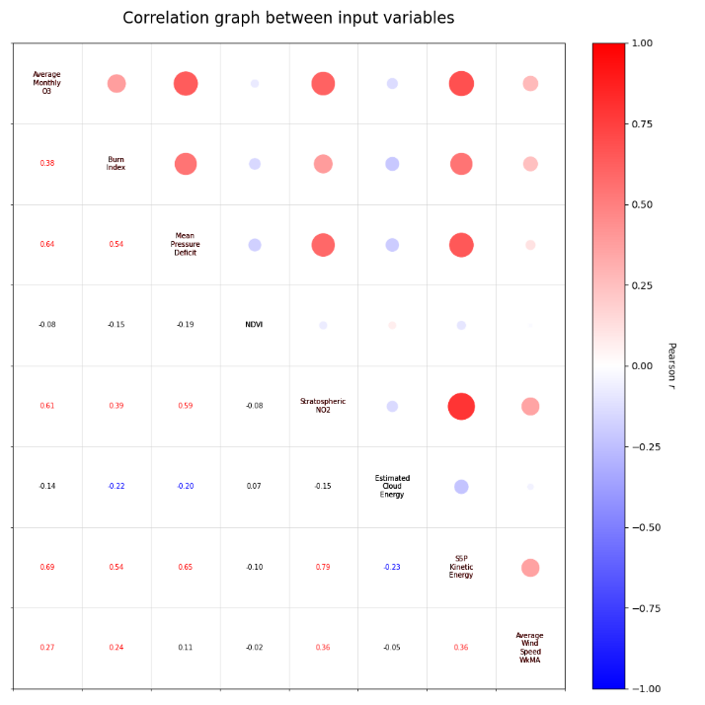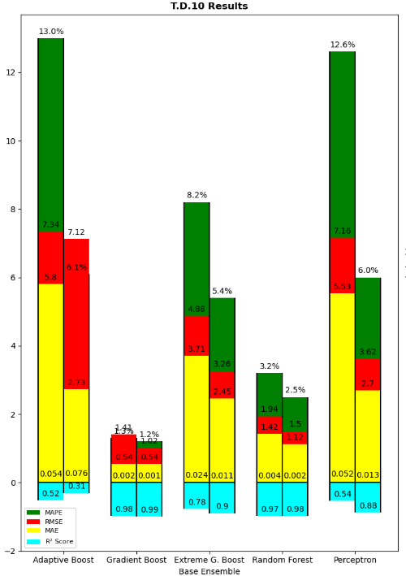Due to the large nature of this project, depicting 2,125 days would be rather disingenuous to mother nature should a printed copy need exist somewhere. Random months and years were selected to keep the number down to 150. Full applications, processing of the full dataset and project management are further discussed in Chapter VII. It was imperative that all seasons were captured in this section, however due to summer temperatures in the AOI, June 2022 and July 2021 were included as duplicate seasons. January 2019, October 2020, and April 2023 depict the remaining Winter, Fall, and Spring seasons respectively. Given the low variance in terrain except around mountainous areas, many of the urban populations are in basins allowing for cumulation of atmospheric gases. The full daily outputs for each month are depicted starting on Map VIII.MAP.X V.2.2. and on. Only the first of each month was shown in detail. Averages for each county are covered, with the health outcomes of exposures at concentrations greater than the EPA Standard of 70 ppb in mind.

The overall predicted concentration of O3 for each county was compared to its average monitor value. It’s worth noting that the distribution of monitors per count was even and the distribution of average concentrations was slightly skewed towards Maricopa; in this study, the area saw higher concentrations on average: Studies have shown numerous respiratory and terminal diseases have been exponentially increasing in areas with poor conditions and high exposure to climate change (Abasilim and Friedman 2022; Anbari et al. 2022; J. T. Lee, Shin, and Chung 1999; Weschler 2006). In addition, studies find that human expansion tends to also increase exposure as a whole, increasing the amount of populations at risk to air pollution and natural hazards (Di Baldassarre et al. 2018; S. Abdullah et al. 2019a; Iglesias et al. 2021). In general, exposure to surface O3 has been associated with mortality risk from non-accidental diseases, circulatory disease, respiratory disease, urinary system disease, and nervous system diseases (Chen et al., 2023; Ito et al., 2005; Jerrett et al., 2009; KazemipaRKouhi et al., 2020; Lim et al., 2019; Raza et al., 2018; Reid et al., 2012; Turner et al., 2016). Some of these health outcomes have been related with exposure to mildly toxic environments and harsher living conditions (WHO 2013; Singh, Suresh, and Vellapandian 2023). Health studies which initially implemented ozone exposure as a confounding variable have instead found ozone to be a driver for concerning health outcomes which differ by age, employment, occupation, race/ethnicity, and other socio-economic status (SES) indicators, affecting a wide range of groups (Bell, Zanobetti, and Dominici 2014). Health outcomes due to exacerbated ozone exposure also tend to vary in severity based on duration and frequency of elevated surface O3 reactions (Turner et al. 2016b; Singh, Suresh, and Vellapandian 2023; Yuting Wang et al. 2023a).

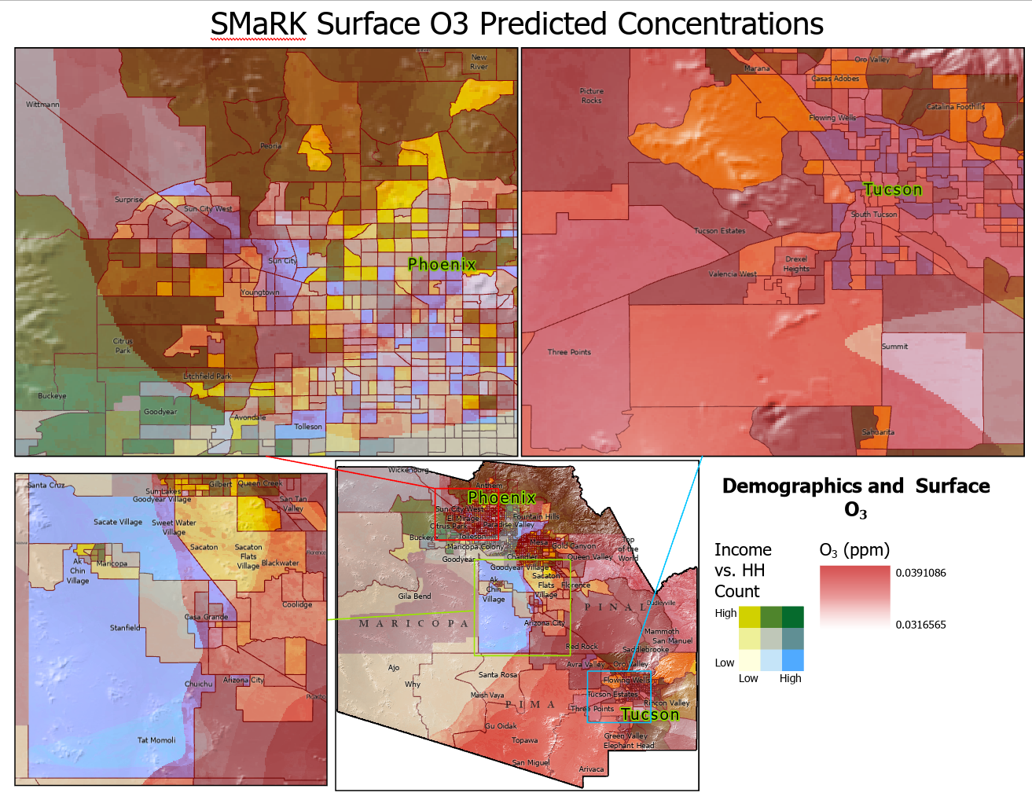

Map 1: This is a caption for my map!

MARICOPA

Distributions of surface O3 for Maricopa County were the most spread out with values ranging from 8.78 ppm to 107.09 ppm. This county houses Phoenix, the most populous city in Arizona as per census counts and number of households The estimated concentrations ranged from x to y based on gradient boosted fields. The distribution of highly populous areas with smaller amounts of occupied homes can be seen closer to Peoria and Glendale west of Phoenix. The coloring scheme shows many green shaded census tracks near the city center, typically surrounded by counties which have little variations in their mean and median income. Noting the surface O3 maps, the urban setting in Maricopa sees the most diversity in concentration distributions.

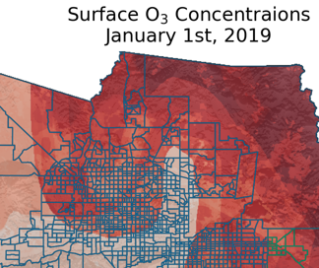When overlaid with corresponding demographic information, many of the census tracts which have a high population, number of occupied households, and low deviation in their overall mean vs. median income are affected by higher concentrations. In addition, during low concentration months such as January, many of the trends show similar tendencies to weather patterns which tend to wrap around certain communities in the area. These same patterns can be seen during the high concentration months like October as well. The effects of both urban heath island effects and high-quality vegetative areas show the trends mentioned in Chapter II.3 where in O3 tends to settle in dry, undermaintained areas where the reaction is not stemming from.

PIMA

Distributions of surface O3 for Pima county were the most spread out with values ranging from 8.78 ppm to 107.09 ppm. The estimated concentrations ranged from x to y based on gradient boosted fields.

PINAL

Distributions of surface O3 for Pima county were the most spread out with values ranging from 8.78 ppm to 107.09 ppm. This county is situated in between the Northeastern part of Pima and Southeastern part of Maricopa. The estimated concentrations ranged from x to y based on gradient boosted fields.

O3 EXPOSURE AND POTENTIAL IMPACTS

Nearly all public health studies concerning air pollutants utilize statistical modeling techniques in some shape or form (Knowlton et al. 2004; Ito, De Leon, and Lippmann 2005; Javanmardi et al. 2017; De Marco et al. 2022). Such predictions give people the opportunity to avoid elevated exposure and the related health risks associated with short- and long-term exposure (S. Abdullah et al. 2019a; Ghazali et al. 2010; Ballester et al. 2002; Braik et al. 2024; Duncan et al. 2014; Michael MacCracken 2008). Epidemiological studies have found statistically significant relationships between an increased risk of premature death and exposures to air pollutants. This relationship has been observed in relation to no just surface O3 reactions (Manisalidis et al. 2020; Liang et al. 2018; Nawaz 2023), but also in areas where O3 reactions co-funded with NO2 and temperature are occurring at or above national standards (H. Z. Sun et al. 2024; Weng 2023; Kumar et al. 2015; X. Liu et al. 2022). A lower exposure of O3 typically relates to a high exposure to nitrogen dioxide (NO2), meaning those who are exposed to the risks of NO2 are equally at risk, if not more so, to illnesses and diseases which stem from both pollutants due to frequent movement between toxic environments (Singh, Suresh, and Vellapandian 2023; Akhter et al. 2015; Alexis et al. 2010; Xue et al. 2023; Turner et al. 2016b; T. Zhao et al. 2018).

Urban studies find interactions with redox states and pulmonary toxicity during long-term exposure episodes (Lulu Chen et al. 2019; Marmett et al. 2022; Ni et al. 2024) during reaction favored metrological events have been found to be related to mortality, respiratory, and increases in immune system response in numerous countries at urban locations similar to PHOTUC (Geels et al. 2015; Jerrett et al. 2009; Malley et al. 2017a; Turner et al. 2016a; C. Wang et al. 2021; Y. Zhang et al. 2024). Spatial-temporal analytics on monitoring systems combined with individual level data show activity spaces attribute greatly to a variety of health outcomes associated with ozone concentrations (US EPA 2015b; Anenberg et al. 2018; H. Liu et al. 2018; Nuvolone, Petri, and Voller 2018; T. Zhao et al. 2018; J. Zhang, Wei, and Fang 2019). In addition, this thesis has found that surface ozone reactions typically follow the patterns mentioned in Chapter 2, occurring in middle-class to middle-low class areas in the study area. Combining the known risks and spatial temporal statistics of the SMaRK model, this section depicts the importance of clear representations of high-resolution surface O3 while doing a small systematic review of the effects of short- and long-term exposures to O3 seen in recent public health studies e.g. (Q. Gao et al. 2022; Marmett et al. 2022; Turner et al. 2016a; Xue et al. 2023; T. Zhao et al. 2018).

ENVIRONMENTAL IMPACTS

Epidemiological studies have found statistically significant relationships between an increased risk of premature death and exposures to air pollutants which are common constituents for ozone production (Anenberg et al. 2022; Fuller et al. 2022; Nawaz 2023). Studies such as these tend to utilize the active monitoring of surface O3 reactions combined with statistical models and remote sensing images to create detailed exposure charts assigned to populations of interest (Q. Gao et al. 2022; Jerrett et al. 2009; Turner et al. 2016b). While these are incredibly accurate, the models used can be improved beyond this thesis to allow for larger, more detailed trend analyses of urban environments (US EPA 2015b; Balamurugan, Balamurugan, and Chen 2022; Yuting Wang et al. 2023a). Current O3 exposure models have been used to support analyses which model the effects of other harmful air pollutants as well (M. Huang et al. 2017; Liang et al. 2018; Na Zhao et al. 2021). Due to the molecule’s unstable and reaction-ready state, ozone models need to be as accurate as possible to highlight possible health burdens associated with it and subsequent air pollution (Anenberg et al. 2018; Heal et al. 2013; Jahn and Hertig 2022). Policymakers at both local- and national-scales have lead large scale projects dedicated to improving air quality for the public and environmental health of their jurisdictions (Schlink et al. 2006; Honrath et al. 2017; IPCC 2022; WHO 2021; Kobayashi et al. 2015). The studies, data, and resulting policies which stem from these findings rely on consistent and accurate distributions of said pollutant gathered over time (Honrath et al. 2017; Tao 2023; Yuting Wang et al. 2023a; Weng 2023). While recent years have added a wealth of information to atmospheric chemistry studies (H. Liu et al. 2018; Gaudel et al. 2018a; Bourgeois et al. 2020; Johnson et al. 2024); historical analysis are difficult to create, and their importance for those encased in environmental injustice cycles is invaluable. More data is required for the slight correlations that have been found with the lack of early spatial information (Borja-Aburto et al. 1997; Hoek et al. 1997; Schlink et al. 2006; T. Zhao et al. 2018; J. Zhang, Wei, and Fang 2019; Anbari et al. 2022).

HEALTH OUTCOMES AND INDICATORS

Health indicators such as measurements of lung function, respiratory symptoms, records of hospital admissions for specific diagnoses, and mortality have all been reported as outcomes due to elevated surface ozone exposure over long periods of time. The variation of health outcomes due to socio-economic status (SES) has been discussed in literature during the late 1990s (Hoek et al. 1997; Kelsall et al. 1997; Zmirou et al. 1998; Schwartz 2000). This known connection between predisposed and vulnerable people provides arguments that short-term mortality trends my actually be advanced by several days due to ozone pollution (SAMHSA 2017; Yi Hu et al. 2012; Lopez-Bueno et al. 2020; Padilla et al. 2016). Trends like these have then shown elevated levels are typically followed by reduced mortality after the increased ozone production event. In historical modeling, coarse datasets have found very weak effects (Borja-Aburto et al. 1997; Hoek et al. 1997; Knowlton et al. 2004; J. T. Lee, Shin, and Chung 1999) only to be more prominent after adding suitable corrections to ozone models (De Marco et al. 2022; Javanmardi et al. 2017; H. Liu et al. 2018; Nuvolone, Petri, and Voller 2018; J. Zhang, Wei, and Fang 2019). Given such conflicting results in modeling outcomes, the assessment of the health risk due to surface ozone is still an intriguing aspect of air pollution monitoring.

FINAL EXPOSURE CONCERNS AND MEAN AOI TRENDS

Health outcomes related to short- and long-term surface ozone have been investigated to find worrying evidence that supports O3 tends to disproportionally affect vulnerable populations based on surrounding environments. (Bell, Zanobetti, and Dominici 2014; Turner et al. 2016b; Malley et al. 2017b; Tessum et al. 2021; A. Hsu et al. 2021; Ermagun, Smith, and Janatabadi 2024). Outcomes such as chronic obstructive pulmonary disease (COPD), elderly cognitive impairment, pro-thrombosis, pediatric asthma, and general inflammation are suspected to stem from exacerbated long-term exposure to surface O3 reactions (Balmes 2019; Q. Gao et al. 2022; Niu et al. 2022a). In short-term ozone studies, pre-teen and post-retirement age groups are more at risk while young, healthy populations varying results due to interactions with oxidative systems in the body. (Barath et al. 2013; Chen Chen et al. 2023, 2023; Díaz et al. 2018; Goodman et al. 2018; Raza et al. 2018; Roth, Hwang, and Li 2008). Short-term ambient exposure to surface O3 may also impact the risk of multiple sclerosis (MS) by increasing triglycerides, cholesterol, and blood pressure in predisposed populations. Women and older adults (especially those over 75) seem to be more affected by short-term ozone exposures (Chen Chen et al. 2023; Fuller et al. 2022). Many of these outcomes occur at or above the EPA standard of 70ppb. Maricopa county, which houses Phoenix, saw high averages of income, population density, and surface O3 concentrations. In addition, areas with better kept greenspace near both Phoenix and Tucson would see the brunt of high concentrations in the area. While January and October showed averages lover than the EPA standard, these areas spiked, with potential exposures above 70ppb according to both in-situ and modelled measurements. Further improvements to the overall code, pre-processing methods, and applications of RK are needed to better depict harmful substances and exposures at high resolutions in urban areas.

CHAPTER VII

CONCLUSION

This project yielded low errors with to minimal incorporation of training values for each quantum mechanical geo-field representing surface O3 at each pixel. If completed properly, the new-found achievements of modern GIS can be further enhanced with in-situ measurements at consistent points. Errors seen in the models can be attributed to the filling of missing values via interpolation and imputation, and missing satellite data. While these values can be either gathered or better interpolated with GEE by adding the surrounding counties outside of the AOI, the pre-processing portion of this project was meant to establish the framework for continued research. The light work required to properly fill NA values should simply be done as part of a larger dissertation creating a model which effectively spans the US. Advanced applications of pre-processing methods would be significantly better for ensuring proper continuity in the initial time-series for variables such as NDVI and formaldehyde. While especially effective for datasets with only a few days missing (e.g TOM/OMI and GRIDmet collections), the interpolation and imputation methods are likely not suitable for long spans of missing data unless given proper consideration into historical available data. In addition, much of the display pre-processing a was complete in python and ArcPRO before final importations into GIMP 3.0 for final touch ups and color corrections. Despite the power of ArcPRO and its contributions to the GIS community, long series mapping such as this thesis did not seem worth the extra time associated with processing each final raster through a toolbox for display. Rather, the creation of such a toolbox which automatically corrects satellite imagery given its monitored value should be implemented as a further project and not as a result of an MA thesis.

This project also required the assumption that monitors were not moved, removing such monitors from the AOI. When a monitor is moved, it no longer offers the potential for future trends unless the original point location and measurements are properly combined prior to being initialized within an ensemble. SMaRK improvements would allow for the proper tuning of monitor locations and their location in reference to the overall geo-field driving process. Further work and incorporation of this method into spatial programs is necessary to unleash the full capacity of GIS into the modern world. The establishment of complex trend analysis from GeoAI and Big Data has finally enabled for the proper quantification of surface O3 estimations. Further applications of RK could advance optical technologies of numerous disciplines which utilize similar observations and correctional schema, e.g. correlating satellite imagery to rovers or stations on Mars.

Remote sensing engineers are constantly finding adaptations to algorithms and noisy data to reduce the error of its coarse results. Utilizing monitoring points as geo-atoms associated with the process they are meant to depict incorporates the concept of GCPs seen in extremely high-resolution remote sensing via remote piloting of drone technology. GCPs in this field are stagnant points which the drone can always see to relate a constant point to all images which need to be tiles. High-resolution satellite retrievals are stored and shared via similar tiling of data, requiring interpolation and resampling techniques like the ones in this thesis. If imagery can be associated with a monitored location during the resampling methods, the concept of an uncertain geo-atom can be accounted for and further reduce the error of the image. This project showed that the application of spatial thought with ML/AI ensembles can better depict geographic patterns and trends noted by analyses of known observations. With better high-resolution surface O3 representations, many communities can be protected from risks associated with it and its constituents.

INTERPOLATION VS IMPUTATION STRATEIGES

The results of the employed K-nearest neighbors (KNN) imputation on the dependent variable achieved a high degree of accuracy due to the available data in this study’s timeframe. Interpolation can be expanded among the entirety of the dataset older measurements from dismantled monitors wish to be utilized. Imputation was crucial for achieving consistency across the available monitors and ensured reliable data for final model training and evaluation. The Linear and Modified Akima interpolation strategies used on the maximum value may not be the best predictive measure if given a larger temporal resolution or reactive feature such as an aerosol. When imputation was conducted on data from 2000-2024, numerous aerosols benefited from 2nd and 3rd degree polynomial interpolation strategies. In addition, interpolation may not be as effective for highly responsive variables such as CO, NO, and Formaldehyde, as these constituents typically show high variability at fine temporal scales. Imputation can be further utilized to accurately predict these features; however, the overall estimation of unknown values leads to increased spreads of error in the final model. This project focused on interpolation of unknown values with the methodology for imputations provided in case it’s needed.

FEATURE EVALUATION, IMPORTANCE AND DEVELOPMENT

Most of the satellite data launched in late 2018 were highly correlated with surface ozone. Individual features known to be precursors for surface ozone reactions from prior models and simulations (Ahmadov et al. 2015; Akimoto et al. 2019; Bowdalo, Evans, and Sofen 2016; Engardt 2008; Hakim et al. 2019; Jacob 2000) were among the top features. The distribution of latitudes, longitudes and elevation were heavily skewed as per Table X; while a more normal distribution of these features may provide higher correlation areas spanning numerous elevations, two main caveats still come to light from using latitudes and longitudes as a numerical feature in geospatial models:

1. They are essentially properties of a geo-atom, such as time, elevation, site-id, etc.; incorporating a property as a feature is like incorporating a tuning metric into the model as a feature.
2. The spatial dependency of a monitor’s metrological depiction is provided by a transformation based on its remotely sensed source, numerical representations of spatial data artificially group these transformations and adds bias to models

ML/AI ensembles utilizing geospatial data are estimating trends based on geo-atoms gathered over the estimated AOI in the way of pixels. When latitudes and longitudes are incorporated into prediction, the distribution must be assumed normal, hence why these may not yield significant results in AOIs whose spatial properties don’t vary via the typical normal bell-curve.

Residual Kriging offers a more stable solution to incorporate geospatial data into ML/AI by integrating geo-atoms as separate, predictive measures. They become a feature of the model without acting as a feature withing the ensemble itself, better depicting spatial dependance and improving overall accuracy as seen in this study. RK is written to model spatial drift, which is difficult to capture for ML/AI models as an dependent variable; RK enhancements to the final models account for drift while separating the prediction from group bias. As per the literature review, finely tuned models such as WRFC-XGB and MATCH[1] (Engardt 2008; Xiaomin Hu et al. 2022) mainly utilize chemical transport models in addition to satellite imagery to account for spatial error by integrating atmospheric dynamics and emission inventories, enhancing the accuracy of pollutant dispersion estimates across available resolutions. Studies like (Becker 2021; Centoni 2017; G. Chen et al. 2021; X. Chen et al. 2023; Xiaomin Hu et al. 2022) incorporate more data; such as fine resolution land-use data, evaluations of tropospheric/ground level ozone measurements, and higher quality data from the source[2], yielding extremely accurate results without the correction of monitor values.

Remote sensing is simply the analysis of measured, reflected light. After numerous optical corrections and mathematical transforms rooted in sibling-sciences, astronomy-based processes and biological activity can be detected with great accuracy and precision. For example, the normalized differential vegetation index (NDVI) is a great depiction of plant health stemming in differences between red and shortwave UV light. Remote Sensing can be a geographer’s best tool in this modern day of spatial computing. Studies utilizing this analysis of geospatial correction to reflected light are attempting to incorporate geospatial corrections into these models as hardcoded feature transformations. As imagery gets more advanced, technology begins to better account for the errors recorded among satellite imagery, models which don’t incorporate spatial error via residual kriging are slightly incorporating this error by way of complex physics and optics. The estimated kinetic energy depicted on the day and time that the ozone concentration was gathered may offer key insights into a new, highly correlated feature with minimal collinearity

AN ADVANCED ADAPTATION OF LAGRANGIAN MECHANICS

The basics of Lagrangian field theory were initially known to the research and used to construct two features for prediction, one of which does not exist for gaseous states: KE and UE. Using a series of transformations, an entire system can be explained as an integral of internal energies over time: The general scope of this theory is if a system's motion is subject to any form of constraint, then there exists a set of generalized coordinates which are compatible with those constraints and hence, simplify the analysis of the system's motion. It was initially believed that a system carried out motions that minimize its actions. This was called the Principle of Least Action, but later, it was realized that an infinitesimal variation in the path yielded no effect on the action of the system. In the world of physics, the difference between minimal and 0 drastically changes the theory. With this new assumption that actions are assumed to be stationary with respect to small variations in their motion, a set of equations known as Euler-Lagrange equations can be implemented and utilized as a feature known as the Action Potential.

These equations represent general coordinates that are replaced by Lagrangian densities (Lρ). Like replacing loss functions within a statistical model to change outcomes, LFT allows for numerous representations of Lρ to account for the numerous mechanics discovered in thermodynamical and chemical-based features mentioned in Chapter III. The history of these developing theories and their core, the Principle of Least Action (PLA), offers exciting new relationships to modern satellite technology which can be further developed into features of many molecular and mechanical surface measurements.

THE PRINCIPLE OF LEAST ACTION

PLA was initially established under the theory that a system always moves in regards to the minimal number of actions allowable from the degrees of freedom defining the system. Later, PLA established that an infinitesimal variation within the path yielded no effects on the overall actions a system can have. In the world of physics, the difference between minimal and 0 drastically changes the theory; actions now are assumed to be stationary with respect to small variations in motion. A set of equations known as Euler-Lagrange equations can be implemented and utilized as a feature known as the Action Potential (AP). These represent a function of general coordinates that are replaced by Lagrangian densities (Lρ). Like replacing loss functions within a statistical model to change outcomes, LFT allows for numerous representations of Lρ to account for the numerous sub-fields in physics.

The proposed kinetic energy calculations for the properties of geo-atoms in this thesis are precursors to a much broader set of terms stemming from these Lagrangian mechanics. In its most general form, any independent variable in LFT can be represented as some theoretical event in space-time S(x, y, z, t) similar to the geo-atom established in 2007 by Dr Goodchild. Dependent variables can be represented as a quantifiable action attributing to the independent event occurring at that time, φ(x,y,z,t). If these actions can be properly defined as properties establishing values for a geo-atom and in a geo-field, then implementation of LFT via modern complex ensembles would assume that once an event has happened, it does not happen again until the same number of actions are present in the system. While underlying complex mathematics like this are included in CTMs by way of features representing emissions, the accuracy offered by RK shows there are potential missing transport mechanisms that can be further improved.

In general, this thesis used three main takeaways from LFT which are also used in the bases of CTM models to establish the core concepts of KE depictions in Chapter III:

* + A system wants to be stationarity unless actions cause it to be otherwise. Stationarity ensues an energy state of 0, or a systems ground state.
  + Where a system's motion is subject to constraints, there exists a set of generalized coordinates that are compatible with those constraints
  + The analysis of the system's motion can be represented as an equivalency of energy such that:

$$L=KE-UE=\int_{i}^{t}{L}d^{μ}=0$$

Where i represents any number of actions in the system at any point in time t. Some systems do not contain potential energy given their state, such as chemical systems. Chemical potential energy and thermodynamic relationships drastically change the representation of Lagrangian densities; vast fields dedicated to this concept have yet to fully reach the world of GIS transformations. If given a continuous set of maximum and minimums over time, the property of a geo-atom can be a representation of Lρ using Euler–Lagrange transformations of available imagery. These equations are a system of second-order ordinary differential equations whose solutions are stationary points of a given action. They can be related to entropy and thermodynamics to describe the geodesic flow of any field, φ, for some set of time:

$$\frac{δS}{δφ_{i}}= \int_{i}^{N}{L}dμ_{q}$$

Taking the variation with respect to φ, one obtains the typical states of systematic entropy:

Given the space and time features produced in pre-processing, variables ds/dt, dp/dt, dv/dt, etc., geo-atoms representing the PLA of any states can be implemented via proper consideration of these transformations. The final representation of surface ozone actions via Euler-LaGrange Mechanics then can be further implemented into a multidisciplinary approach known as the Supersymmetric Theory of Stochastic Dynamics (SSD).

SPONTANEOUS SYMMETRIC BREAKING

The estimated kinetic energy depicted on the day and time that the ozone concentration was gathered may offer key insights into a new, highly correlated feature with minimal collinearity. The estimated kinetic energy must be representative of the chemical and physical properties just mentioned. Further analysis of Lagrangian Field Thery applied to surface ozone densities is mentioned in Chapter 6. The basic take away from this is the construction of the theoretical kinetic energy of the reaction at a given state, in some space at some time it is given as a combination of chemical-thermodynamics and LFT, for later use with a scaled field correlating to the predictor variable:

If one delves deep enough into the darkness of condensed matter physics, field theory and applications of Feynman mechanics; the act of “spontaneous symmetry breaking” seems oddly familiar to the spontaneity of ozone reactions. Spontaneous symmetry breaking (SSB) refers to a special case where the lowest energy state (a vacuum), may not be invariant under all symmetries. In other words, several vacuums are possible, and the overall field may not change with respect to a singular process. SSB states that a spontaneous process of symmetry breaking, by which a physical system in a symmetric state may spontaneously end up in an asymmetric state. In the case of surface ozone, light, NO2, and other atmospheric processes which drive ozone, depict the symmetric states required to produce the asymmetric state of surface ozone. Proper implementation of this theory with regards to remote sensing, geospatial transformations, and spatial-temporal analytics may be a novel missing link in modeling chemical transport systems.

ADVANCING SURFACE O3 EXPOSURE MAPPING WITH RK REGRESSION

The RK method emerged as a standout approach, offering robust spatial refinement to all baseline models by accounting for residual spatial dependencies. While some base ensembles out predicted SMaRK based estimations due to a stronger complex property, the overall SMaRK version of that ensemble still shows stronger associations with the in-situ value at each location. This approach successfully captured O3 concentrations across diverse anthropogenic environments with similar meteorological conditions as well as if not better than current ensemble approaches to correcting imagery. If the associated instrument can be correlated to a monitor of the same type which is properly gathered (e.g. Dobson Monitors and TOMS/OMI imagery or high-resolution drone imagery corrected with GCPs and NDVI imagery from Landsat in-between retrievals), then predictive ensembles using remotely sensed data would inherently benefit from the reduced error in imagery. SMaRK’s low error rates and enhanced spatial precision offers novel solutions to correcting high-resolution imagery beneficial for numerous sectors; like public health research, urban chemical transport studies, and local weather mapping, where fine-scale exposure assessments are critical (Kong et al. 2023; Lo et al. 2024; Northeim, Tiwari, and Oppong 2021; Yin et al. 2019). RK can be used to mitigate the Modifiable Areal Unit Problem (MAUP) and a unique advantage for remotely sensed imagery, providing more accurate, localized predictions of retrieval from current and historical technologies. By modelling the relative distance an observation is from its predicted value, the SMaRK approach can be thought of a mathematical implementation of Tobler’s Law in ML/AI models. Each residual geo-atom, a representation of a complex trend based on geo-atoms within a set field, dictates the amount of similarity between the source and estimated value. By including this in modern imagery, large sets of geo-spatial uncertainty can be accounted for.

IMPLICATIONS FOR PUBLIC HEALTH AND POLICY

Enhanced ozone modeling has significant implications for public health. By addressing spatial and temporal variability more effectively, RK and ensemble methods can support targeted interventions to reduce ozone exposure, particularly in vulnerable populations. Policies informed by high-resolution ozone models can prioritize areas with high exposure, guiding infrastructure development and resource allocation for air quality improvement initiatives. Furthermore, the capacity of RK to capture fine-scale ozone variations holds potential for advancing urban planning, where localized emission control measures could significantly impact public health (Jerrett et al., 2009; Bell et al., 2014).

This study’s findings underscore the need for high-resolution models to achieve accurate exposure assessments that inform public health strategies and urban expansion plans. The RK method provides an advanced tool for mapping not only surface O3 concentrations, but many air pollutants and aerosols at resolutions finer than 300m in need be. If the dataset for surface O3 is expanded upon, it can offer the ability to rapidly estimate exposure risks for participants in exposure studies, especially in densely populated urban centers. Public health officials and policymakers could leverage this to implement localized interventions and standards, such as regulating vehicular emissions and industrial pollutants via emission credits, ultimately reducing health burdens associated with ozone and air pollution exposures.

INSIGHTS INTO HISTORICAL EXPOSURES AND CONCENTRATIONS

The historical feasibility of high-resolution ozone modeling, particularly from 1980 to 2000, relies heavily on the RK method’s ability to accurately capture residual spatial dependencies. With RK, historical data from sources like TOMS can be spatially refined to produce monthly average ozone concentrations, filling a critical gap in historical ozone exposure records. This capability is invaluable for public health research, as it allows for the retrospective analysis of exposure patterns over time, linking long-term ozone trends with health outcomes in different populations. The RK method’s refinement of historical datasets can thus support an unprecedented level of detail in exposure mapping, fostering a new understanding of how ozone exposure has evolved in response to environmental and socio-economic changes. From 2000 onwards, with the advent of advanced satellite data from instruments like Sentinel-5P, the RK method can facilitate daily average ozone models by enabling granular spatial predictions, making high-resolution daily models feasible for the first time.

One of the most promising aspects of the RK method lies in its potential to improve existing statistical models, estimating predictions before 2005. By predicting geospatial error within a larger temporal range, RK can enhance the predictive accuracy of ML/AI corrections used for understanding trends over large decades if collected imagery. Statistical models, when combined with residual kriging, are empowered to deliver predictions that reflect both large-scale trends and localized variations. This integration enables a new generation of high-resolution spatial datasets that offer valuable insights for epidemiological studies, allowing for a more precise estimation of the impacts associated with different O3 exposure levels and more. The RK method provides a structured means of adjusting for the inherent variability in ozone concentrations that traditional statistical models cannot easily account for. This adjustment is critical in capturing the ozone’s complex behavior across diverse landscapes, which is essential for accurate long-term health impact assessments.

In tandem, the enhancement of remote sensing monitoring systems through RK underscores the potential for a more comprehensive air pollution monitoring network that combines satellite data with ground-level measurements. This approach addresses a key limitation of remote sensing: the lack of fine-scale spatial detail required for accurate exposure predictions in urban and rural microenvironments. RK can improve the spatial accuracy of satellite data by integrating it with in-situ measurements, thereby creating a more precise depiction of ozone concentrations near densely populated areas. Such high spatial resolution is essential for not only quicky estimating exposures, it showed populations in this thesis are disproportionately affected by O3 due to their geographic location, socio-economic status, or underlying health vulnerabilities given their surroundings. By refining satellite-based O3 estimates, RK can also facilitate more responsive public health interventions, allowing for the timely identification and mitigation of high-exposure areas.

Multi-disciplinary GIS modeling techniques such as SMaRK have become more widespread because of this most recent data revolution (Goodchild 2018). Brought about by the exponential growth in data storage and processing capacities via advancements in Big Data, new-found spatial and temporal analysis of both micro- and macro- ecologies have spurred the need for simplified, sound methodologies. The pursuit of high spatial resolution O3 models may represent a landmark methodology for GIS users. This ambition, driven by the imperative need for readily available, accurate, spatial-temporal based data has only become attainable due to advances in technology. Particularly, the availability of Big Data like TOAR/Google Earth Engine, application of spatial uncertainty into ML/AI representations of satellite data, and overall improvement of programming language syntaxes (Python 3.12.x, Java 8.x, R 4.x, SQL Server 2022, etc.). The SMaRK approach significantly enhanced the predictive accuracy of traditional ML/AI models by spatially interpolating residuals from features at a given point and adding the predicted error back into the model. Satellite imagery in the PHOTUC region via SMaRK provides transformative capabilities for surface O3 mapping, CTMs, and exposure studies by including known values detected at the surface. The incorporation of spatial uncertainty into ML/AI methods for the proper display of geospatial information is critical to the progression of GIS programs. It enables finer, more nuanced depictions of any independent variable of interest across any temporal and geographic scale with the appropriate coverage of monitors. These fine-grained enhancements are critical for uncovering the full spectrum of micro- and macro-effects of the many pollutants threatening human health, ecosystems, and air quality.

FINAL COMMENTS ON THE SMARK METHOD

In general, utilizing the RK method allowed for capturing complex error trends associated with predicted and actual values of surface O3. SMaRK displayed high variability and complexity of O3 concentrations due to emissions (Staehle, Rieder, and Fiore 2023) while accounting for minute associations due to metrological factors (Hou et al. 2024; Liang et al. 2018; S. Liu et al. 2023; K. Meng et al. 2022; Venkanna et al. 2015). While kriging has been known about for some time, it’s frequency and applications to geospatial representation in ML/AI ensembles and corrective measures remain extinct. In addition, a high-spatial resolution less than 300m of surface O3 does not yet exist for the USNA as it does for other nations . Models have been utilized via atmospheric monitoring networks provided by large institutions and networks such as tropospheric ozone assessment report (TOAR), EPA, and NASA.

The RK method’s innovations addressed explicit limitations inherent in traditional geo-statistical models, particularly with respect to handling complex spatial dependencies and improving spatial resolution. Statistical models, such as linear and ridge regression, have long served as foundational tools for geographic and environmental predictions due to their simplicity and interpretability. However, their effectiveness in ozone modeling has been restricted by an inability to handle non-linear and spatially heterogeneous relationships, which are fundamental characteristics of ozone transport and transformation in the atmosphere. Atmospheric chemistry models, like geos-chem, offer the non-linear predictive power required to understand ozone formation processes at large scales but often lack the spatial granularity necessary for detailed exposure assessments. These models, though informative for understanding ozone formation mechanisms, typically provide results that are too coarse to capture the spatial variations crucial to localized public health research. The RK method, by interpolating spatial residuals from baseline models, introduces a critical enhancement that addresses these deficiencies, providing a more refined spatial resolution that is suitable for high-resolution monthly and daily historical modeling.

NECESSITY OF RESIDUAL KRIGING

The advent of satellite monitoring systems has also contributed significantly to ozone modeling by supplying remote sensing data that is crucial for large-scale atmospheric studies. Instruments like the total ozone mapping spectrometer (toms) and the more recent Sentinel-5P satellite offer invaluable datasets that track ozone and its precursors at a global level. These data, however, are subject to spatial limitations and are constrained by their resolution, particularly in densely populated or topographically diverse regions where ozone variability can be substantial. Satellite data alone cannot achieve the spatial and temporal precision needed for accurate, localized exposure assessments. However, the integration of satellite data with the RK method opens new possibilities. By applying residual kriging to the baseline satellite data, we can account for local variability and improve upon the spatial resolution, rendering the dataset much more useful for high-resolution historical and current-day models. This enhancement is particularly promising for bridging the gap in ozone data quality from 1980 to the present, enabling continuous historical models that track monthly and daily ozone variations across decades.

FUTURE DEVELOPMENTS AND DIRECTIONS

The deployment of advanced ozone models, however, particularly regarding funding and the willingness of research institutions and governmental bodies to sustain long-term efforts in ozone exposure modeling. High spatial resolution ozone models require substantial computational resources and ongoing support for data collection and analysis. In particular, the production of continuous historical models from 1980 to 2000 necessitates significant funding for the acquisition and processing of archival data, as well as the refinement of modeling techniques to ensure accuracy. Moreover, the establishment of daily average models from 2000 to the present will require robust investment in both hardware and software infrastructure capable of handling the high-resolution demands of RK-enhanced datasets. This sustained funding is essential not only for the generation of accurate ozone models but also for fostering public health research that can meaningfully impact policy and environmental regulations.

A commitment to understanding the full scope of ozone’s impact on human health extends beyond the scientific community and requires collaborative action from public health officials, environmental agencies, and policymakers. The development of high-resolution ozone models could reveal the toxicology of surface ozone with unprecedented clarity, illustrating the exposure risks associated with both indoor and outdoor environments. This knowledge is critical for protecting vulnerable populations, especially those who live in regions with frequent ozone pollution events or who work in industries where indoor ozone exposure may be elevated. Ozone modeling those accounts for both indoor and outdoor exposure is crucial for accurately estimating the true burden of ozone-related diseases, as indoor exposure can vary significantly depending on building ventilation, material interactions, and proximity to outdoor pollution sources. A comprehensive understanding of ozone exposure patterns could facilitate policies aimed at reducing indoor ozone levels in Workplaces, schools, and homes, further protecting public health.

Accurate ozone models have the potential to reduce mortality rates associated with air pollution by informing more targeted and effective interventions. By providing a clearer picture of where and when high ozone concentrations occur, these models empower public health officials to issue more accurate advisories and allocate resources to areas in need. This can lead to reduced hospital admissions, fewer cases of respiratory distress, and ultimately a decrease in the mortality rate associated with ozone-related health issues. The knowledge gained from high-resolution ozone models can also serve as a foundation for preventative measures, such as urban planning initiatives that reduce vehicle emissions in densely populated areas, minimizing the risk of acute ozone exposure. Such measures not only improve air quality but also contribute to sustainable urban environments, promoting public health and well-being over the long term.

CLOSING REMARKS

The insights gained from these models can aid the development of high-resolution surface ozone metrics for numerous areas. To reduce ozone-related health risks, support sustainable urban environments, and restore the Earth’s natural ozone cycles, the SMaRK method enables a more accurate representation of ozone concentrations across diverse settings. This has the potential to reshape current understandings of ozone exposure, impacts to general air pollution, and could pave the way for a future where scientifically informed air quality management and deeply attuned to the needs of human health and environmental sustainability.

There are many worries associated with semi-known/fully known health outcomes. Developing theories on health associations from surface ozone exposure on pediatric/elderly populations call for more detailed ozone models to quickly assign accurate exposures to aid air quality, public health, and urban ecology studies. Given that data for these studies are typically small in total area (compared to that of an entire nation or state), there is a need for methodology that can incorporate machine learning and geographic information, when necessary, fully leveraging advantages of both sides for use in high-resolution geographic modelling.

A Note from the Researcher

Atmospheric chemistry plays a foundational role in the history of life on Earth (Barzeghar et al. 2020; Chapleski et al. 2016; Flynn et al. 2021; Tanimoto et al. 2008). Abiogenetic processes on Earth nearly 4 billion years ago were attributed to the emergence of oxygen during the Great Oxidation Event (GOE); enabling the formation of the ozone (O3) layer and promoting photosynthetic processes (Schell, Ackemann, and Hass 2002; Lyons, Reinhard, and Planavsky 2014). As O3 and organisms respectively grew in abundance and complexity, atmospheric composition began to stabilize, eventually resulting in the Earth as we know it today. For eons, the niche composition of chemicals on Earth has allowed life to further evolve by maintaining hypoxia tolerances through the variance in energy levels reaching the surface (Sperling et al. 2022). In this sense, atmospheric chemistry is both guardian and shepherd to biological evolution.

The safety and well-being of past, present, and future generations is essential work of many in geography. Applications of spatial analytics are being utilized in numerous fields to refine and theorize the complexities of the human health and cognition to better understand environmental impacts on daily life (Jerrett, Gale, and Kontgis 2010; Greenough and Nelson 2019; Nawaz 2023; Fuller et al. 2022; Schlink et al. 2006; Cakaj et al. 2023; Borchert et al. 2023). Decades of geospatial computer science implementations with statistical modeling have paved the way for unique, multi-disciplinary specializations to investigate these topics. As computer science grows in availability, quality, and most importantly, ease of access, geographers continue to weave complex spatial thought into “sibling-sciences”, creating innovative solutions to known and unknown problems (Goodchild 2009; Blaschke and Merschdorf 2014).

This thesis seeks to genesis a new initiative with available satellite imagery; stemming from its final product, the high-resolution imagery proposed has potential to further reduce emissions beyond their current trajectory, bolster American economy, and induce harmony between environmental activists and private cooperate entities. The SMaRK method can be further improved with additional coding enhancements and appropriate tuning. Between the ease of access of current/future satellite technologies, incorporation of geospatial thought ML/AI methods, and resulting enhancements to depictions of molecular systems; this thesis can be further used to develop highly accurate, historical, and future predictions of molecular imagery to aid in the establishment of a new molecular credit, rewarding businesses for maintaining a certain standard.

SMaRK operates with correlations to in-situ measurements; when monitors are properly placed as they currently are for some urban areas, the resulting change in environmental patterns due to Anthropogenic sources can be properly translated into monetary units of maintenance the proposed pollutant per area. Like a Carbon Credit (S. Shah et al. 2024; Trouwloon et al. 2023), the resulting system would be significantly more reliable due to in-arguable comparisons to monitoring systems. Unlike some forms of carbon credit (e.g. mentioned in (Probst et al. 2024; Lokuge and Anders 2022); the newly established credit from a final can be offered with more confidence and reliability in the modeled outcomes.

ACCESSING CODE AND DATA

All raster data is freely available on GitHub. Scripts for downloading the necessary data are based in python. While the full project is privately available on GitHub, a public version with access to scripts and sample data can be accessed via the following link: The full scope of this project is in its infancy, and while discerning the available code now may be difficult; developments and improvements are being made daily to make this an easily distributable package via python to facilitate development of high spatial resolution imagery.

CHAPTER VIII

APPENDIX

VIII.1. Bibliography

Automatic citation updates are disabled. To see the bibliography, click Refresh in the Zotero tab.

VIII.2. TABLES

Table 1

Groups of words used during the API download process. Combinations of these were used to create unique search results resulting in over tens of thousands of relevant papers and documents. The Python based search accessed Academic Search Ultimate, Business Search Ultimate, Education Source Ultimate, Sociology Source Ultimate, and Environment Complete on EBSCOHost (EBSC). For Web of Science (WoS), only the Core Collection was utilized as this collection alone offered nearly double the amount of literature compared to EBSC. Topic 1, the main topic, was used with the AND operator for each of the initial searches after a search by itself. Commas are replaced with the OR operator in searches. The * operator allows for searches consisting of everything before the star and the completion of the word after it.

|  |  |  |  |  |
| --- | --- | --- | --- | --- |
| **Topic** | **Category** | **Search Terms** | **EBSCO** | **WoS** |
| **1** | **O3** | surface ozone, ground ozone, O3, ozone | 112,673 | 177,569 |
| **2** | **Models** | linear, ridge regression, LASSO, adaboost, gradient boost, random forest, machine learn, deep learn | 5,140 | 8,833 |
| **3** | **Ecology** | environment, public health, public polic, air pollution, air quality, air chemistry | 49,081 | 68,666 |
| **4** | **Human** | death, mortality, injur*, illness*, death toll*, hospital* | 8,716 | 16,200 |
| **5** | **Risk** | dispropo*, vulner*, risk*, health burden | 21,125 | 48,387 |
| **6** | **Prediction** | predict*, air qual*, air chem*, model*, evaluat*, forecast, simulation | 51,508 | 90,932 |
| **7** | **Transport** | transport*, trajector*, circulat*, advection*, plume, dispersion* | 17,520 | 31,633 |

Table 2

Final counts from each database are given with their corresponding combination of terms using the AND operator. EBSCOHost is slightly older, resulting in a more constrained filtering style and less overall literature sources. Each combination of terms is meant to be used with an associated chapter, relating their overall contents into a pseudo-summary based on these keywords. The literature for the first three chapters and chapter VI was more than enough to build the resulting database for this thesis. Searches were limited from 2010 to 2024 as 2025 and on are intended for the future work mentioned in Chapter VII.

|  |  |  |  |  |
| --- | --- | --- | --- | --- |
| **Chapter** | **Set Combination** | | **EBSCO** | **WoS** |
| I | All sets | | 29 | 196 |
| II | T1, T2, T6, T7 | | 436 | 964 |
| III | T1, T2, T6 | | 2,365 | 4,750 |
| VI | T1, T3, T4, T5, T7 | | 350 | 1,238 |
|  | | **Total Count** | | **246** |

Table 3

Variable codes are as follows. The spreads and distributions of data can be seen in the figures following the Tables section of the Appendix.

|  |  |  |  |  |  |  |
| --- | --- | --- | --- | --- | --- | --- |
| **Historical** | | | : | | | |
| **Modern** | | | : | | | |
| **Theory** | | | : | | | |
| **G.O.A.T.25** | | | : | | | |
| **Satellite Features** | | | | | | |
| **V1** | Downward Shortwave Radiation | **V9** | | Stratospheric NO2 | **V17** | Water Column Energy |
| **V2** | D.S Radiation WkMA | **V10** | | Max Surface Temperature WkMA | **V18** | Average Wind Speed WkMA |
| **V3** | TOMs/OMI Kinetic Energy | **V11** | | Mean Pressure Deficit WkMA | **V19** | Water Column Density |
| **V4** | S5P Kinetic Energy | **V12** | | Min Surface Temperature | **V20** | Cloud Fraction |
| **V5** | Max Surface Temperature | **V13** | | Burn Index | **V21** | S5P 1km WkMA |
| **V6** | Mean Pressure Deficit | **V14** | | Formaldehyde | **V22** | Estimated Cloud Energy |
| **V7** | S5P TCO Temperature WkMA | **V15** | | Formaldehyde Slant Column | **V23** | NDVI |
| **V8** | S5P TCO Temperature | **V16** | | TOMS/OMI 10km O3 WkMA |  |  |
| **Temporal Dummy Variables** | | | | | | |
| **V24** | Spring | **V25** | | Summer | **V26** | Winter |

Table 4

Model outcomes and their best datasets.

|  |  |  |  |  |  |
| --- | --- | --- | --- | --- | --- |
| **Model** | **N params Tuned** | **Best Dataset** | **Best MAPE** | **Best RMSE** | **Average Improvement** |
| **Adaptive Boost** | 3 | G.O.A.T.25 |  |  | -6.31% |
| **Gradient Boost** | 6 | Theory |  |  | -4.99% |
| **Extreme G. Boost** | 5 | Theory |  |  | -5.80% |
| **Random Forest** | 5 | Theory |  |  | -4.40% |
| **Multi-Layered Perceptron** | 9 | G.O.A.T.25 |  |  | -6.31% |

Table 5: Model Results

|  |  |  |  |  |  |  |
| --- | --- | --- | --- | --- | --- | --- |
|  |  | **Statistical Ensembles** | | | | |
| **Categories** | **Metric**  **(ppb)** | **Adaptive Boost** | **Gradient Boost** | **Extreme G. Boost** | **Random Forest** | **Multi-Layered Perceptron** |
| **Historical** | MAE | 5.96 | 5.12 | 3.73 | 1.32 | 5.57 |
| MSE | 0.57 | 0.46 | 0.2436 | 0.33 | 0.53 |
| RMSE | 7.58 | 6.79 | 4.92 | 1.82 | 7.26 |
| Total | 13.4% | 11.9% | 8.45% | 2.96% | 12.85% |
| **Modern** | MAE | 6.1 | 4.68 | 3.66 | 5.28 | 6.09 |
| MSE | 0.59 | 0.39 | 0.23 | 0.48 | 0.62 |
| RMSE | 7.7 | 6.25 | 4.83 | 6.91 | 7.86 |
| Total | 13.73% | 10.74% | 8.27% | 12.07% | 13.97% |
| **Theory** | MAE | 5.96 | 0.61 | 3.70 | 1.42 | 5.78 |
| MSE | 0.57 | 0.02 | 0.24 | 0.037 | 0.56 |
| RMSE | 7.57 | 1.56 | 4.89 | 1.93 | 7.52 |
| Total | 13.43% | 1.47% | 8.26% | 3.17% | 13.39% |
| **G.O.A.T.25** | MAE | 5.51 | 6.02 | 3.42 | 4.61 | 5.79 |
| MSE | 0.49 | 0.63 | 0.2 | 0.37 | 0.56 |
| RMSE | 7.03 | 7.94 | 4.44 | 6.08 | 7.51 |
| Total | 12.48% | 14.18% | 7.64% | 10.54% | 13.15% |
|  |  | **SMaRK Methodology** | | | | |
| **Historical** | MAE | 2.79 | 2.78 | 2.64 | 1.19 | 2.8 |
| MSE | 0.14 | 0.14 | 0.12 | 0.026 | 0.14 |
| RMSE | 3.78 | 3.78 | 3.56 | 1.62 | 3.8 |
| Total | 6.31% | 6.28% | 5.95% | 2.67% | 6.33% |
| **Modern** | MAE | 2.79 | 2.7 | 2.62 | 2.77 | 2.77 |
| MSE | 0.14 | 0.13 | 0.12 | 0.14 | 0.14 |
| RMSE | 3.78 | 3.65 | 3.51 | 3.75 | 3.76 |
| Total | 6.31% | 6.09% | 5.91% | 6.25% | 6.29% |
| **Theory** | MAE | 2.82 | 0.59 | 2.5 | 1.15 | 2.8 |
| MSE | 0.40 | 0.013 | 0.12 | 0.02 | 0.14 |
| RMSE | 6.28 | 1.13 | 3.34 | 1.56 | 3.8 |
| Total | 6.36% | 1.39% | 5.62% | 2.59% | 6.33% |
| **G.O.A.T.25** | MAE | 2.77 | 2.74 | 2.55 | 2.69 | 2.77 |
| MSE | 0.14 | 0.14 | 0.12 | 0.13 | 0.14 |
| RMSE | 3.75 | 3.71 | 3.41 | 3.66 | 3.75 |
| Total | 6.26% | 6.2% | 5.71% | 6.07% | 6.28% |
| Total | Reduced Error (%) | -6.31% | -4.99% | -5.80% | -4.40% | -6.31% |

County Averages

VIII.2. FIGURES

Figure 1

Matching of Literature into main groups. This thesis sought to use all papers but will have a particular focus on the 83 papers in the center which tend to depict modelling, health, and transport topics. While this rough separation of key terms based on abstracts and titles may leave out older sources, personal review of the literature and well-established researchers aided in covering each topic equally throughout this thesis.

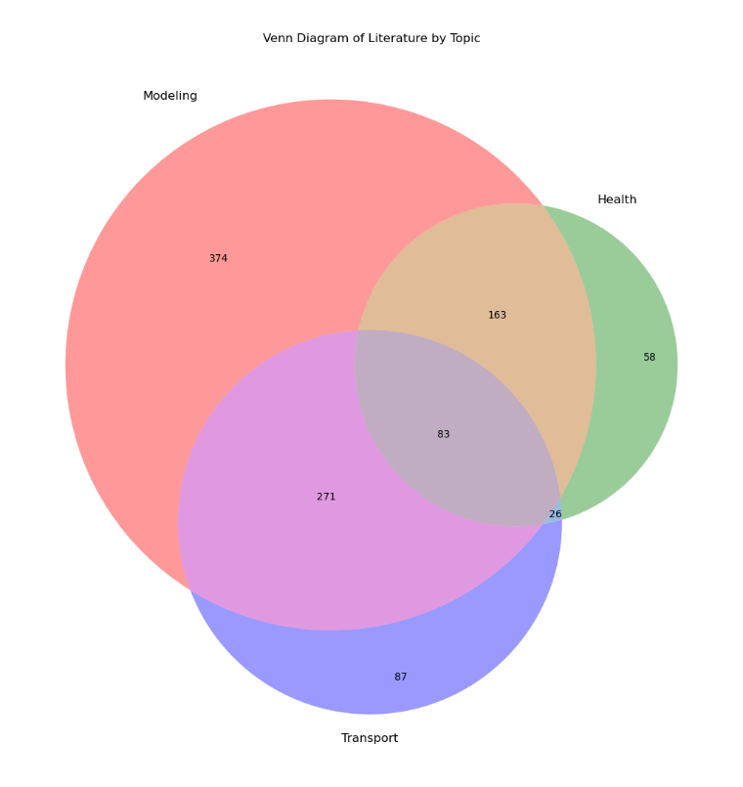

Figure 2

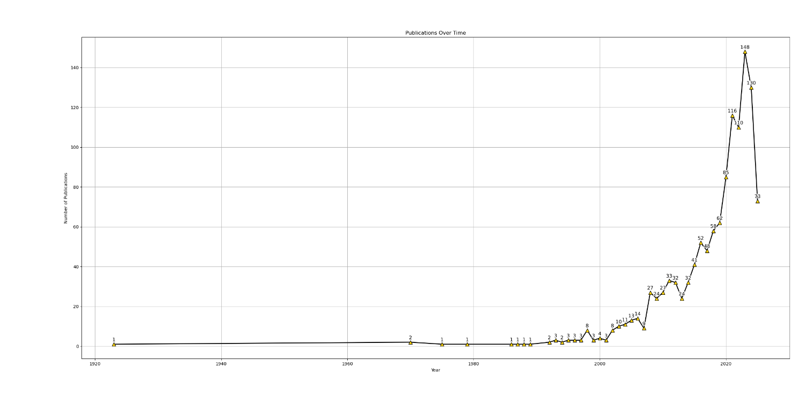 Number of research papers and publications regarding ozone overtime. The spike in literature after 1990 is representative of the historical actions described in the literature review on page ().

Figure 3

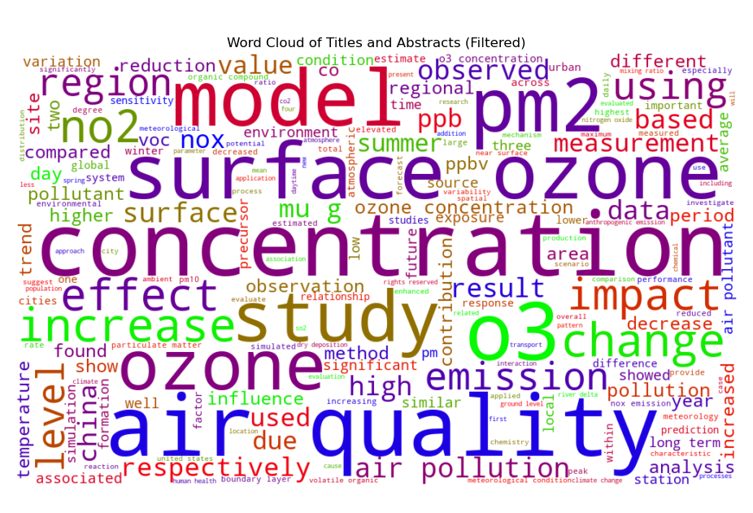Word Cloud of most frequently used words in the literature database. These words were gathered from each paper's available title and abstract to establish an overview of what was most frequently seen. While this can be assumed to encompass the most important parts of collected literature, future inspection of the literature and overall material showed a wide variety of applications and fields dedicated to ozone research.

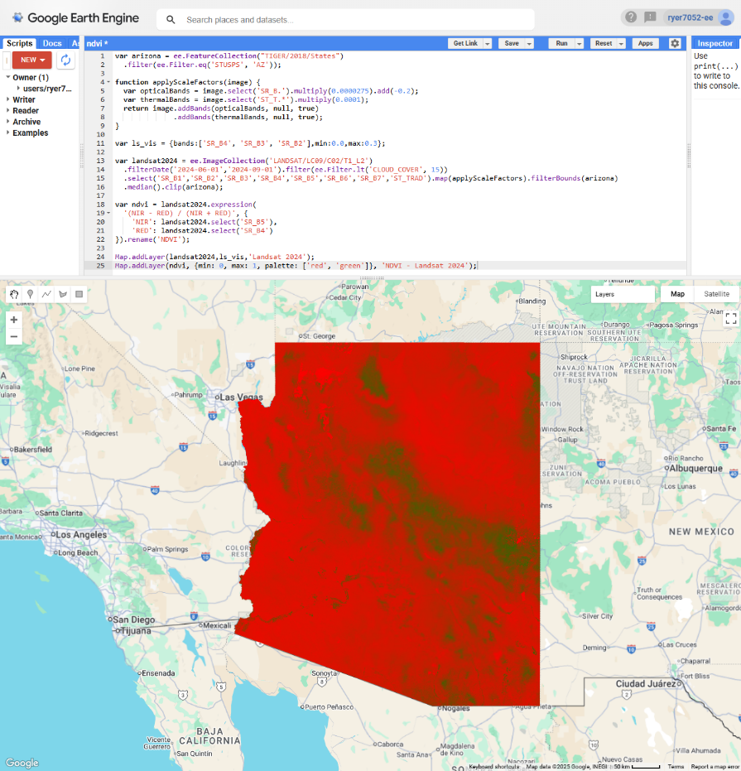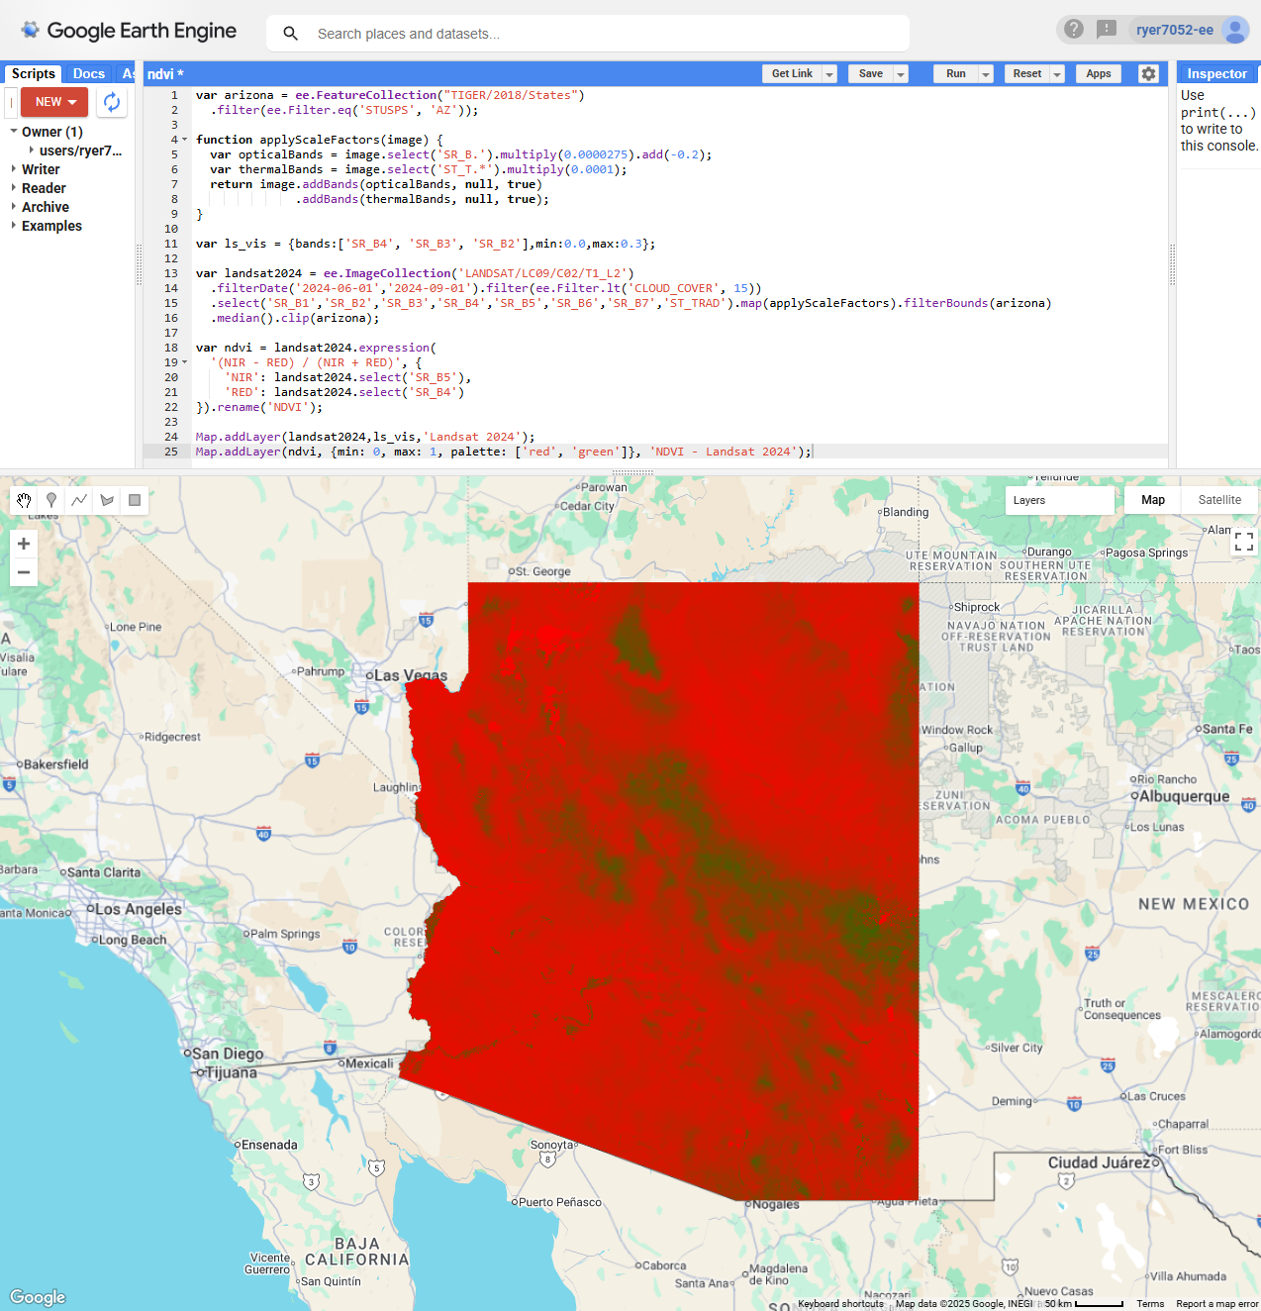

Figure 4:

The Google Earth Engine code editor GUI is based in JavaScript. NDVI is portrayed to show the ease of developing features and analyses in GEE.

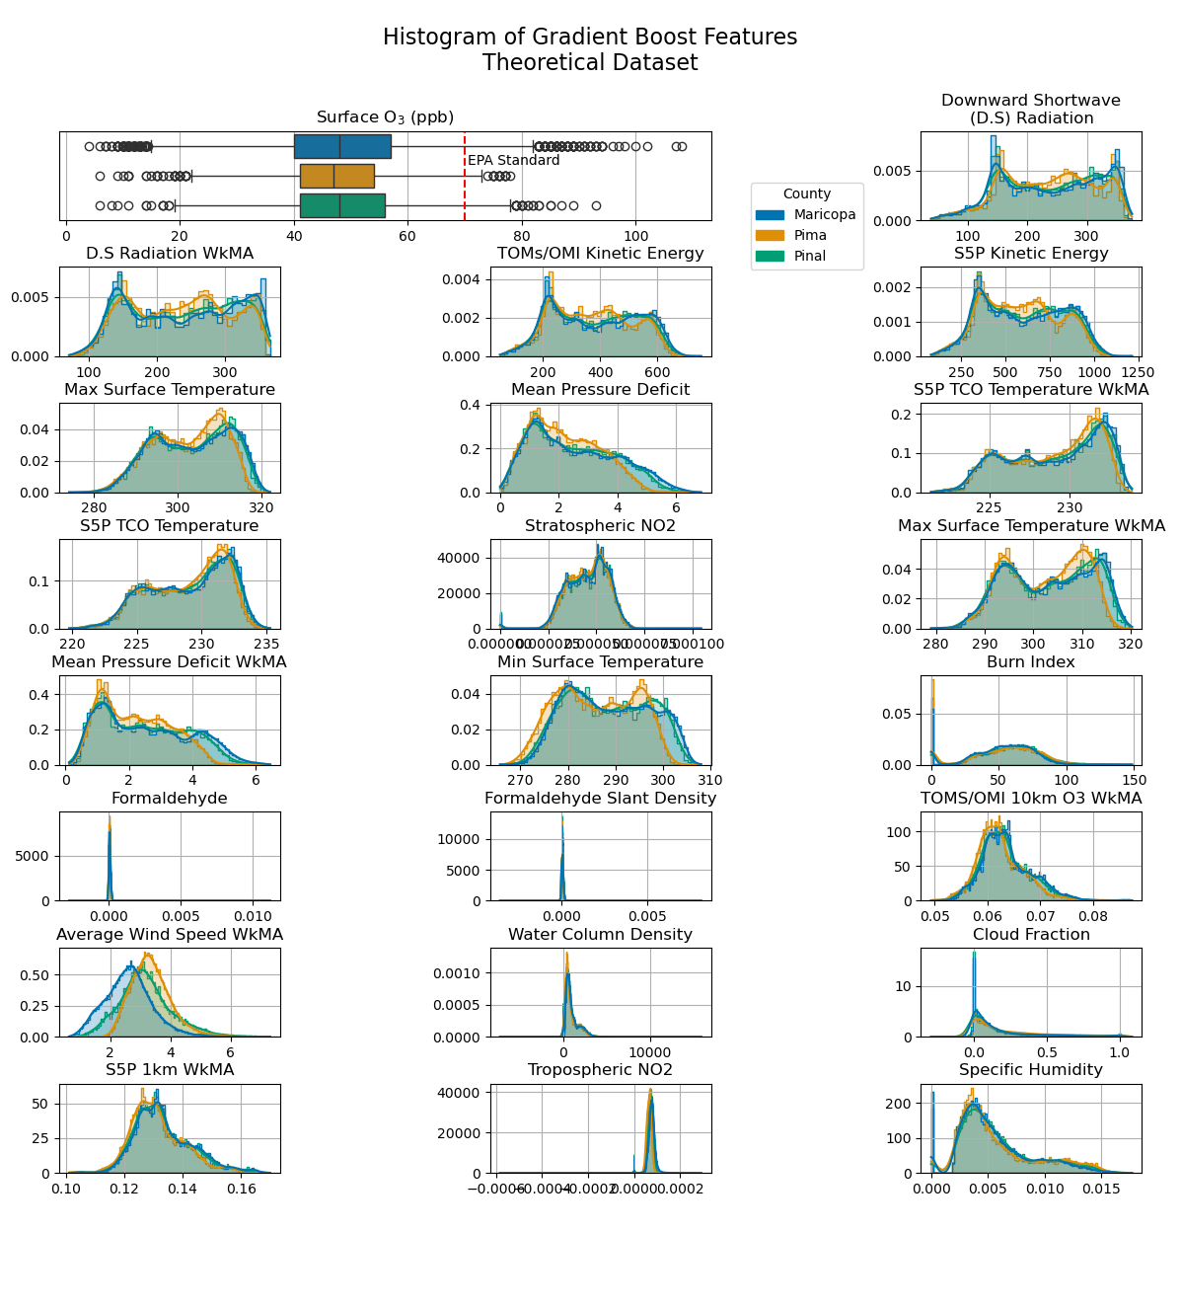Figure 5: Distribution of Features.

Figure 6: Scatterplots of Dependent vs. Independent values

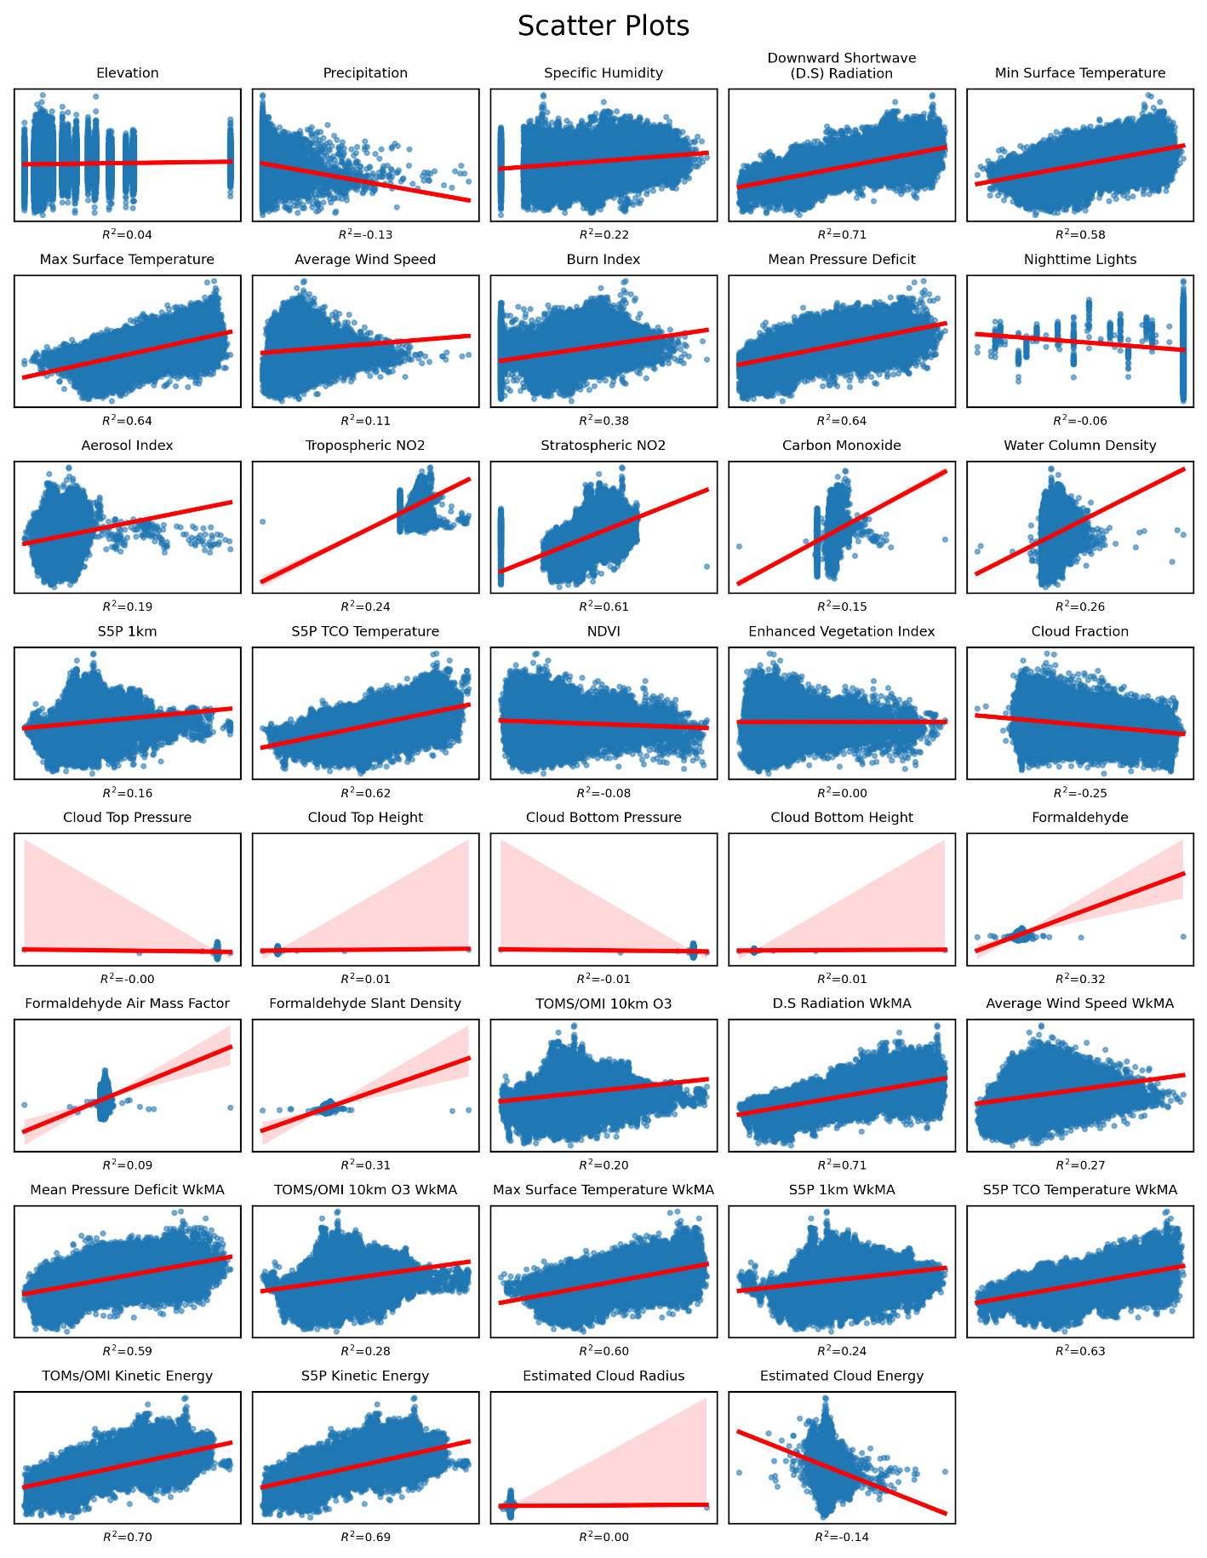

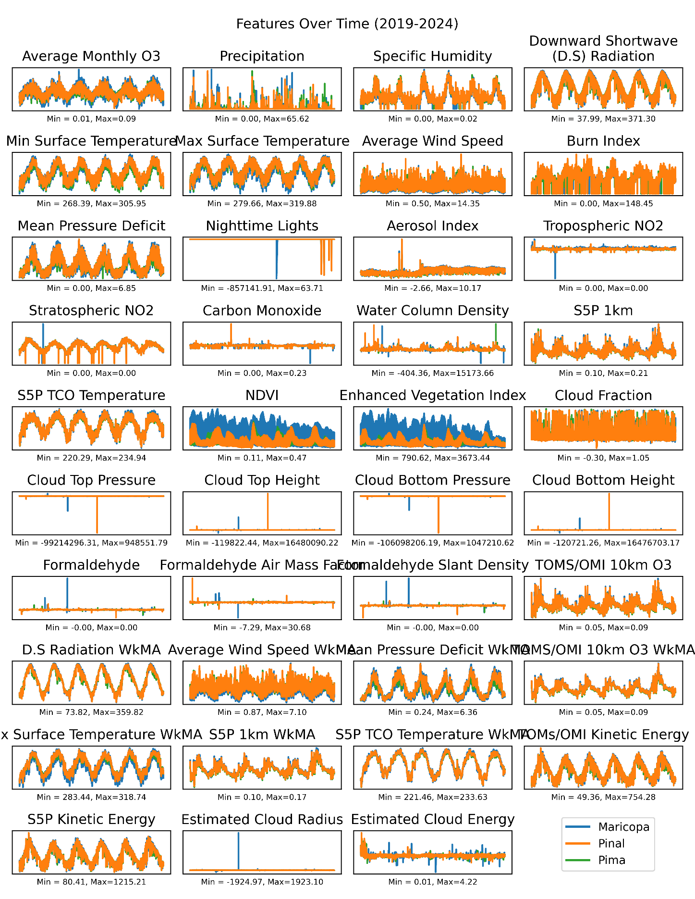Figure 7: Features split over time by county. Orange depicts consistent values across the study area. NDVI and EVI are higher in Maricopa than Pima and Pinal. Overall, larger fluctuations of the

Figure 8: Histogram of Surface O3

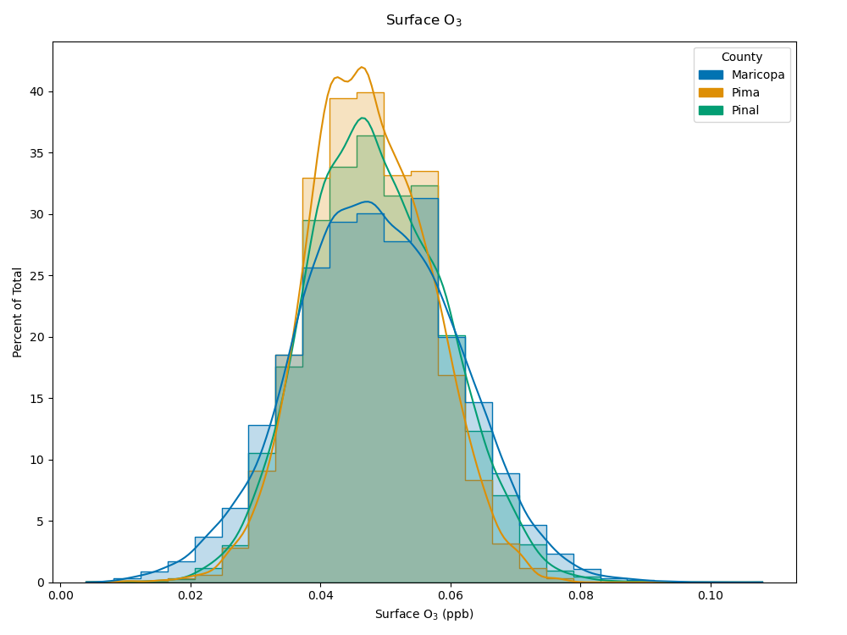

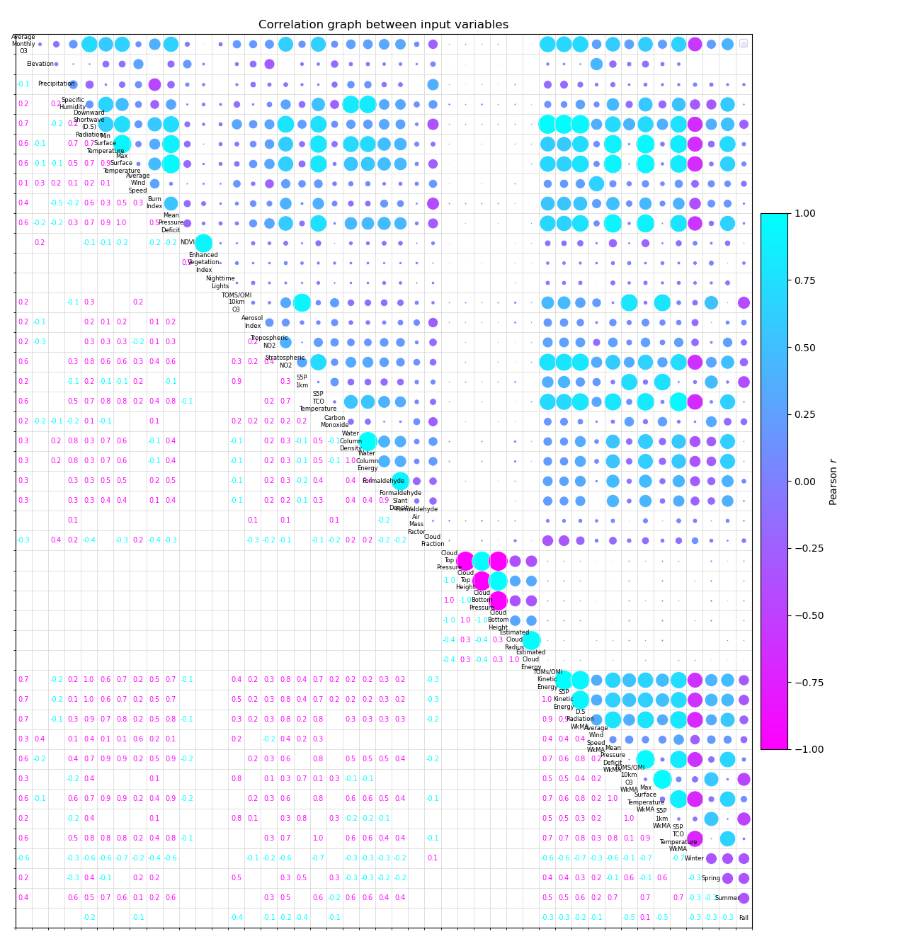

FIGURE 9

The full Pearson correlation coefficient matrix used to select variables before model fitting. Individual correlation matrixes that follow are much easier to read and used for references. This was included to depict the absurd difficulty facing GIS engineers, display of large datasets. This is comprised of 44 features inclusive of features that were created. Note: Fall was omitted from future models due to lower correlations among seasonal dummy variables

FIGURE 10

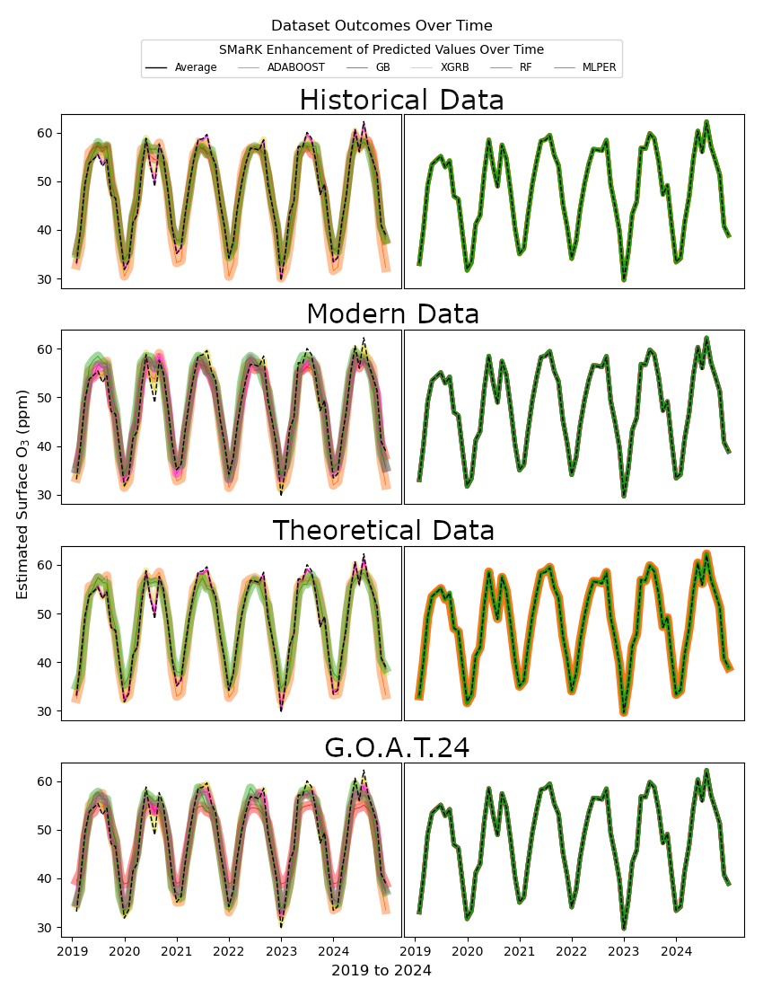All models averaged overtime per month. ML methods on the left don't always agree with the in-situ measurement.

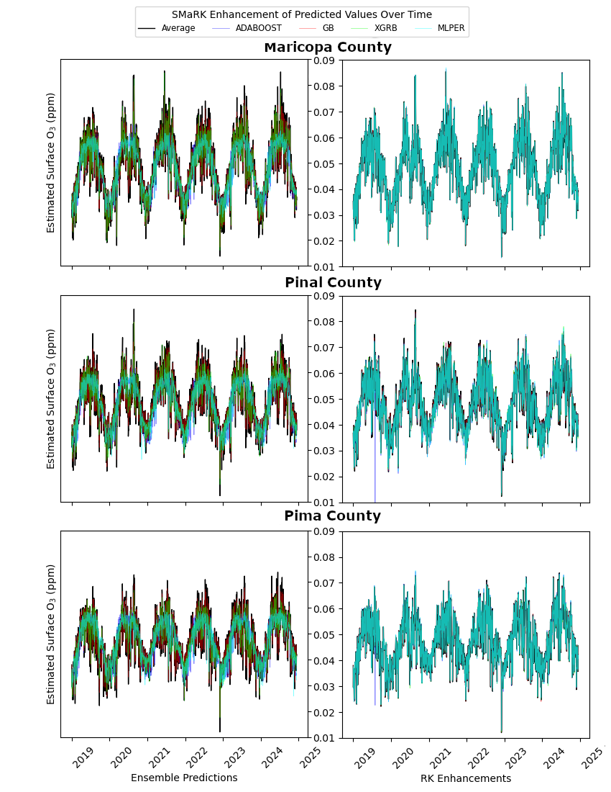

Figure 11

Surface O3 concentrations and predictions over time. Lines are split by model, statistical models in the left column have trouble depicting outliers in summer seasons. SMaRK predicted rasters vary with ground truth data much better and yielded stronger stability around seasonal trends. Ensemble methods tended to agree more with ground truth values during low seasons while failing to account for variability during high O3 seasons.

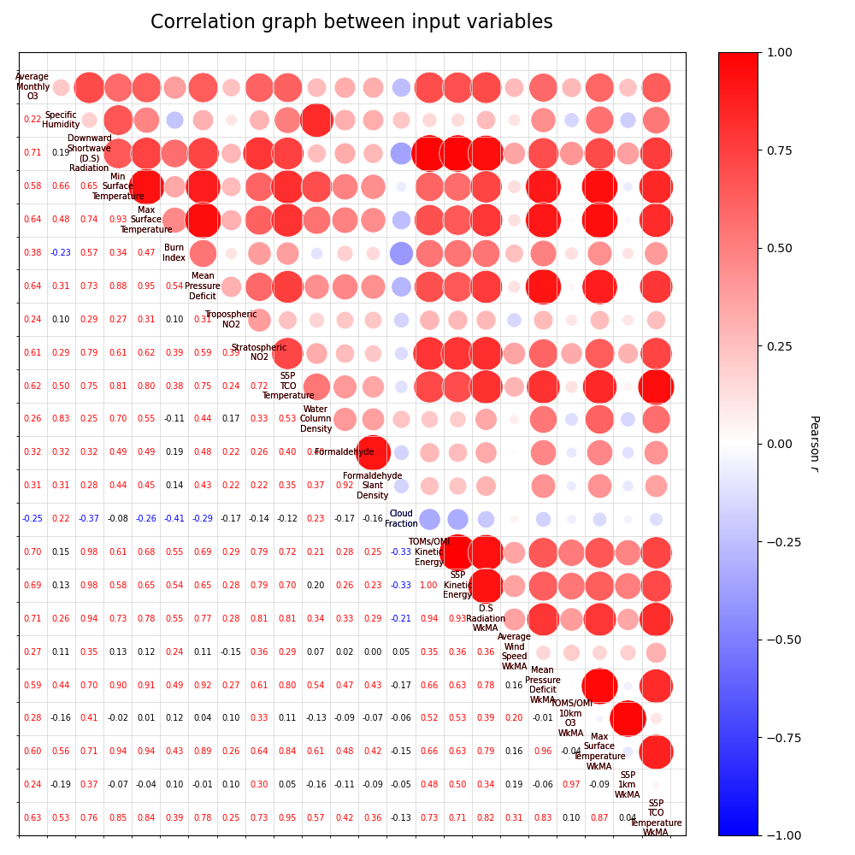Figure 12: GOAT

Figure 13: Historical

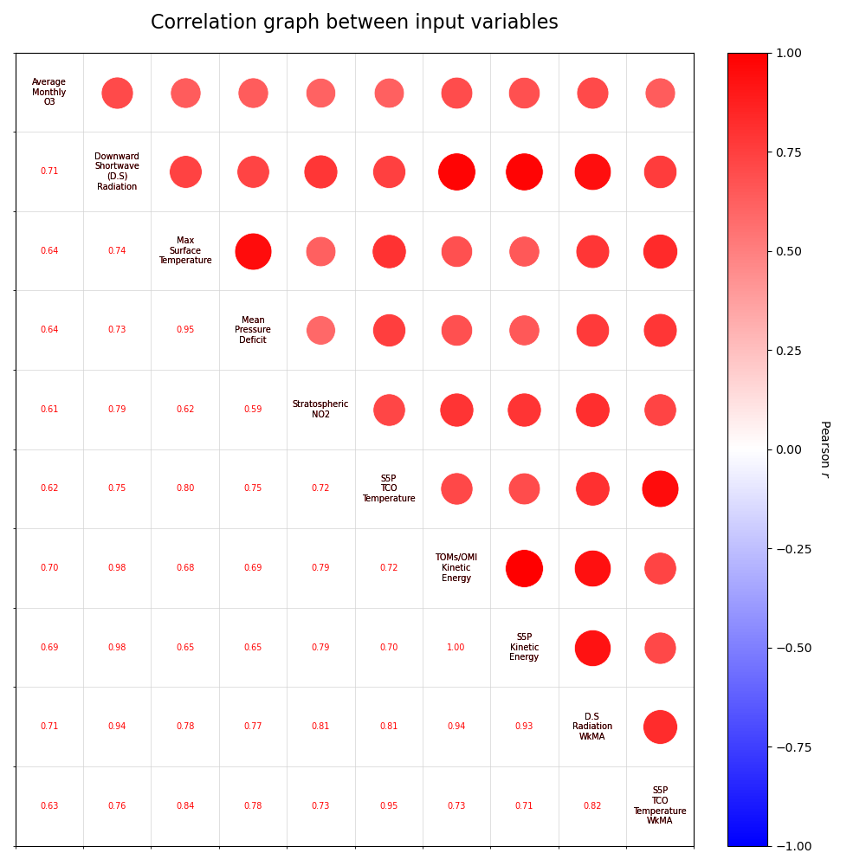Figure 14: Modern

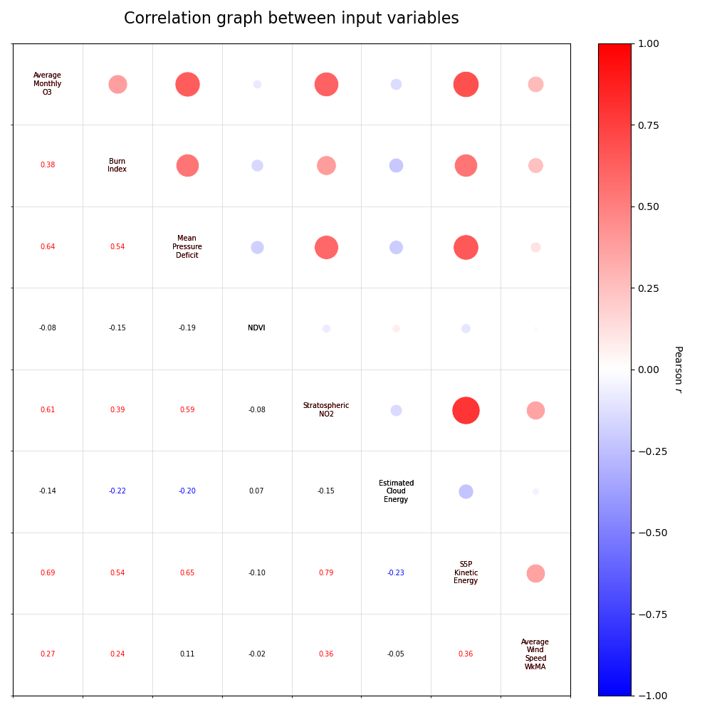Figure 15: Theory



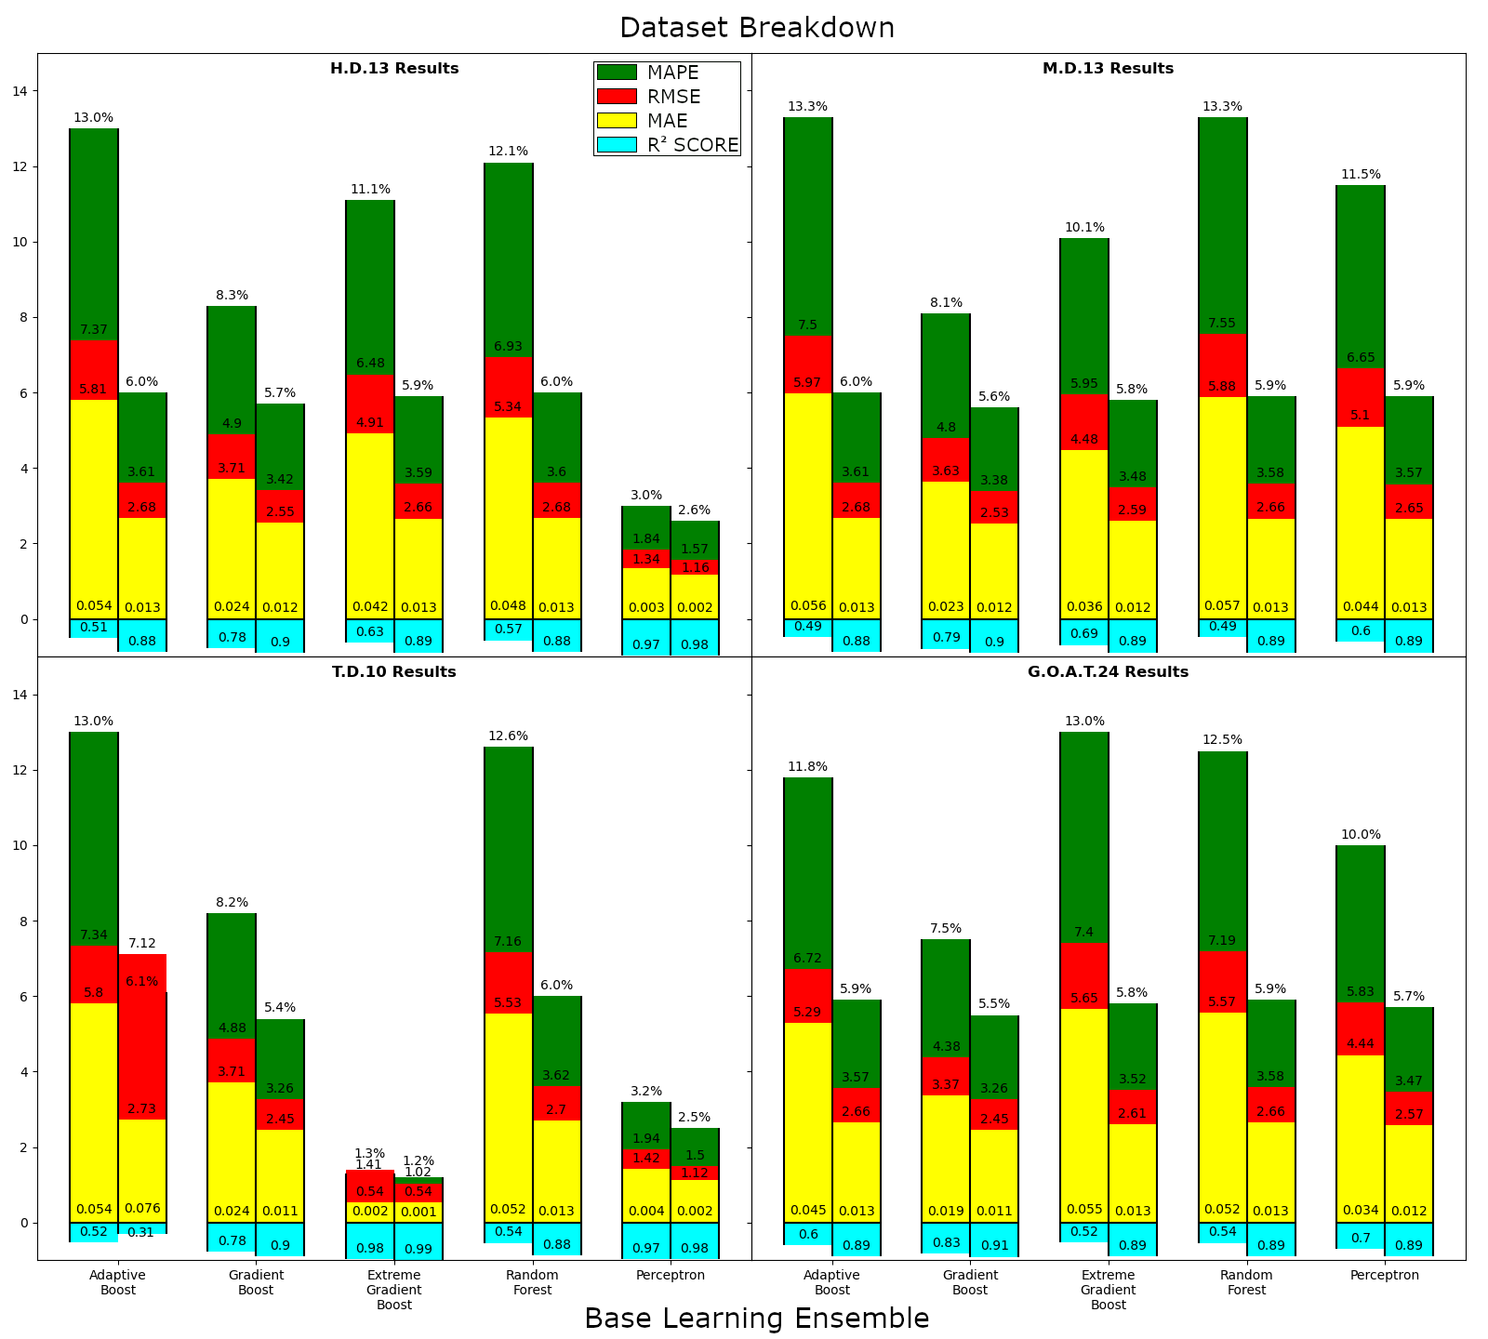

Model Boxplots by Dataset

MAPS

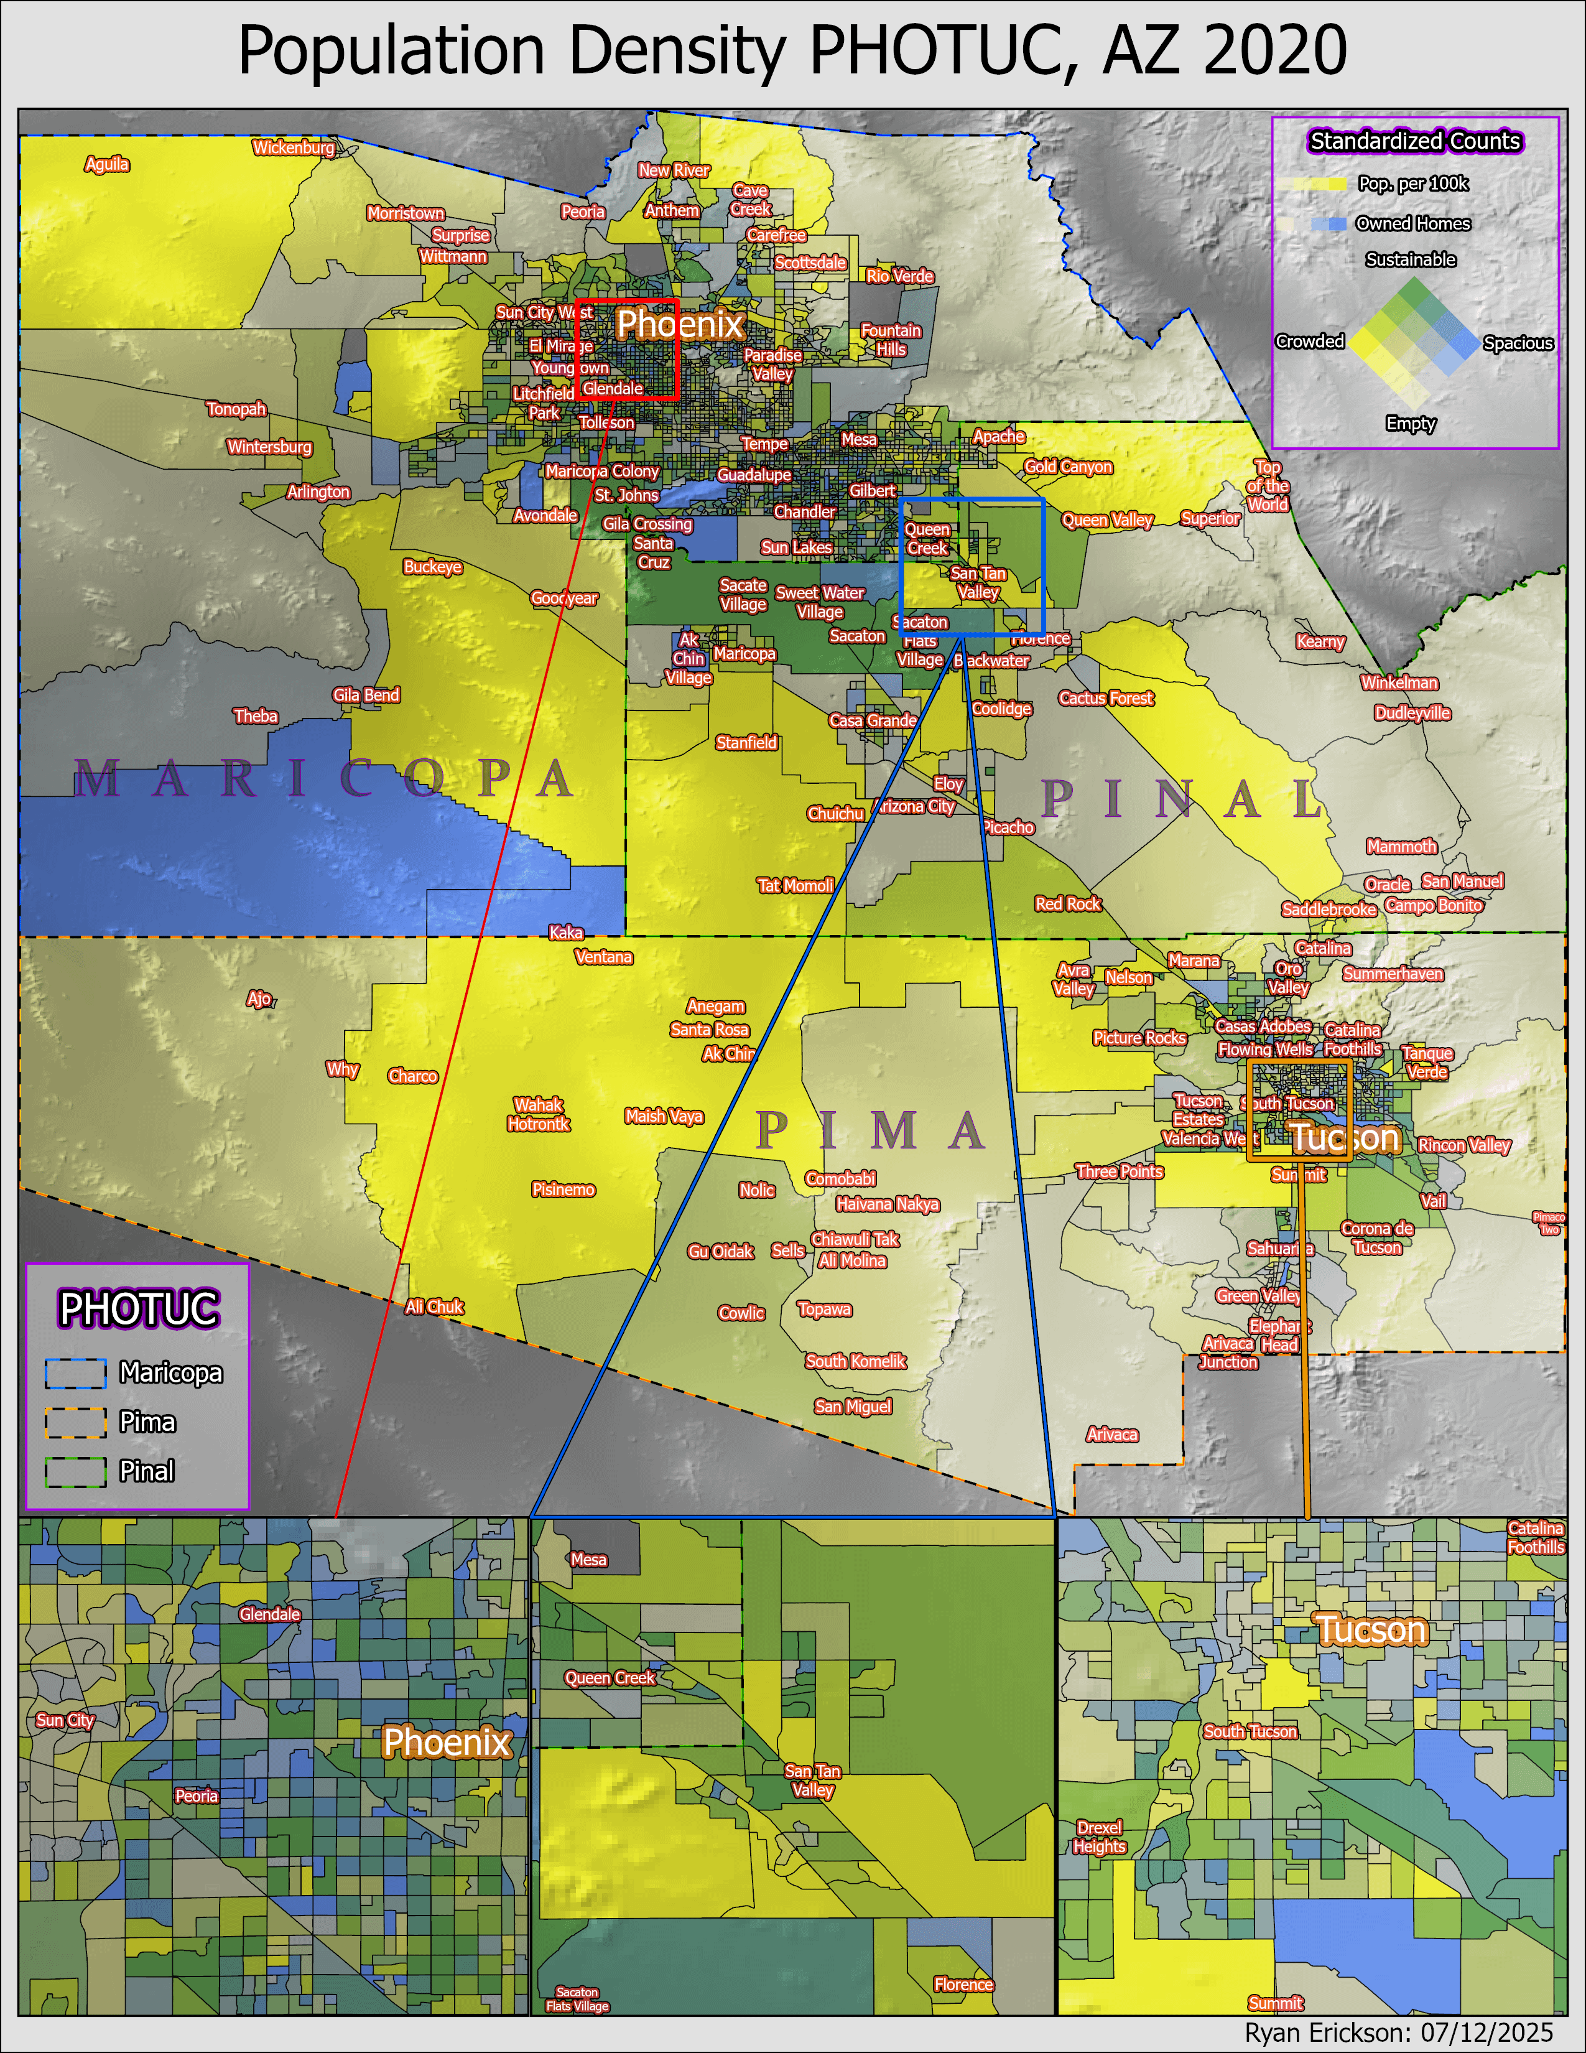

Map 1

Demographic distributions of the Pheonix and Tucson area. A bivariate color scheme is provided to depict the number of housing units and total population per census tract block group. Census data was provided by...

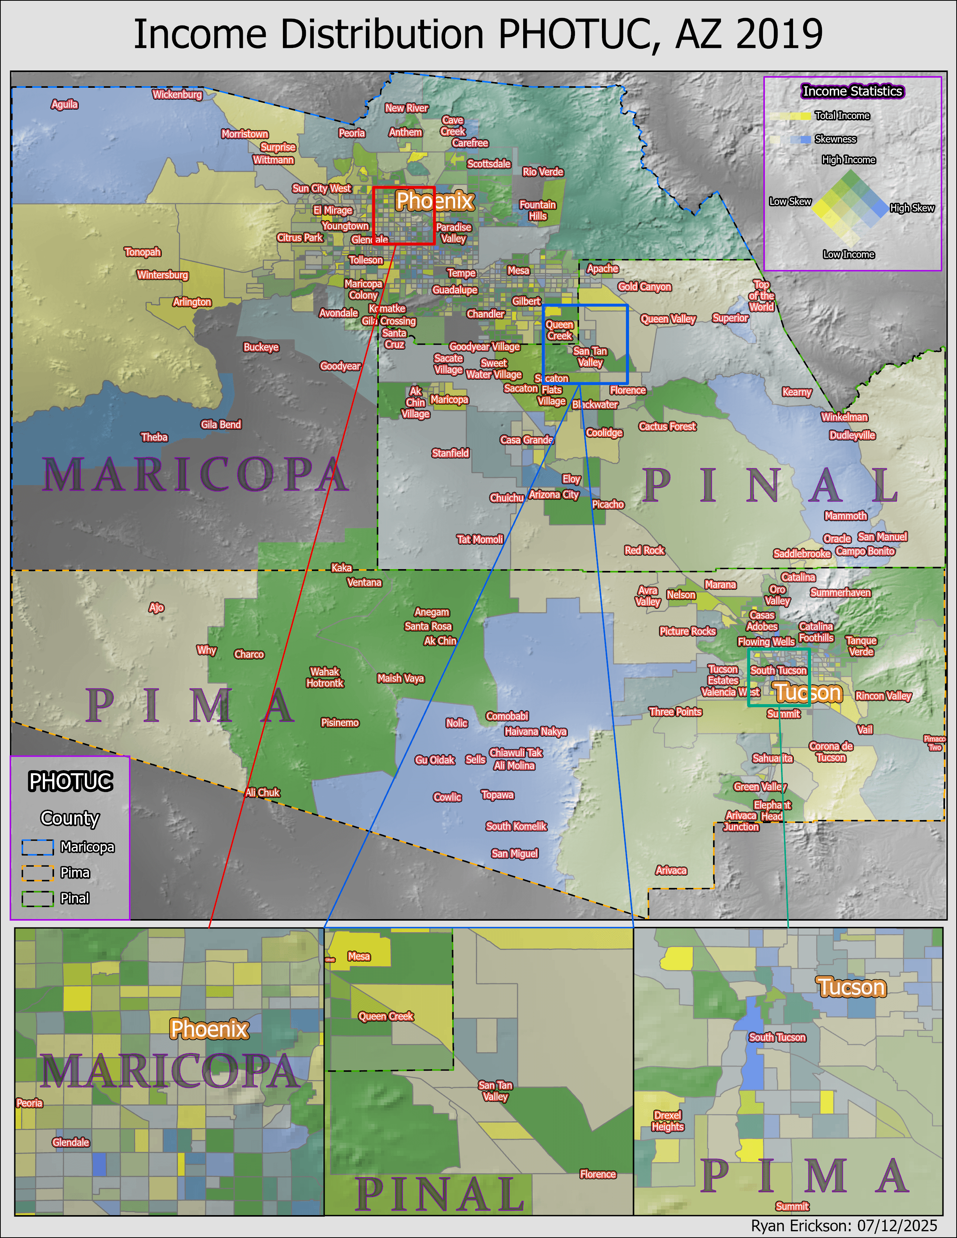Income per 100k Map

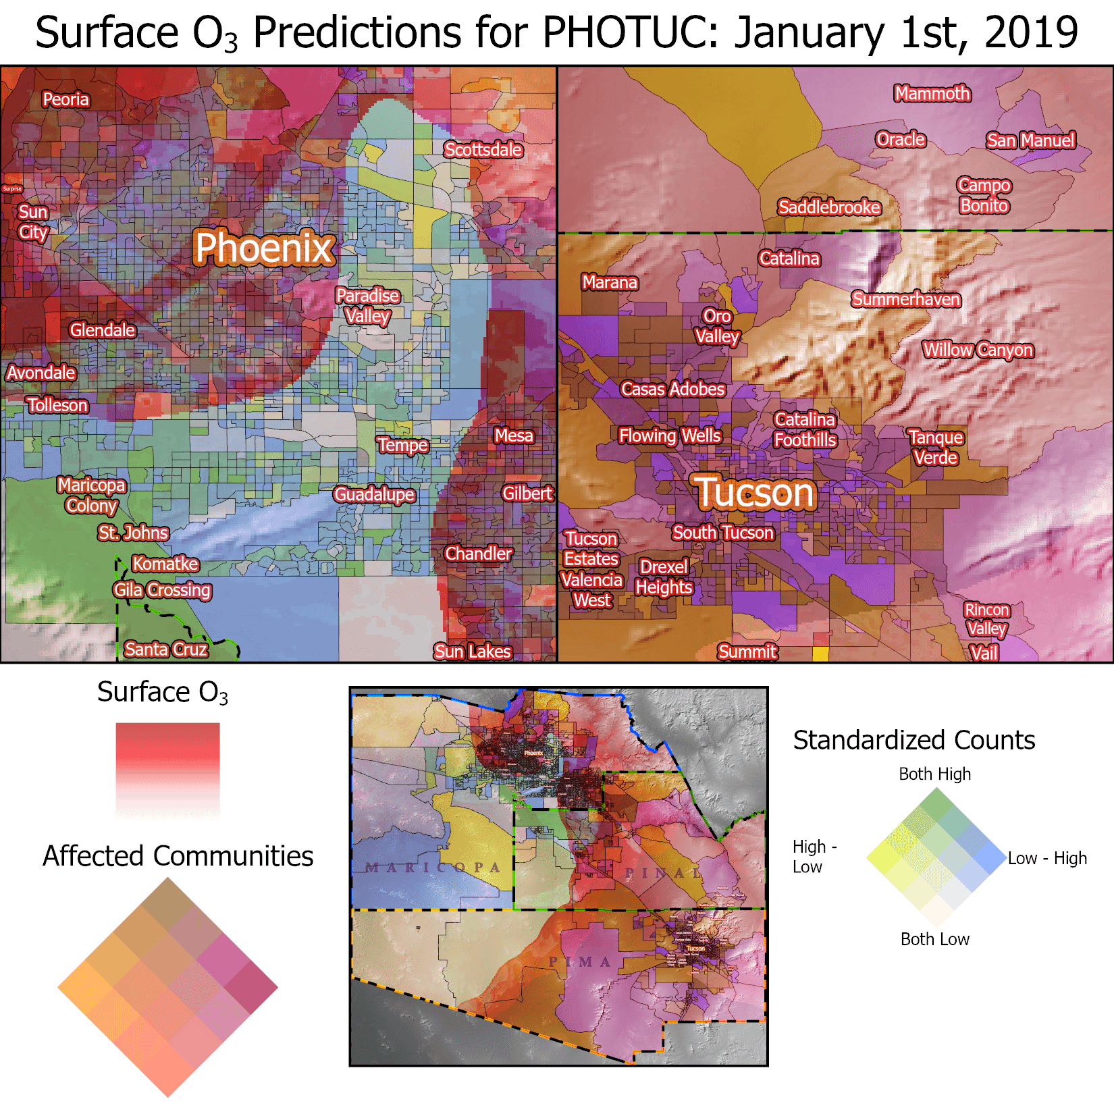

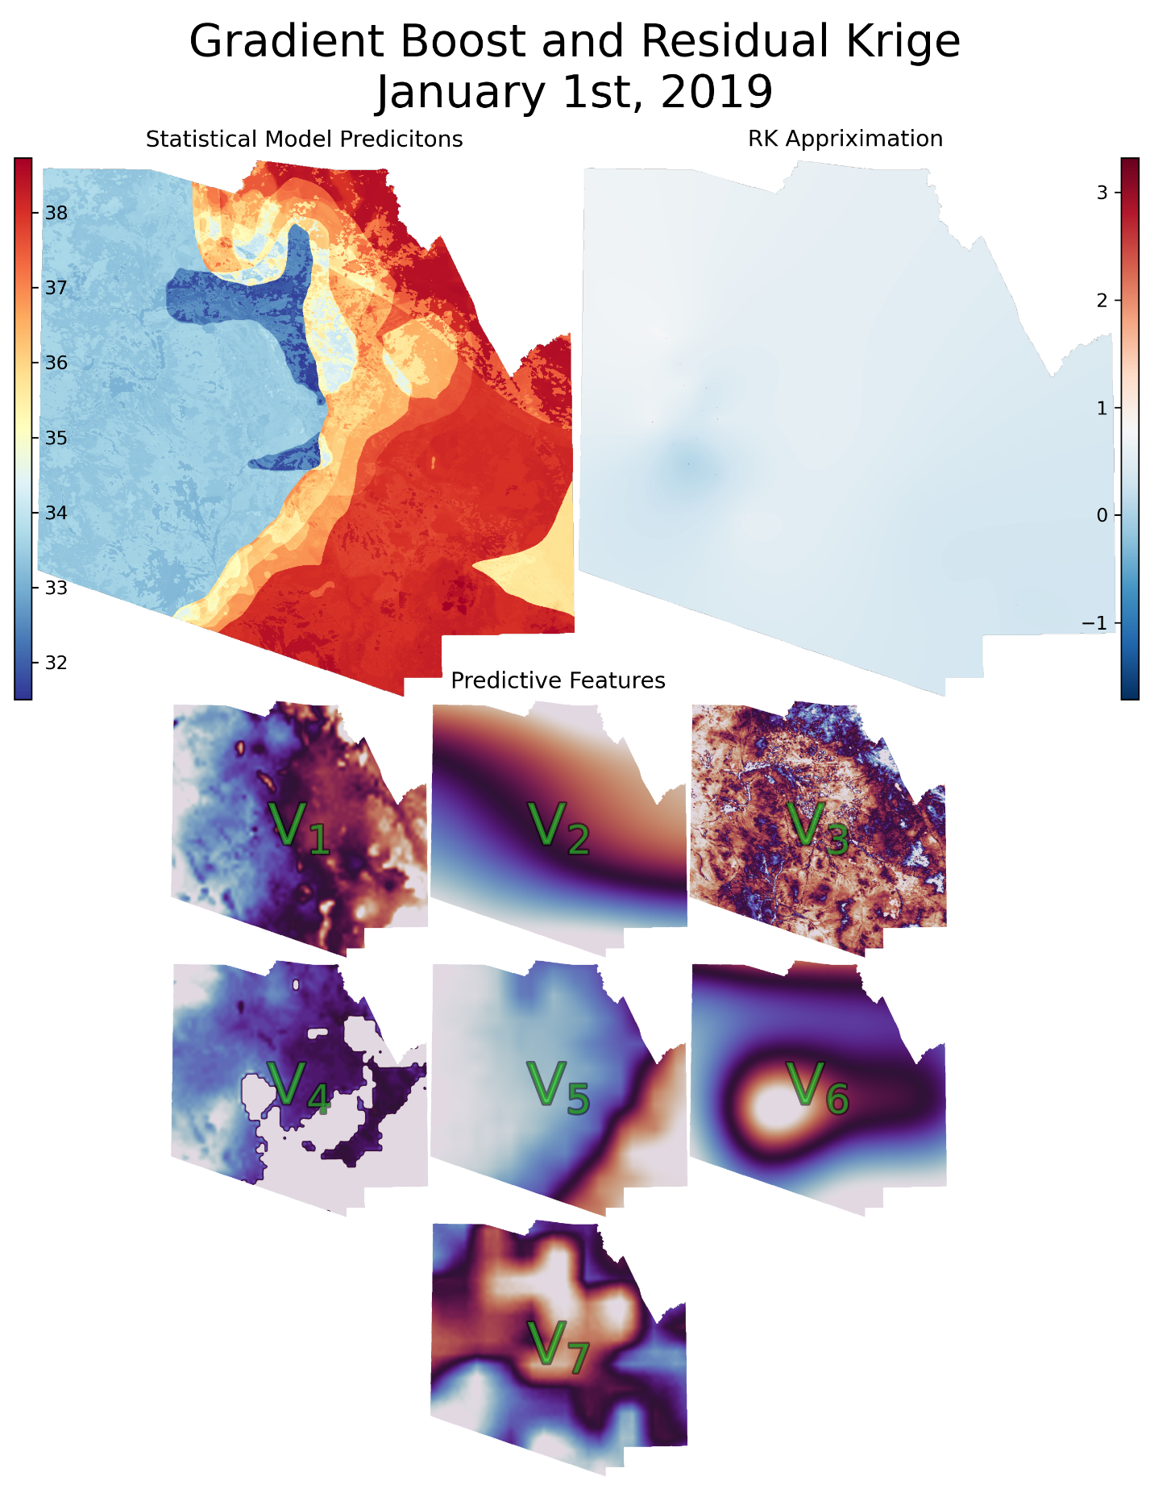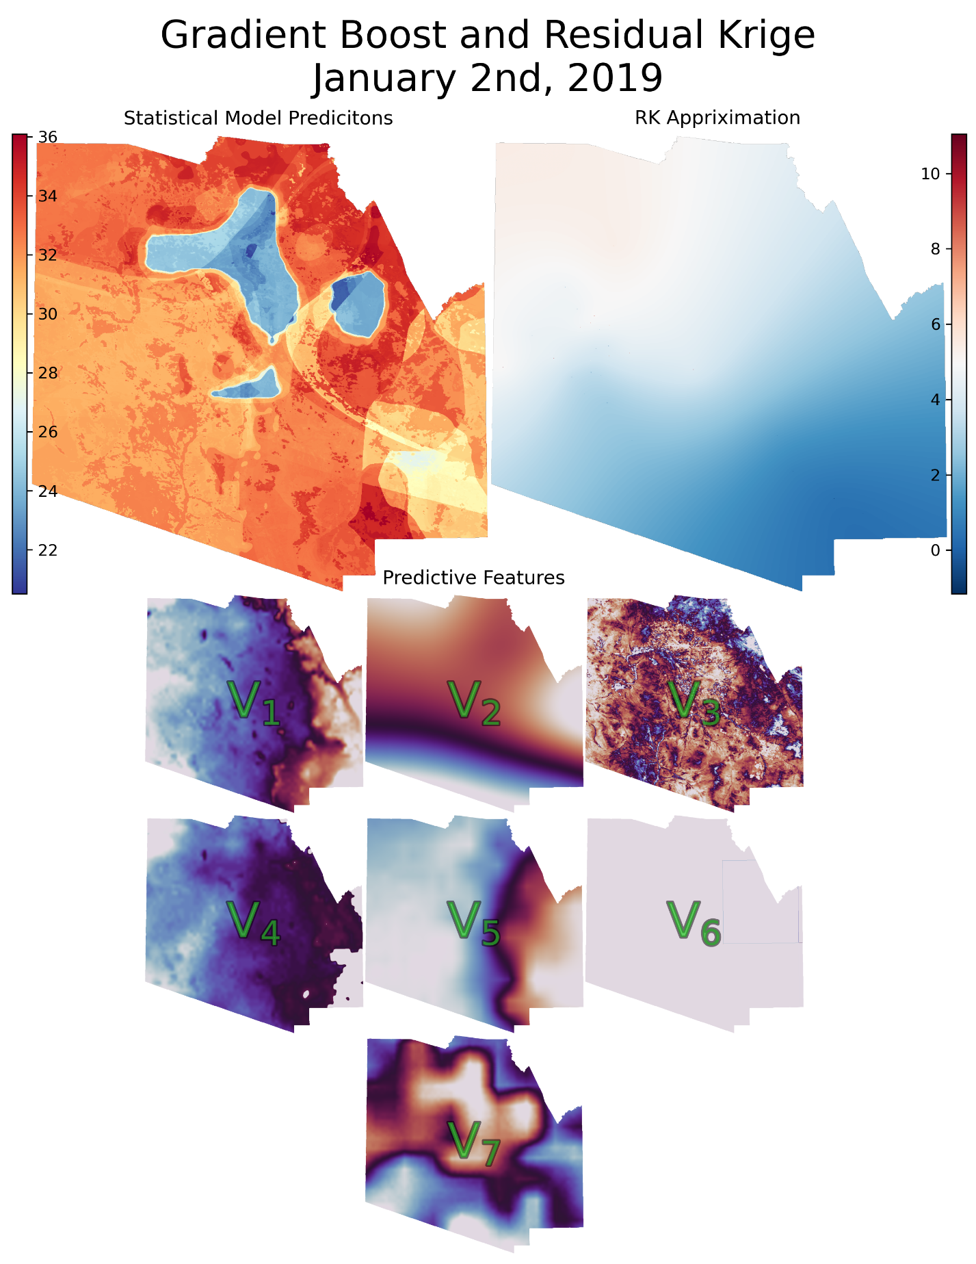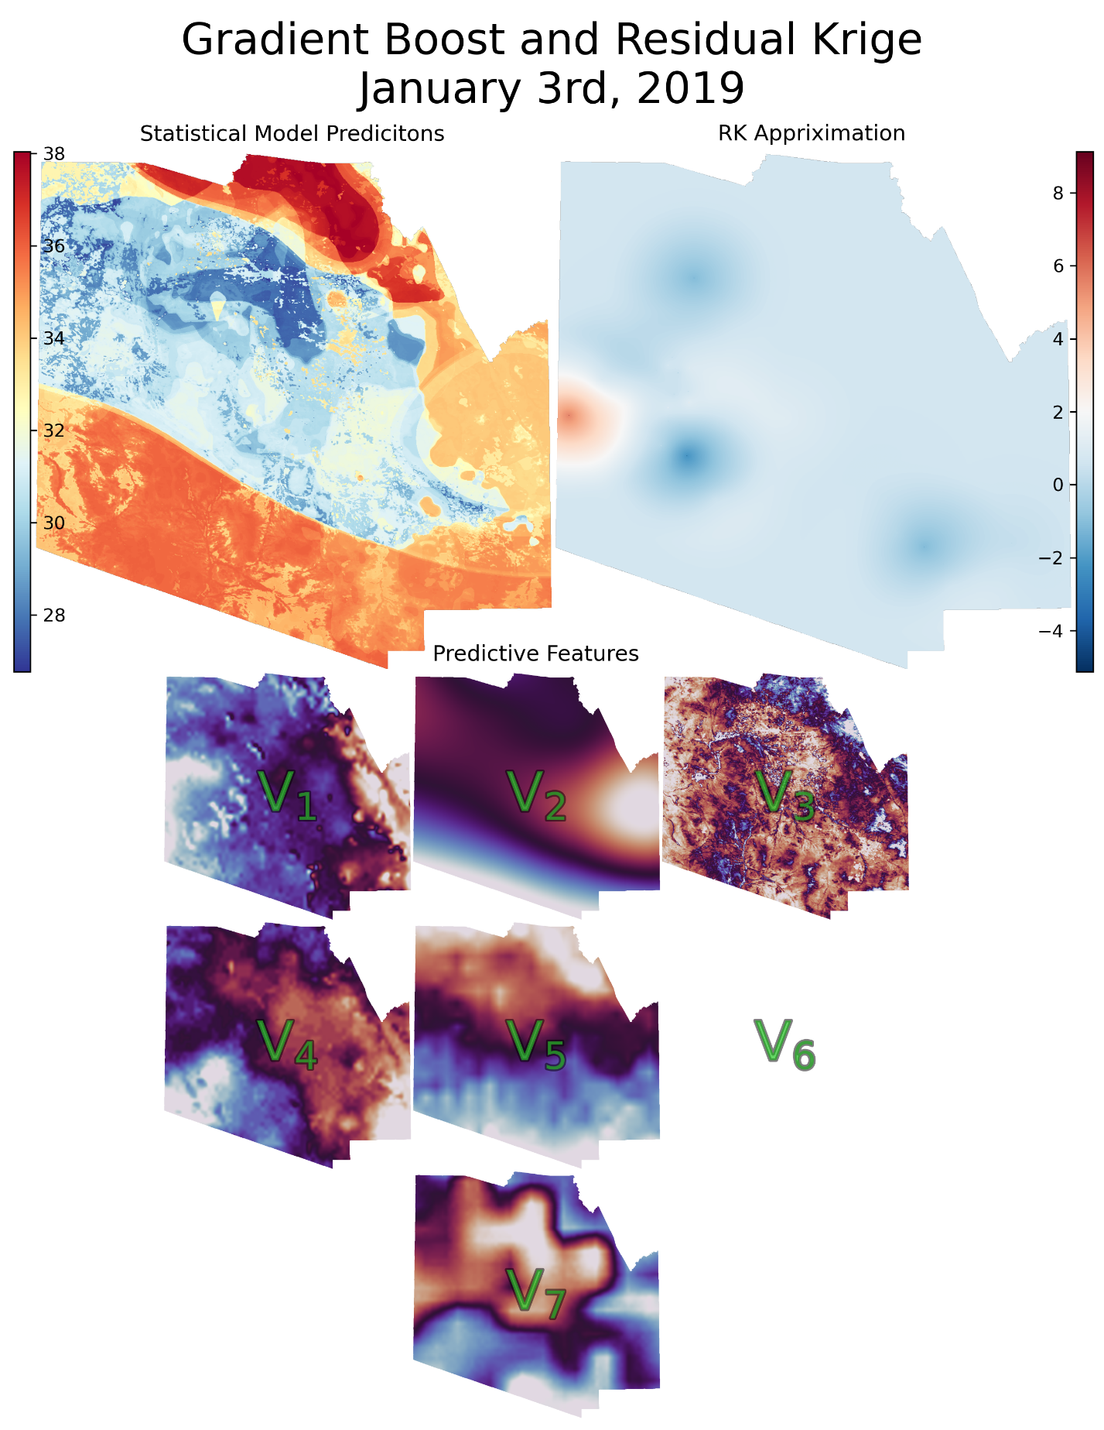

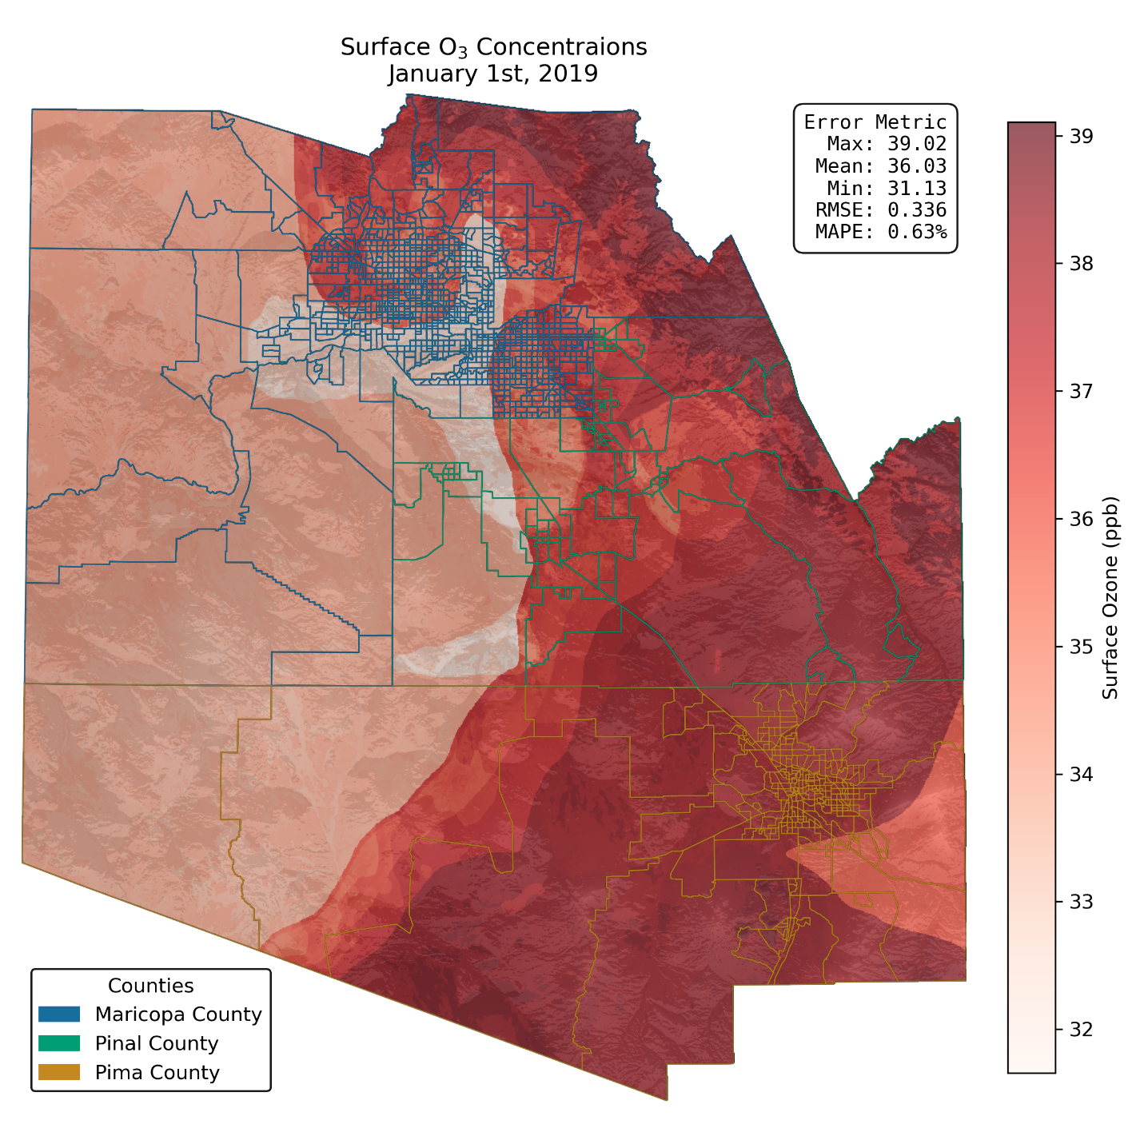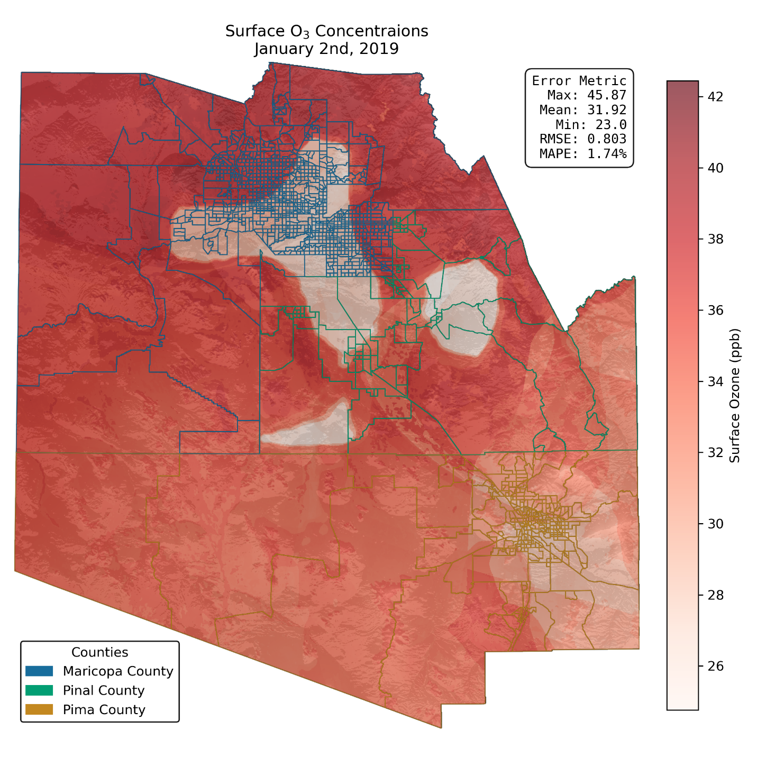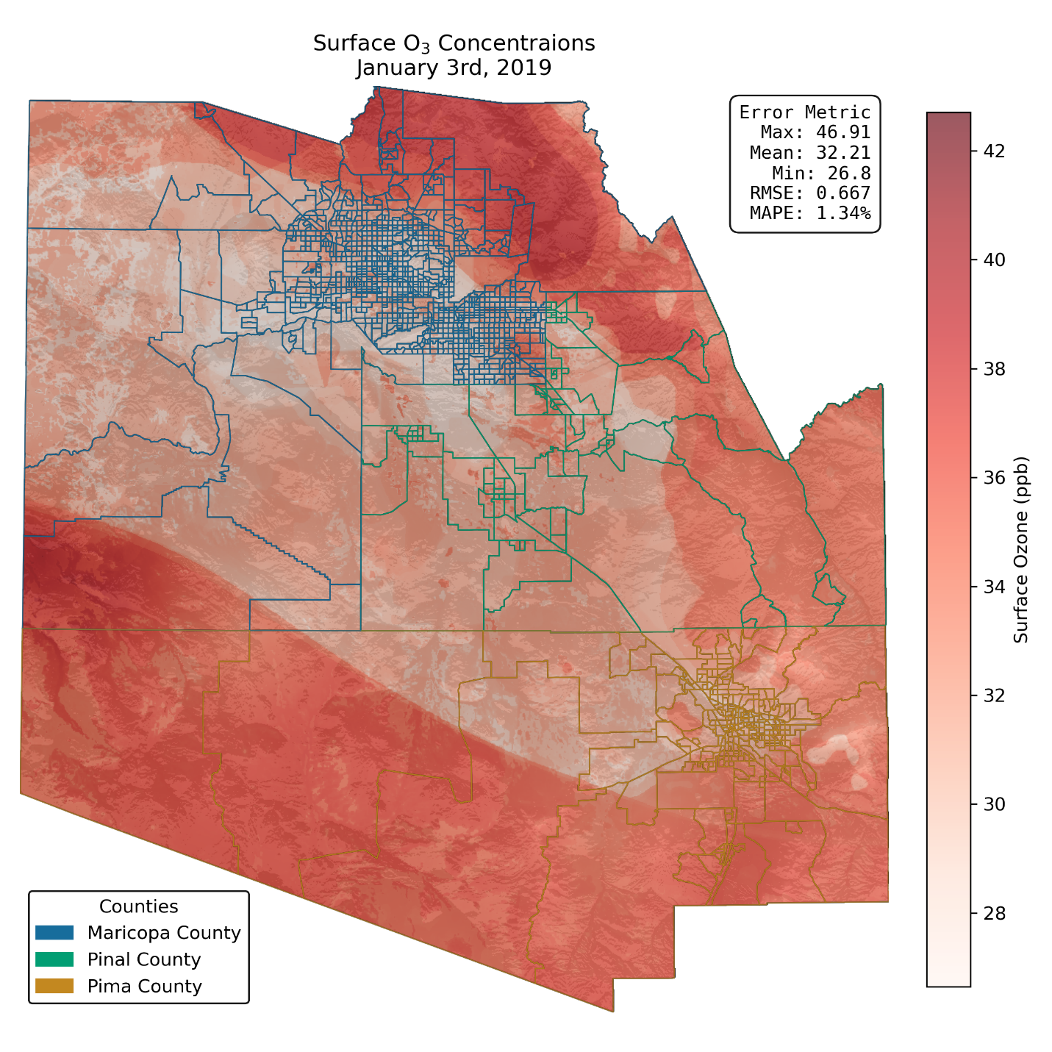

1. Multiple-scale Atmospheric Transport and Chemistry modelling system, in this case, version 4.4.0
2. I.e not pre-processed via methods mentioned in Google Earth Engine in chapter 3